# Sites that were included

NTAARP0004 Test Set: (Timestamp('2002-12-11 00:00:00'), Timestamp('2005-08-21 00:00:00')), Period: 78  
  
NTADAC0001 Test Set: (Timestamp('2008-07-26 00:00:00'), Timestamp('2011-10-31 00:00:00')), Period: 74  
  
NTAGFU0001 Test Set: (Timestamp('2006-02-16 00:00:00'), Timestamp('2008-11-04 00:00:00')), Period: 91  
  
NTAGFU0006 Test Set: (Timestamp('2020-01-06 00:00:00'), Timestamp('2022-12-21 00:00:00')), Period: 93  
  
NTAGFU0011 Test Set: (Timestamp('2019-12-29 00:00:00'), Timestamp('2022-12-13 00:00:00')), Period: 94  
  
NTAGFU0013 Test Set: (Timestamp('1993-04-09 00:00:00'), Timestamp('1998-09-14 00:00:00')), Period: 93  
  
NTAGFU0014 Test Set: (Timestamp('2003-10-22 00:00:00'), Timestamp('2006-05-31 00:00:00')), Period: 93  
  
NTAGFU0016 Test Set: (Timestamp('1993-02-20 00:00:00'), Timestamp('1998-09-30 00:00:00')), Period: 91  
  
NTAGFU0017 Test Set: (Timestamp('1987-09-16 00:00:00'), Timestamp('1992-12-02 00:00:00')), Period: 91  
  
NTAGFU0019 Test Set: (Timestamp('1993-02-20 00:00:00'), Timestamp('1998-09-30 00:00:00')), Period: 91  
  
NTAGFU0020 Test Set: (Timestamp('2015-07-10 00:00:00'), Timestamp('2017-11-28 00:00:00')), Period: 88  
  
NTAGFU0026 Test Set: (Timestamp('2015-10-30 00:00:00'), Timestamp('2017-12-30 00:00:00')), Period: 85  
  
NTAGFU0027 Test Set: (Timestamp('2020-04-18 00:00:00'), Timestamp('2022-12-12 00:00:00')), Period: 81  
  
NTAGFU0029 Test Set: (Timestamp('2018-09-04 00:00:00'), Timestamp('2020-09-01 00:00:00')), Period: 86  
  
NTAGFU0032 Test Set: (Timestamp('2006-06-14 00:00:00'), Timestamp('2008-12-12 00:00:00')), Period: 82  
  
NTAGFU0035 Test Set: (Timestamp('1992-11-30 00:00:00'), Timestamp('1998-11-15 00:00:00')), Period: 81  
  
NTAGFU0037 Test Set: (Timestamp('2002-11-09 00:00:00'), Timestamp('2005-10-01 00:00:00')), Period: 156  
  
NTAGFU0039 Test Set: (Timestamp('1998-07-10 00:00:00'), Timestamp('2002-11-09 00:00:00')), Period: 160  
  
NTAGFU0041 Test Set: (Timestamp('2020-06-03 00:00:00'), Timestamp('2022-12-10 00:00:00')), Period: 89  
  
NTAMGD0002 Test Set: (Timestamp('2011-11-29 00:00:00'), Timestamp('2015-06-18 00:00:00')), Period: 166  
  
NTAMGD0004 Test Set: (Timestamp('2008-11-10 00:00:00'), Timestamp('2012-06-06 00:00:00')), Period: 86  
  
NTAPCK0001 Test Set: (Timestamp('1998-05-21 00:00:00'), Timestamp('2002-06-09 00:00:00')), Period: 146  
  
NTAPCK0002 Test Set: (Timestamp('2005-09-30 00:00:00'), Timestamp('2008-08-05 00:00:00')), Period: 149  
  
NTAPCK0004 Test Set: (Timestamp('2003-08-24 00:00:00'), Timestamp('2006-05-27 00:00:00')), Period: 134  
  
NTAPCK0006 Test Set: (Timestamp('2013-06-15 00:00:00'), Timestamp('2015-09-09 00:00:00')), Period: 125  
  
NTAPCK0007 Test Set: (Timestamp('1994-06-04 00:00:00'), Timestamp('1999-05-01 00:00:00')), Period: 134  
  
NTAPCK1009 Test Set: (Timestamp('2005-11-25 00:00:00'), Timestamp('2008-07-12 00:00:00')), Period: 79  
  
NTAPCK1011 Test Set: (Timestamp('1987-09-05 00:00:00'), Timestamp('1993-07-19 00:00:00')), Period: 81  
  
NTAPCK2014 Test Set: (Timestamp('2020-07-29 00:00:00'), Timestamp('2022-12-18 00:00:00')), Period: 80  
  
NTASTU0001 Test Set: (Timestamp('1998-11-22 00:00:00'), Timestamp('2003-08-16 00:00:00')), Period: 87  
  
NTASTU0002 Test Set: (Timestamp('1987-09-05 00:00:00'), Timestamp('1993-04-30 00:00:00')), Period: 87  
  
NTASTU0003 Test Set: (Timestamp('1993-01-24 00:00:00'), Timestamp('1999-03-30 00:00:00')), Period: 88  
  
NTASTU0004 Test Set: (Timestamp('2015-09-02 00:00:00'), Timestamp('2018-03-18 00:00:00')), Period: 89  
  
NTASTU0005 Test Set: (Timestamp('1999-06-02 00:00:00'), Timestamp('2003-12-06 00:00:00')), Period: 90  
  
NTTDAC0001 Test Set: (Timestamp('1992-12-21 00:00:00'), Timestamp('1998-08-16 00:00:00')), Period: 75  
  
NTTDMR0001 Test Set: (Timestamp('2009-02-14 00:00:00'), Timestamp('2012-08-25 00:00:00')), Period: 90  
  
NTTDMR0002 Test Set: (Timestamp('2012-06-22 00:00:00'), Timestamp('2015-05-22 00:00:00')), Period: 91  
  
NTTDMR0003 Test Set: (Timestamp('2012-07-24 00:00:00'), Timestamp('2015-05-30 00:00:00')), Period: 91  
  
NTTMGD0001 Test Set: (Timestamp('2001-01-31 00:00:00'), Timestamp('2005-06-11 00:00:00')), Period: 125  
  
QDABBS0001 Test Set: (Timestamp('2005-09-16 00:00:00'), Timestamp('2008-10-18 00:00:00')), Period: 85  
  
QDABBS0002 Test Set: (Timestamp('2017-11-21 00:00:00'), Timestamp('2020-02-14 00:00:00')), Period: 86  
  
QDABBS0004 Test Set: (Timestamp('1987-09-23 00:00:00'), Timestamp('1992-12-09 00:00:00')), Period: 84  
  
QDABBS0006 Test Set: (Timestamp('2018-08-13 00:00:00'), Timestamp('2020-08-11 00:00:00')), Period: 116  
  
QDABBS0007 Test Set: (Timestamp('1987-09-18 00:00:00'), Timestamp('1993-09-18 00:00:00')), Period: 84  
  
QDABBS0008 Test Set: (Timestamp('2015-11-26 00:00:00'), Timestamp('2018-07-29 00:00:00')), Period: 83  
  
QDACYP0004 Test Set: (Timestamp('2015-02-20 00:00:00'), Timestamp('2017-07-11 00:00:00')), Period: 65  
  
QDACYP0005 Test Set: (Timestamp('1992-08-06 00:00:00'), Timestamp('1997-08-05 00:00:00')), Period: 66  
  
QDACYP0006 Test Set: (Timestamp('1987-09-27 00:00:00'), Timestamp('1992-09-07 00:00:00')), Period: 71  
  
QDACYP0007 Test Set: (Timestamp('2015-03-16 00:00:00'), Timestamp('2017-09-05 00:00:00')), Period: 66  
  
QDACYP0009 Test Set: (Timestamp('2005-11-24 00:00:00'), Timestamp('2008-09-21 00:00:00')), Period: 115  
  
QDACYP0010 Test Set: (Timestamp('2019-12-08 00:00:00'), Timestamp('2022-12-24 00:00:00')), Period: 58  
  
QDACYP0011 Test Set: (Timestamp('2017-09-21 00:00:00'), Timestamp('2019-12-08 00:00:00')), Period: 58  
  
QDACYP0013 Test Set: (Timestamp('1987-09-11 00:00:00'), Timestamp('1992-09-07 00:00:00')), Period: 54  
  
QDACYP0014 Test Set: (Timestamp('1996-03-26 00:00:00'), Timestamp('2001-06-05 00:00:00')), Period: 53  
  
QDACYP0015 Test Set: (Timestamp('2016-10-04 00:00:00'), Timestamp('2019-09-19 00:00:00')), Period: 50  
  
QDACYP0019 Test Set: (Timestamp('2007-09-09 00:00:00'), Timestamp('2010-11-05 00:00:00')), Period: 68  
  
QDACYP0022 Test Set: (Timestamp('2019-11-06 00:00:00'), Timestamp('2022-12-07 00:00:00')), Period: 80  
  
QDACYP0023 Test Set: (Timestamp('2009-10-09 00:00:00'), Timestamp('2013-04-27 00:00:00')), Period: 76  
  
QDADEU0001 Test Set: (Timestamp('2012-12-07 00:00:00'), Timestamp('2015-07-09 00:00:00')), Period: 79  
  
QDAEIU0001 Test Set: (Timestamp('2006-02-21 00:00:00'), Timestamp('2008-12-27 00:00:00')), Period: 83  
  
QDAEIU0002 Test Set: (Timestamp('2008-10-08 00:00:00'), Timestamp('2012-06-05 00:00:00')), Period: 82  
  
QDAEIU0003 Test Set: (Timestamp('2003-09-25 00:00:00'), Timestamp('2006-04-02 00:00:00')), Period: 81  
  
QDAEIU0004 Test Set: (Timestamp('2005-12-27 00:00:00'), Timestamp('2008-11-17 00:00:00')), Period: 82  
  
QDAEIU0005 Test Set: (Timestamp('1997-08-14 00:00:00'), Timestamp('2002-07-12 00:00:00')), Period: 148  
  
QDAEIU0008 Test Set: (Timestamp('2009-03-02 00:00:00'), Timestamp('2012-09-02 00:00:00')), Period: 79  
  
QDAEIU0009 Test Set: (Timestamp('2017-12-13 00:00:00'), Timestamp('2020-06-19 00:00:00')), Period: 79  
  
QDAEIU0010 Test Set: (Timestamp('2002-09-23 00:00:00'), Timestamp('2005-10-01 00:00:00')), Period: 79  
  
QDAGUP0007 Test Set: (Timestamp('2003-05-26 00:00:00'), Timestamp('2006-01-19 00:00:00')), Period: 166  
  
QDAGUP0008 Test Set: (Timestamp('2008-11-15 00:00:00'), Timestamp('2012-01-04 00:00:00')), Period: 169  
  
QDAGUP0009 Test Set: (Timestamp('2003-03-07 00:00:00'), Timestamp('2006-02-11 00:00:00')), Period: 172  
  
QDAGUP0011 Test Set: (Timestamp('1987-09-11 00:00:00'), Timestamp('1992-09-16 00:00:00')), Period: 158  
  
QDAGUP0012 Test Set: (Timestamp('2011-02-16 00:00:00'), Timestamp('2014-08-27 00:00:00')), Period: 101  
  
QDAGUP0013 Test Set: (Timestamp('2012-08-13 00:00:00'), Timestamp('2015-06-03 00:00:00')), Period: 90  
  
QDAGUP0014 Test Set: (Timestamp('2011-10-22 00:00:00'), Timestamp('2015-03-31 00:00:00')), Period: 162  
  
QDAGUP0015 Test Set: (Timestamp('2008-12-25 00:00:00'), Timestamp('2011-10-30 00:00:00')), Period: 152  
  
QDAGUP0016 Test Set: (Timestamp('2015-04-16 00:00:00'), Timestamp('2017-10-30 00:00:00')), Period: 156  
  
QDAGUP0017 Test Set: (Timestamp('1993-10-12 00:00:00'), Timestamp('1999-07-26 00:00:00')), Period: 100  
  
QDAGUP0018 Test Set: (Timestamp('2013-08-01 00:00:00'), Timestamp('2016-01-14 00:00:00')), Period: 88  
  
QDAGUP0019 Test Set: (Timestamp('2014-05-15 00:00:00'), Timestamp('2016-06-22 00:00:00')), Period: 114  
  
QDAGUP0022 Test Set: (Timestamp('1987-09-02 00:00:00'), Timestamp('1992-10-09 00:00:00')), Period: 155  
  
QDAGUP0023 Test Set: (Timestamp('2017-08-19 00:00:00'), Timestamp('2020-06-01 00:00:00')), Period: 152  
  
QDAGUP0024 Test Set: (Timestamp('1992-05-26 00:00:00'), Timestamp('1999-07-25 00:00:00')), Period: 127  
  
QDAGUP0026 Test Set: (Timestamp('2005-10-14 00:00:00'), Timestamp('2008-09-27 00:00:00')), Period: 133  
  
QDAGUP0029 Test Set: (Timestamp('2003-10-18 00:00:00'), Timestamp('2006-07-06 00:00:00')), Period: 86  
  
QDAGUP0030 Test Set: (Timestamp('2003-08-07 00:00:00'), Timestamp('2006-05-19 00:00:00')), Period: 85  
  
QDAGUP0031 Test Set: (Timestamp('2017-12-27 00:00:00'), Timestamp('2020-05-01 00:00:00')), Period: 86  
  
QDAMGD0027 Test Set: (Timestamp('2020-05-30 00:00:00'), Timestamp('2022-12-14 00:00:00')), Period: 94  
  
QDAMGD0028 Test Set: (Timestamp('2017-09-19 00:00:00'), Timestamp('2020-03-11 00:00:00')), Period: 92  
  
QDAMII0001 Test Set: (Timestamp('2015-04-24 00:00:00'), Timestamp('2017-10-22 00:00:00')), Period: 89  
  
QDAMII0002 Test Set: (Timestamp('1999-09-02 00:00:00'), Timestamp('2004-02-28 00:00:00')), Period: 92  
  
WAACEK0002 Test Set: (Timestamp('2020-05-13 00:00:00'), Timestamp('2022-12-05 00:00:00')), Period: 85  
  
WAADAL0001 Test Set: (Timestamp('1999-07-15 00:00:00'), Timestamp('2003-12-01 00:00:00')), Period: 90  
  
WAADAL0005 Test Set: (Timestamp('2006-07-09 00:00:00'), Timestamp('2009-03-19 00:00:00')), Period: 91  
  
WAANOK0003 Test Set: (Timestamp('1987-09-01 00:00:00'), Timestamp('1993-04-10 00:00:00')), Period: 90  
  
WAANOK0004 Test Set: (Timestamp('2015-03-14 00:00:00'), Timestamp('2017-08-10 00:00:00')), Period: 87  
  
WAANOK0005 Test Set: (Timestamp('1987-09-01 00:00:00'), Timestamp('1992-11-01 00:00:00')), Period: 86  
  
WAANOK0007 Test Set: (Timestamp('2020-01-31 00:00:00'), Timestamp('2022-12-06 00:00:00')), Period: 86  
  
WAANOK0008 Test Set: (Timestamp('2015-02-10 00:00:00'), Timestamp('2017-07-17 00:00:00')), Period: 88  
  
WAAVIB0001 Test Set: (Timestamp('2017-12-09 00:00:00'), Timestamp('2020-04-29 00:00:00')), Period: 89  
  
WAAVIB0003 Test Set: (Timestamp('2009-05-01 00:00:00'), Timestamp('2012-12-11 00:00:00')), Period: 90  
  
WAAVIB0004 Test Set: (Timestamp('1999-04-04 00:00:00'), Timestamp('2004-01-04 00:00:00')), Period: 90

# Table: MSE of the Random Forest on each output

|  |  |  |  |  |
| --- | --- | --- | --- | --- |
|  | pv_filter | npv_filter | bs_filter | loss_mean |
| Train | 2.459 | 2.371 | 2.342 | 2.391 |
| Test | 37.378 | 54.424 | 61.639 | 51.147 |

# Permutation Importance

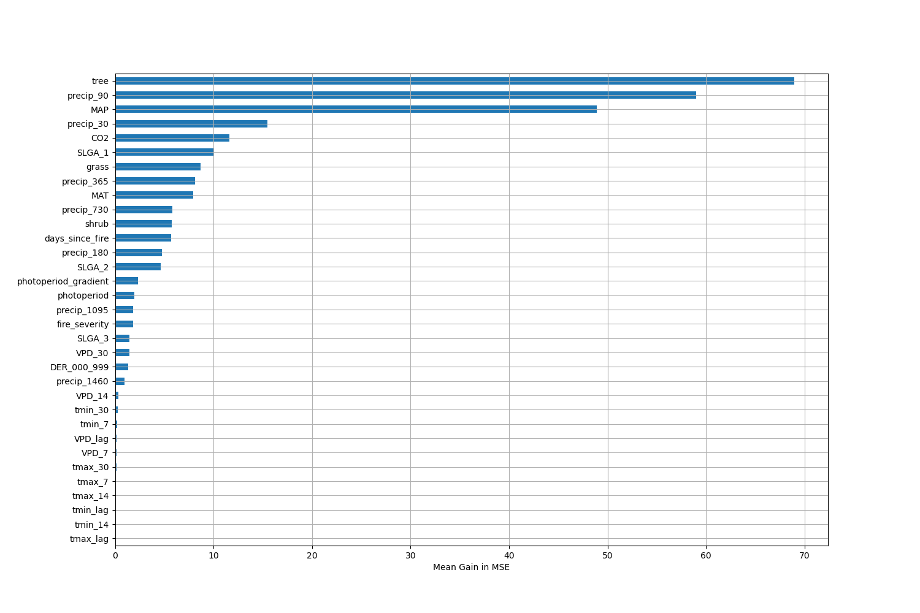

# Permutation Importance by Precip

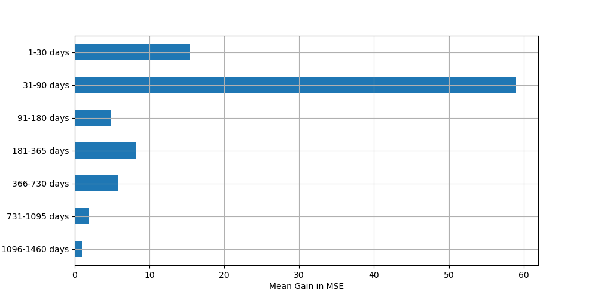

# ALE Importance

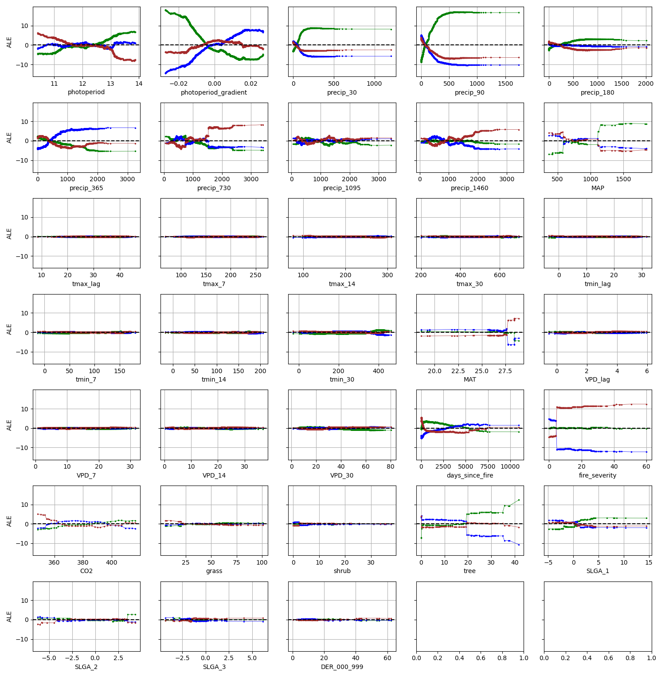

# NTAARP0004

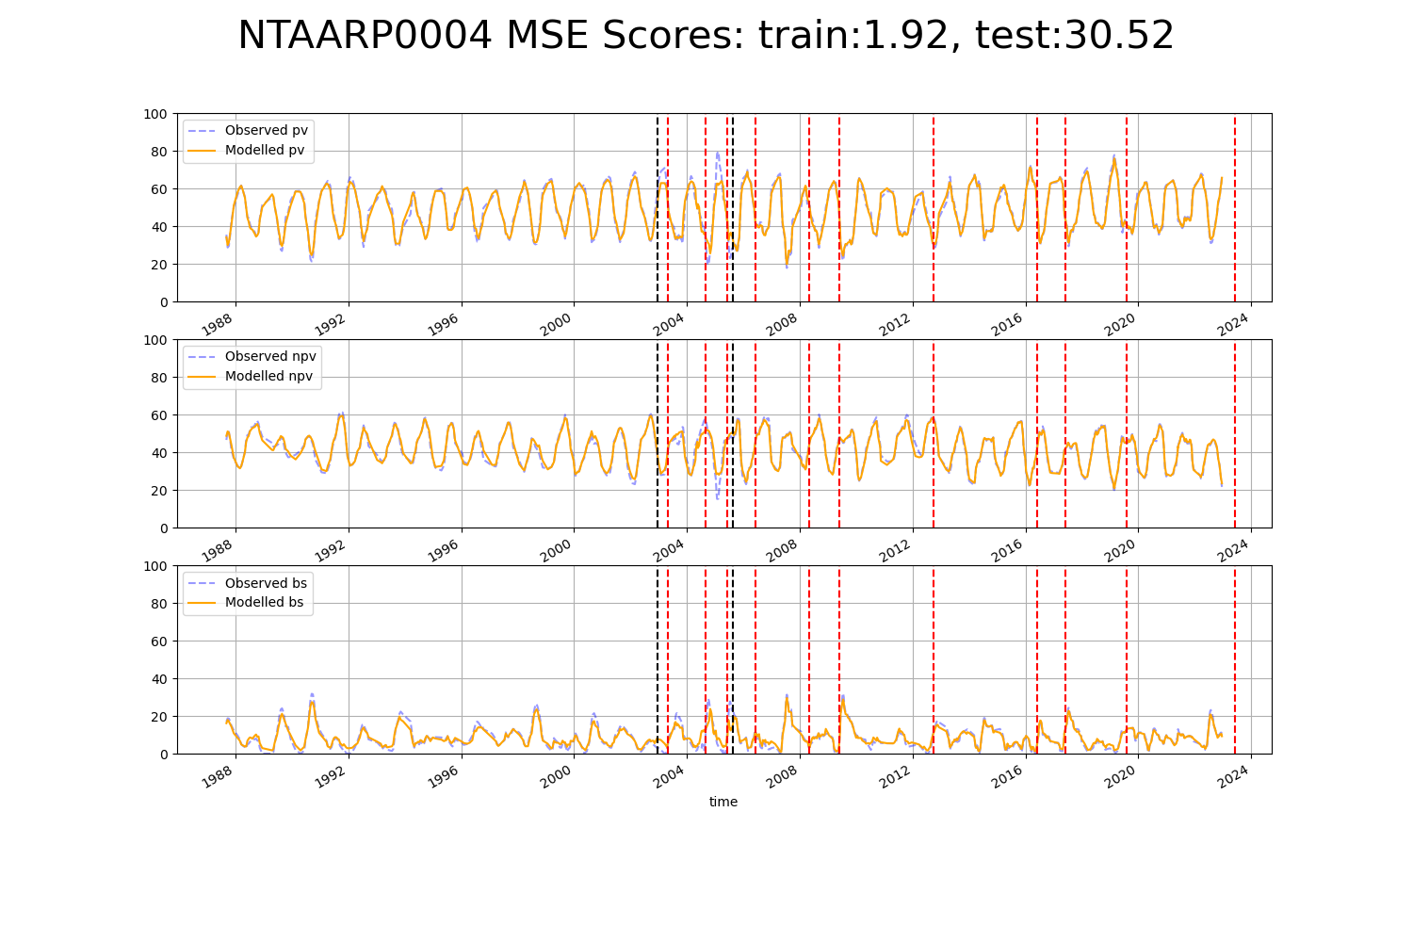

# NTADAC0001

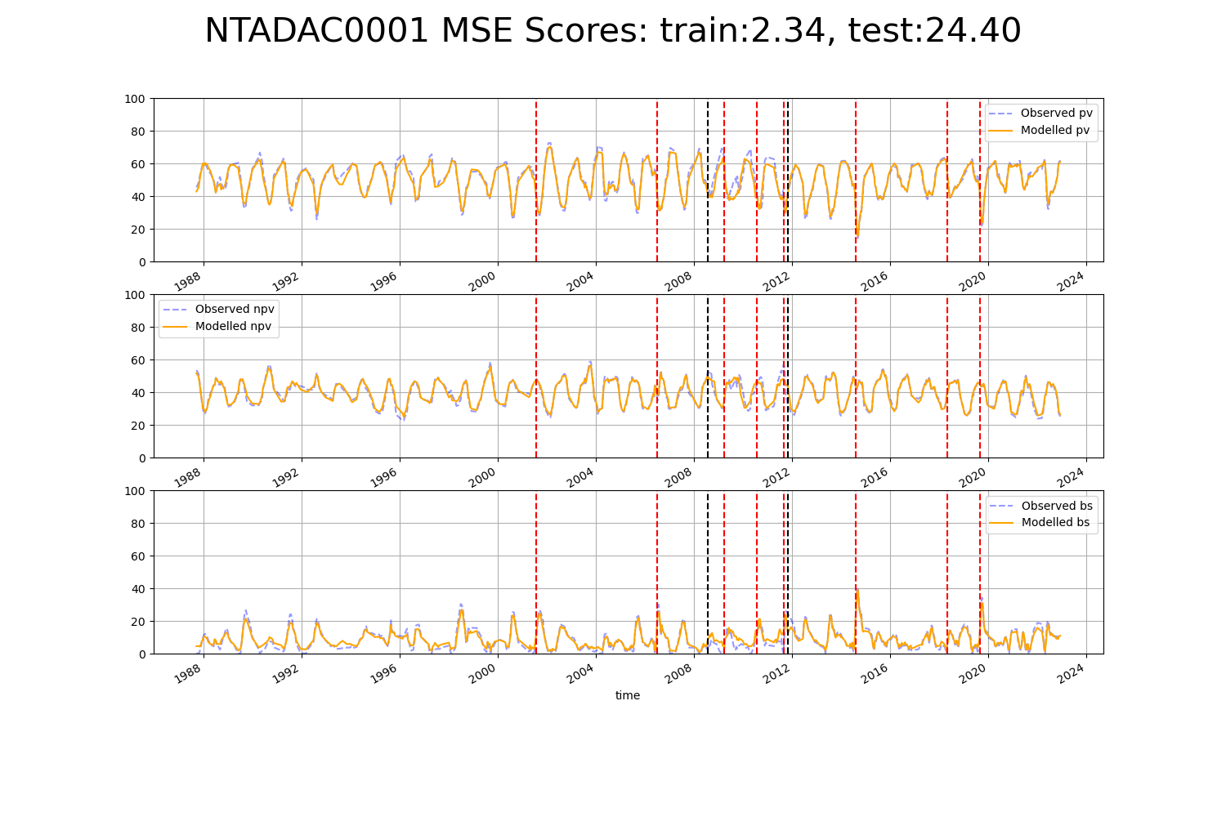

# NTAGFU0001

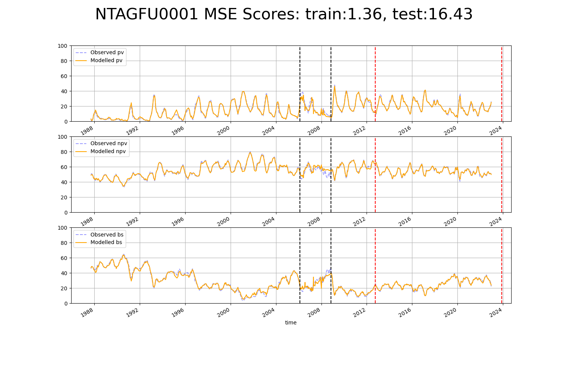

# NTAGFU0006

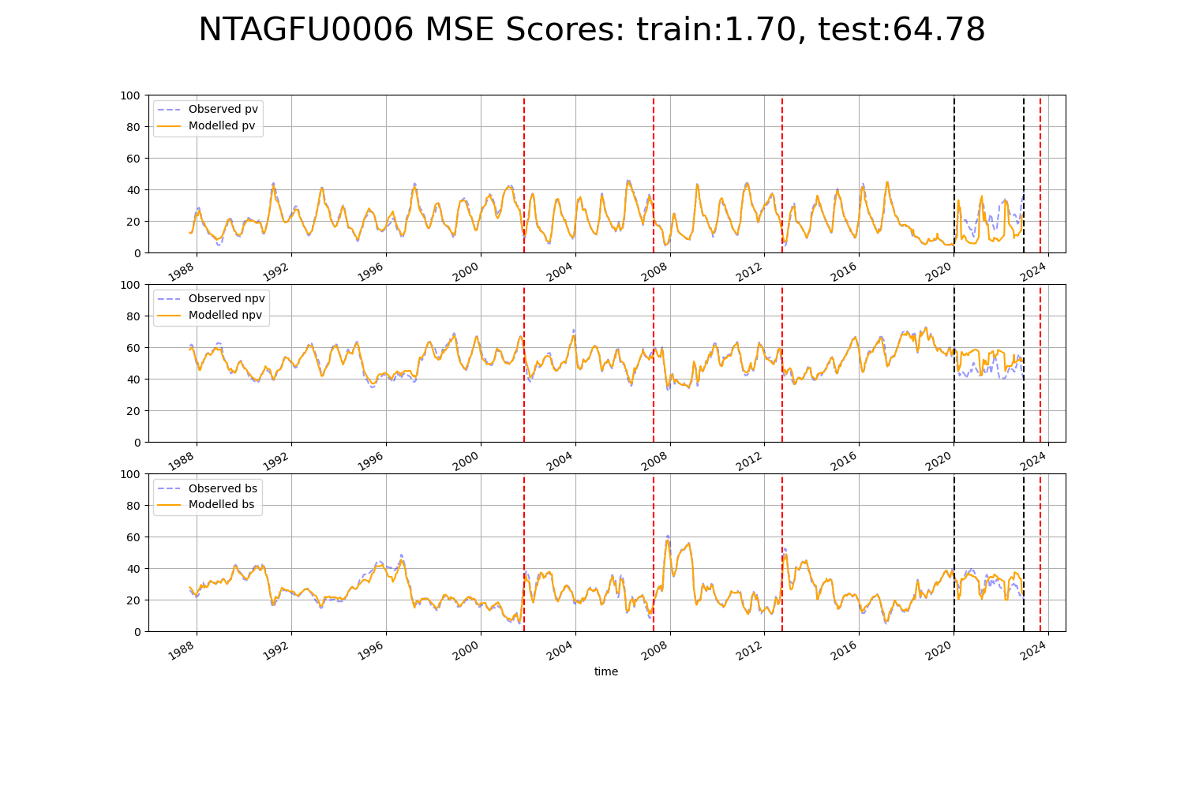

# NTAGFU0011

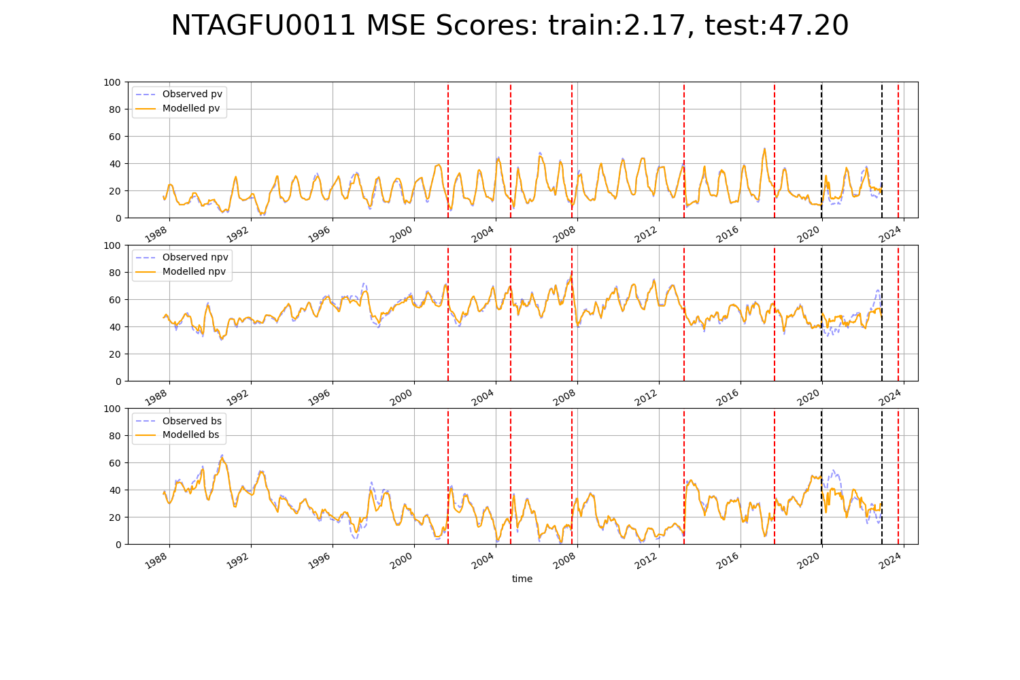

# NTAGFU0013

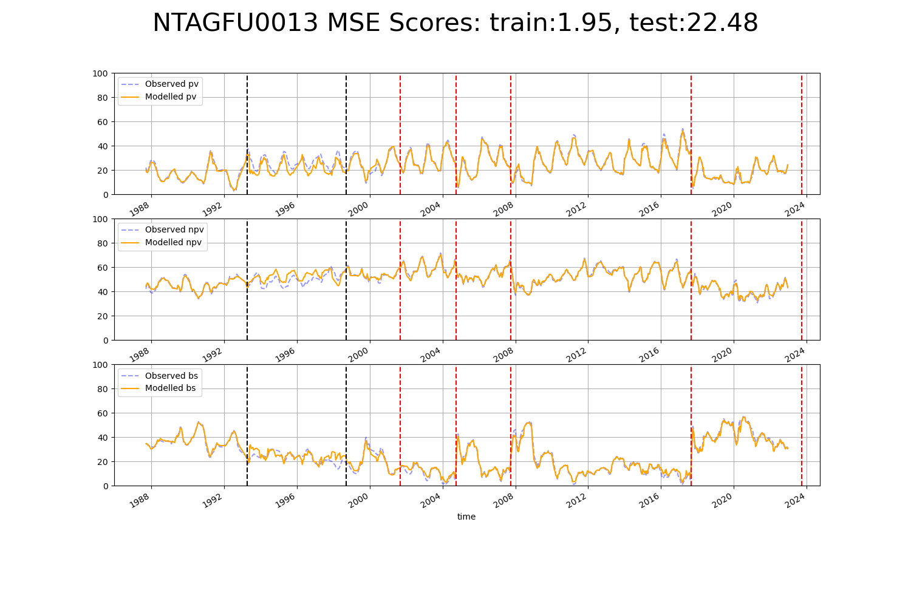

# NTAGFU0014

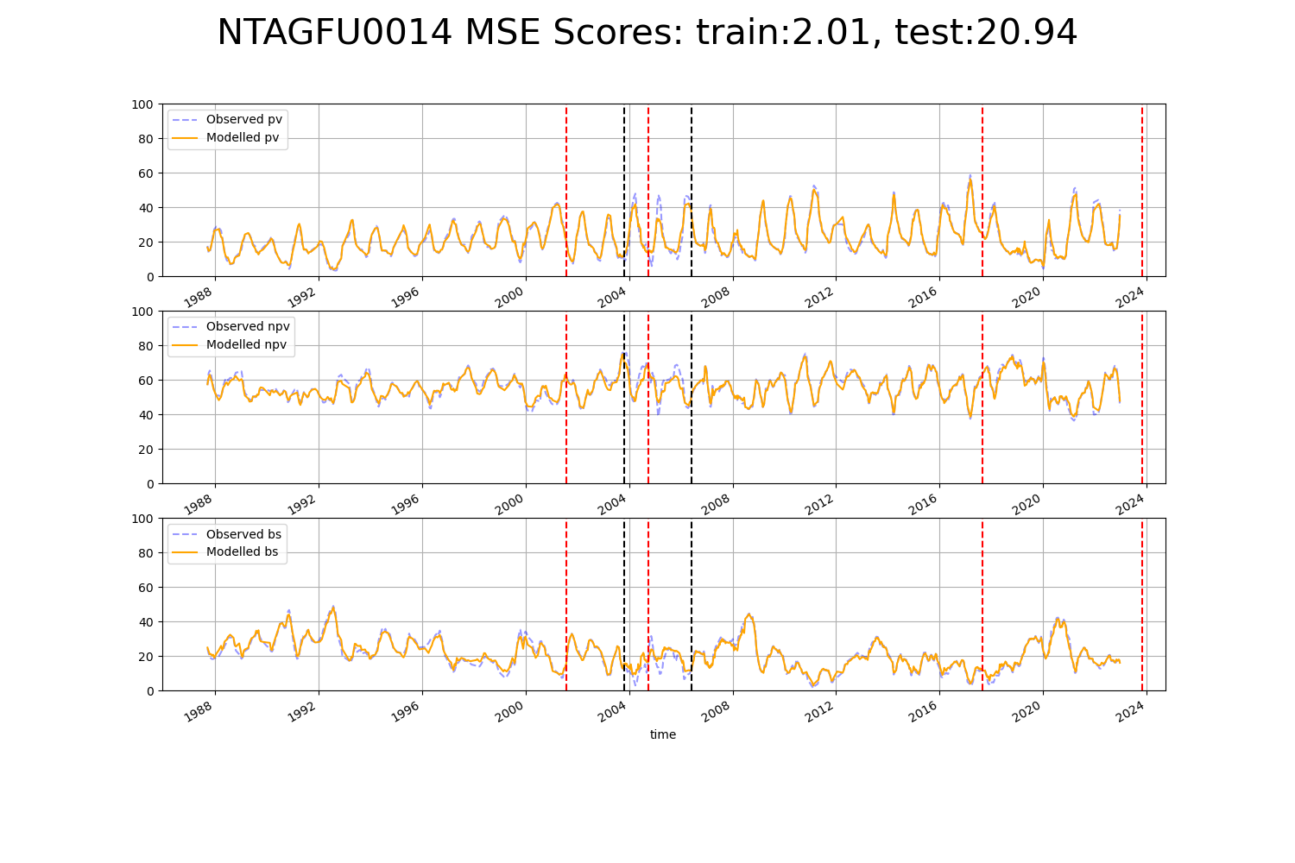

# NTAGFU0016

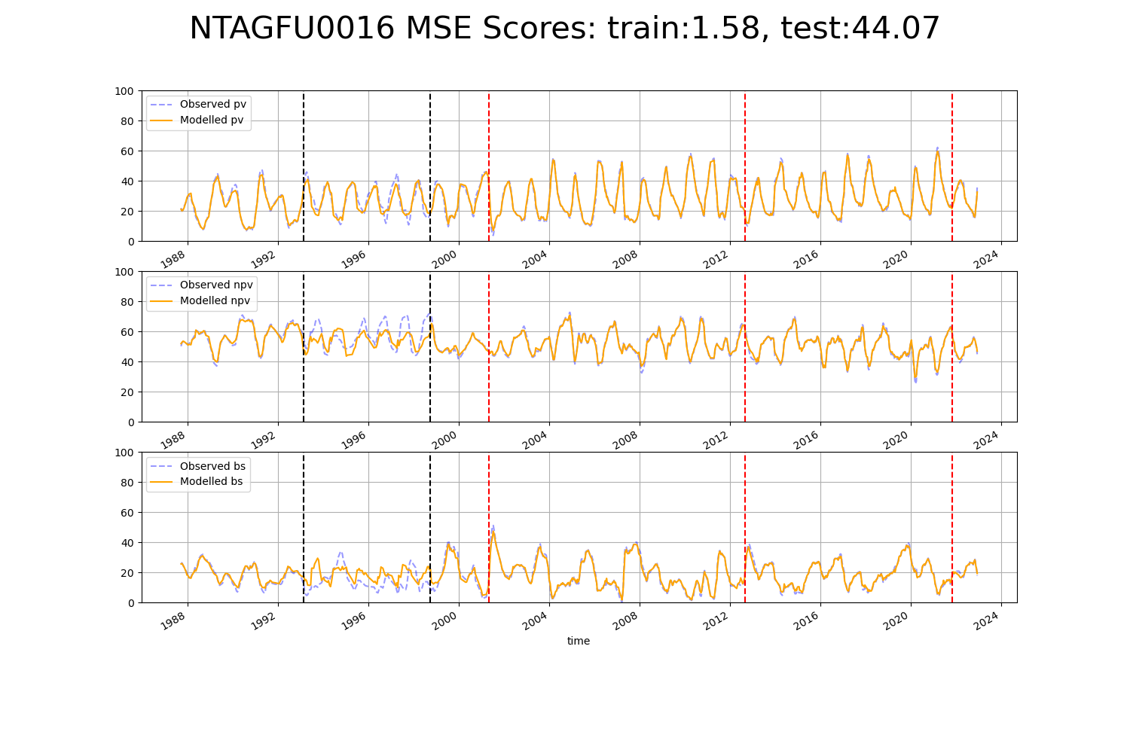

# NTAGFU0017

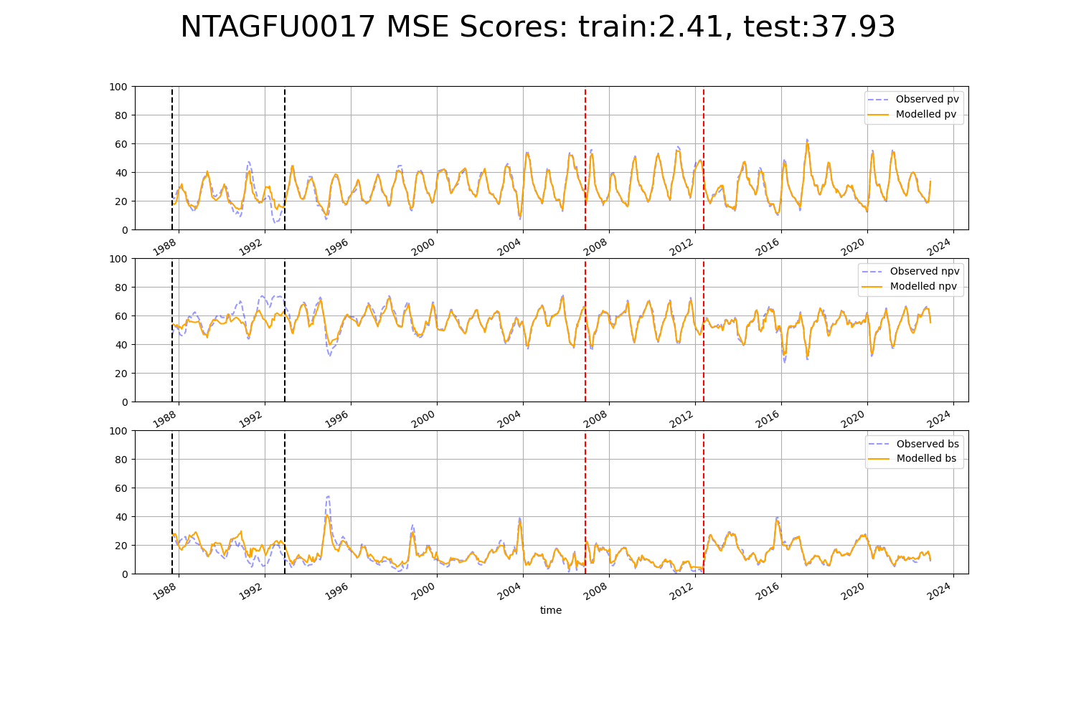

# NTAGFU0019

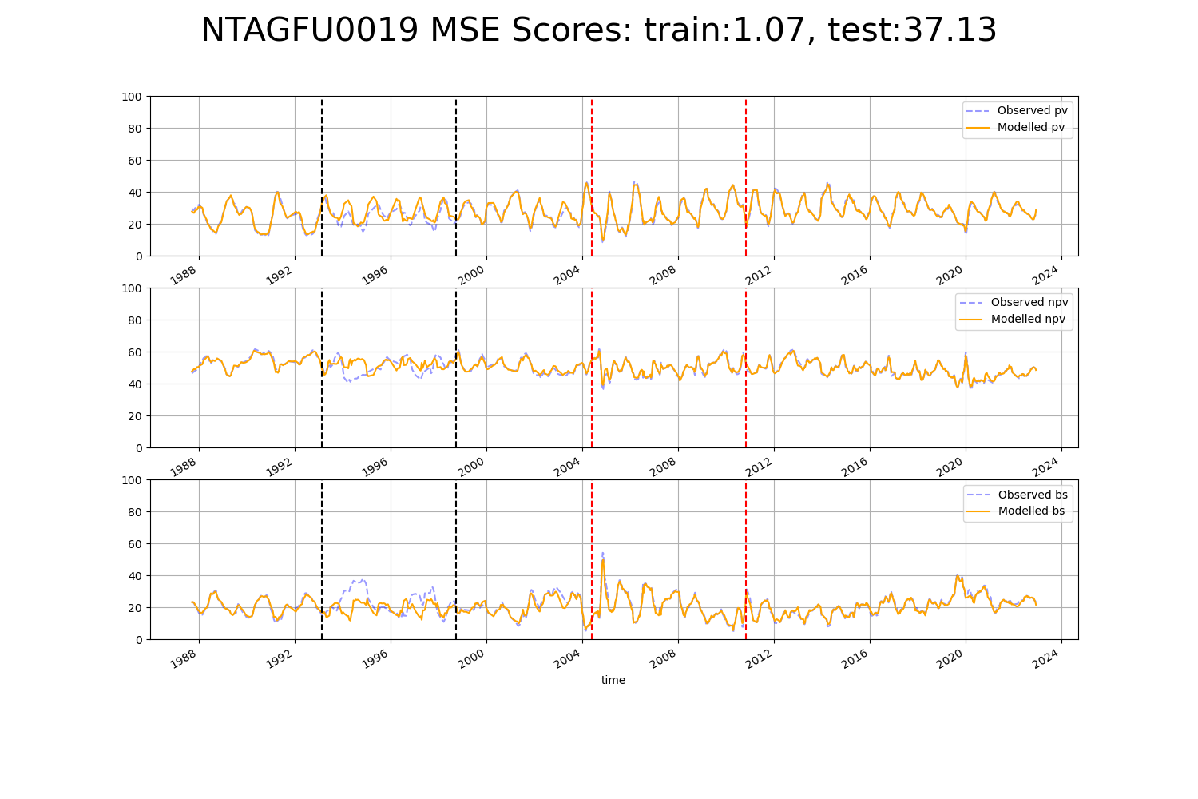

# NTAGFU0020

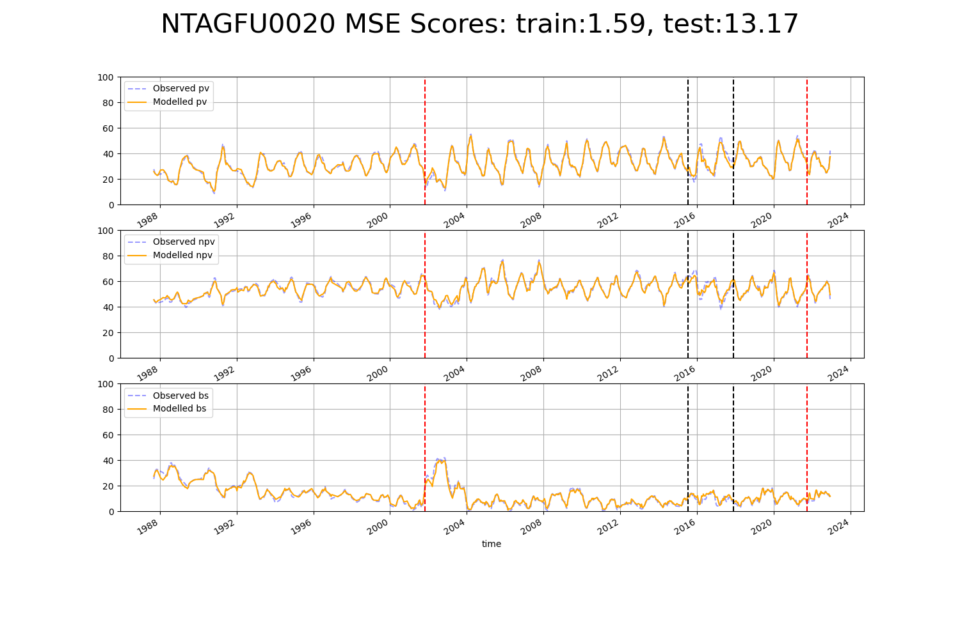

# NTAGFU0026

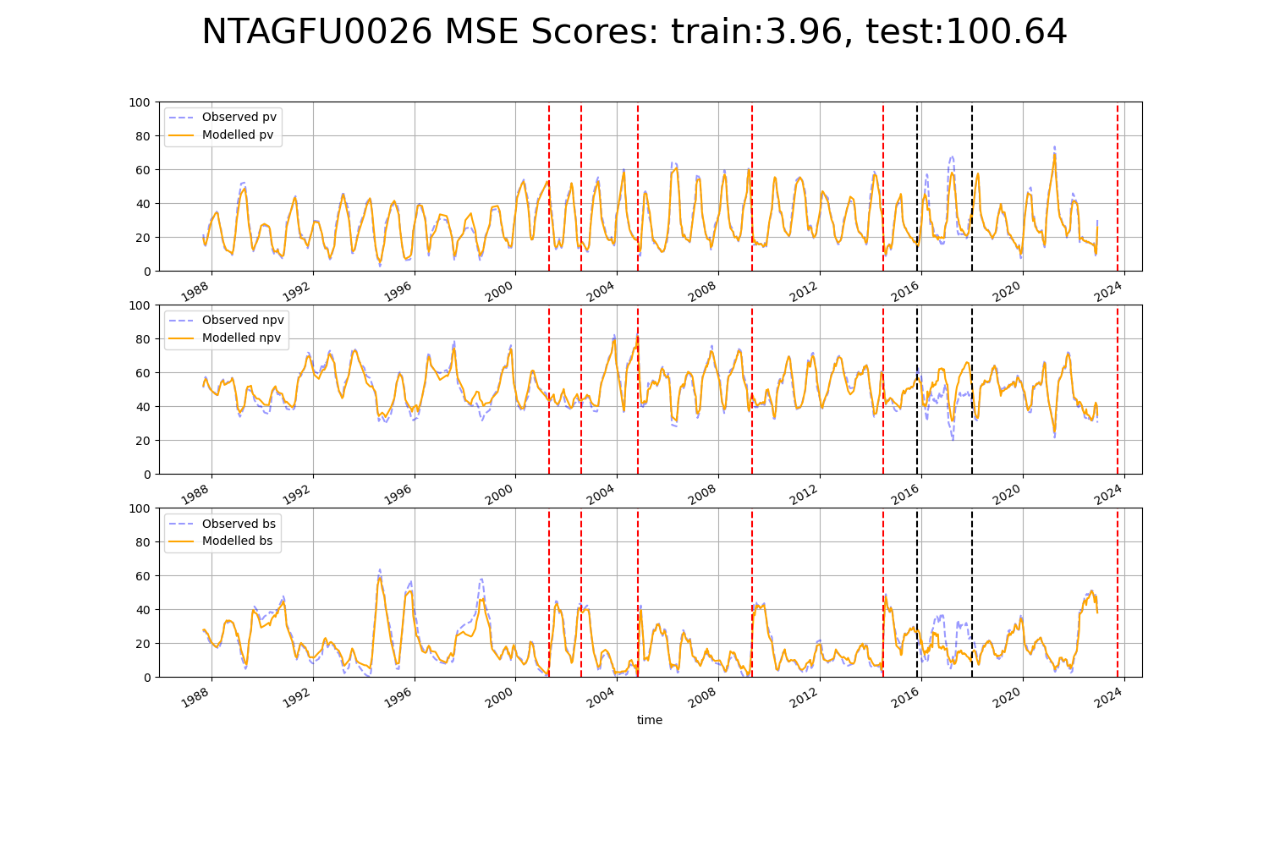

# NTAGFU0027

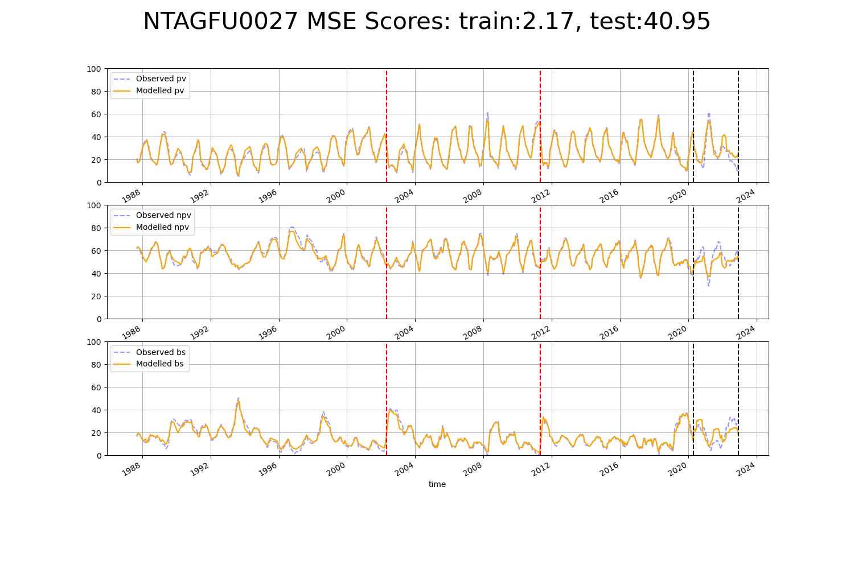

# NTAGFU0029

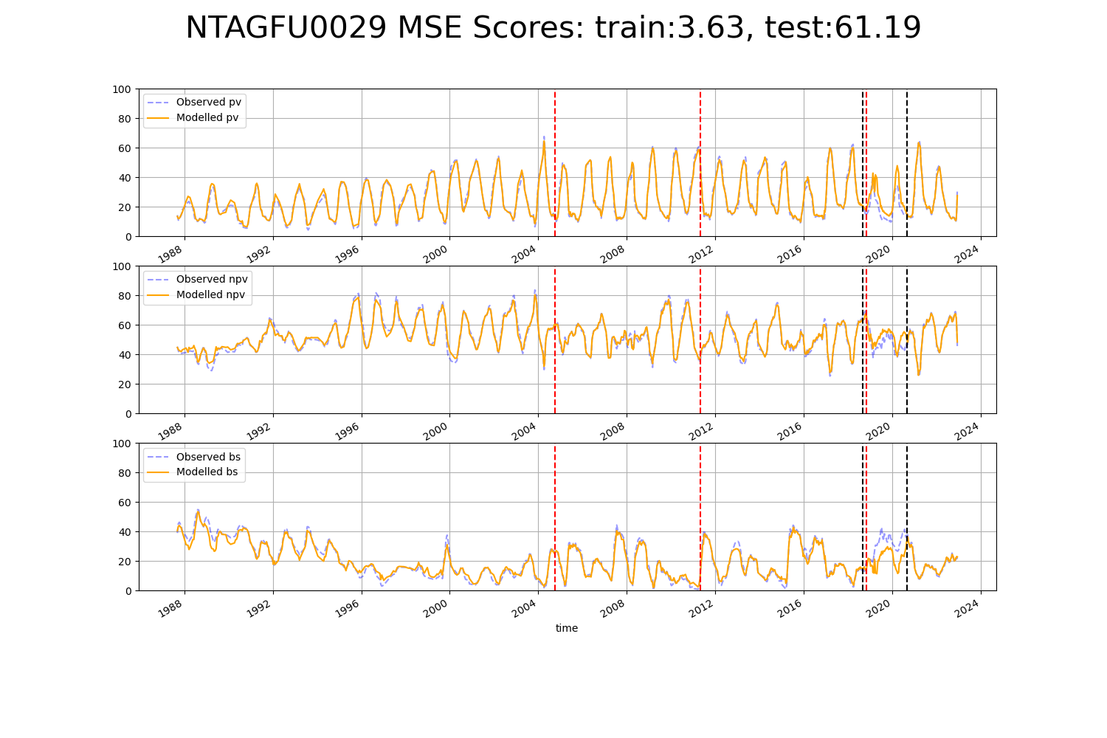

# NTAGFU0032

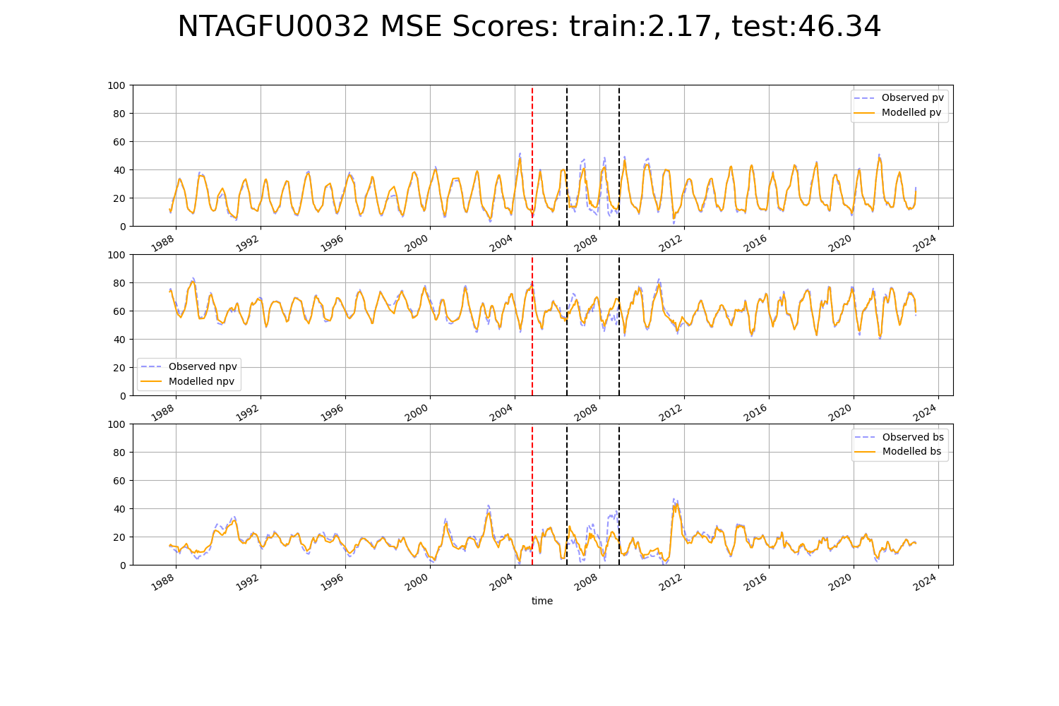

# NTAGFU0035

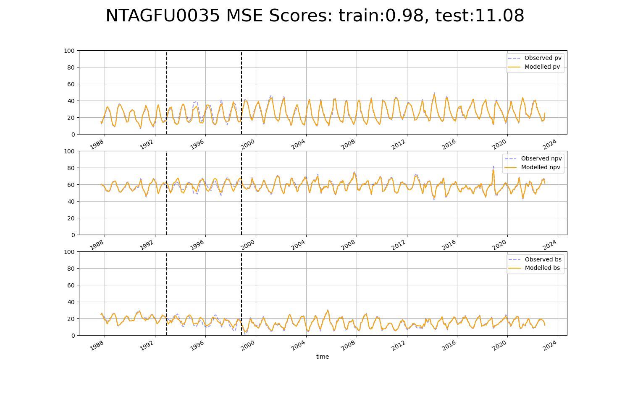

# NTAGFU0037

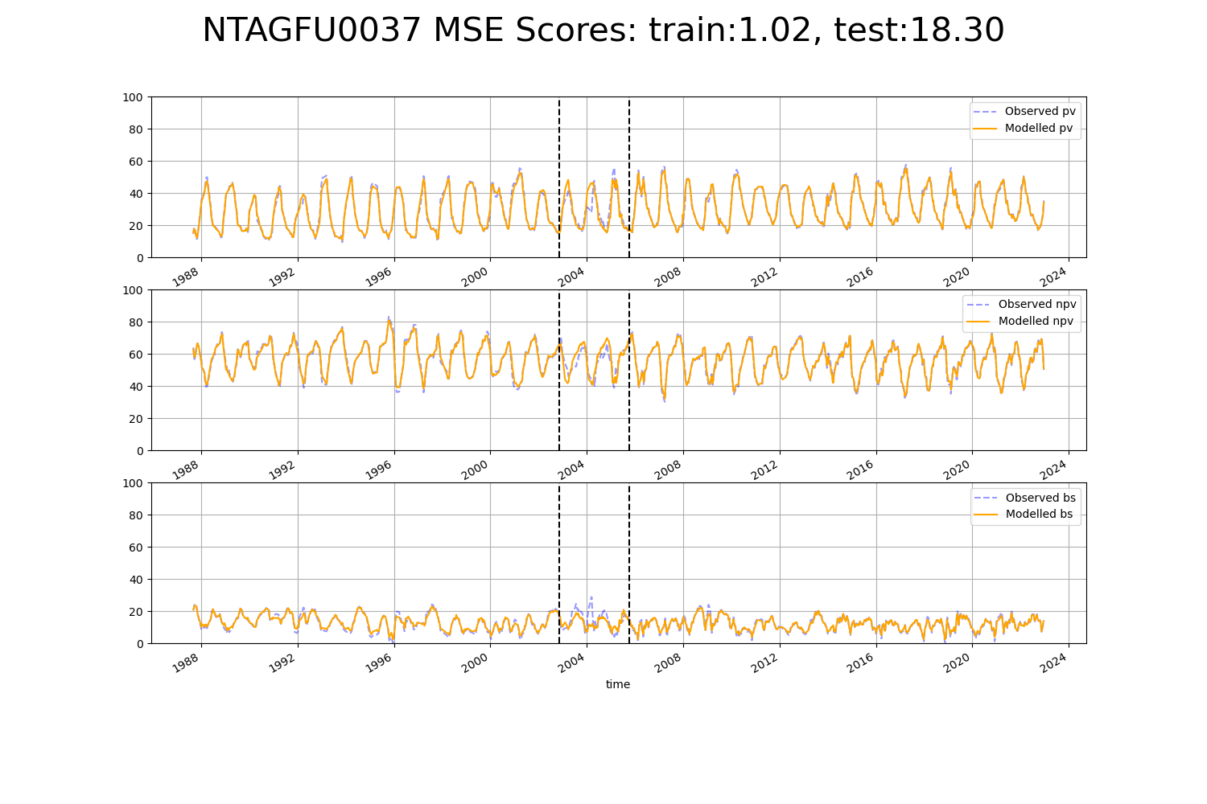

# NTAGFU0039

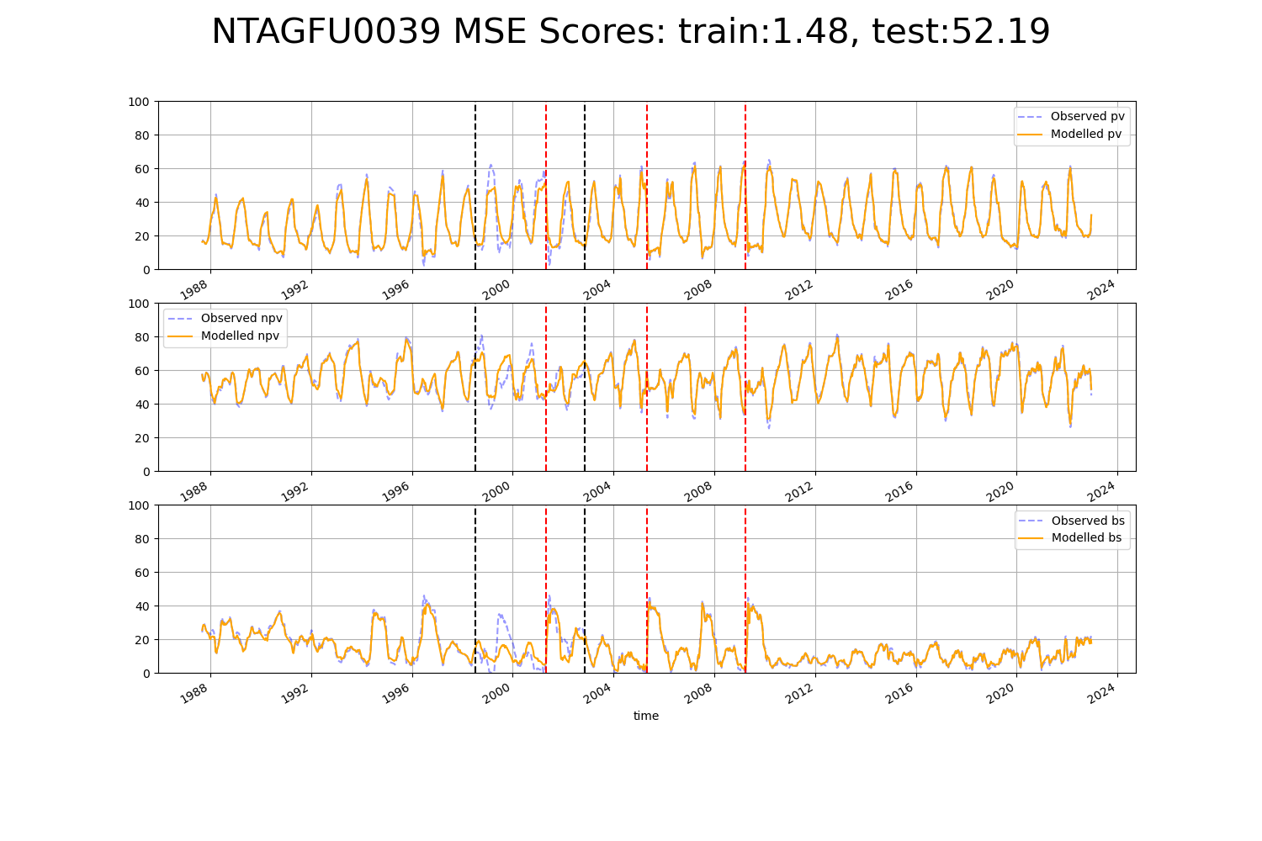

# NTAGFU0041

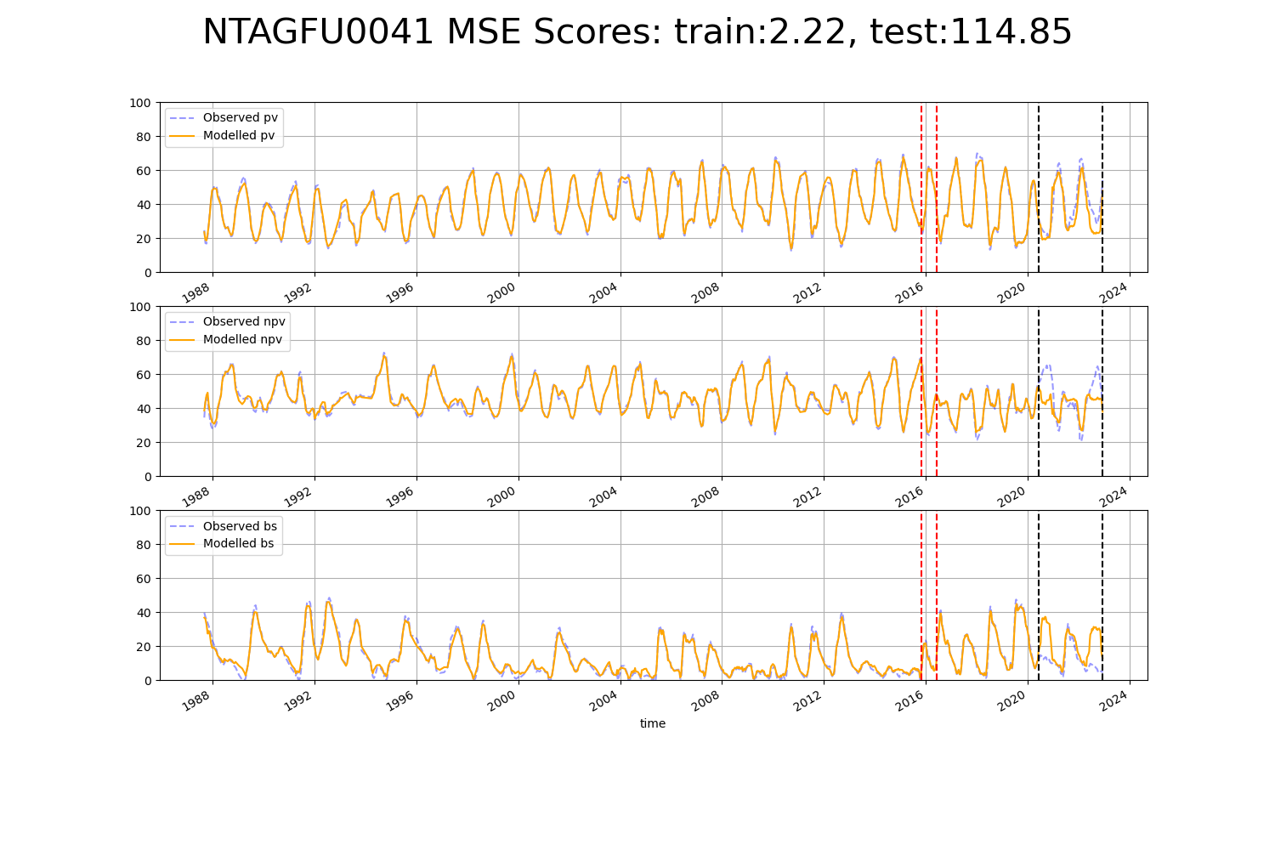

# NTAMGD0002

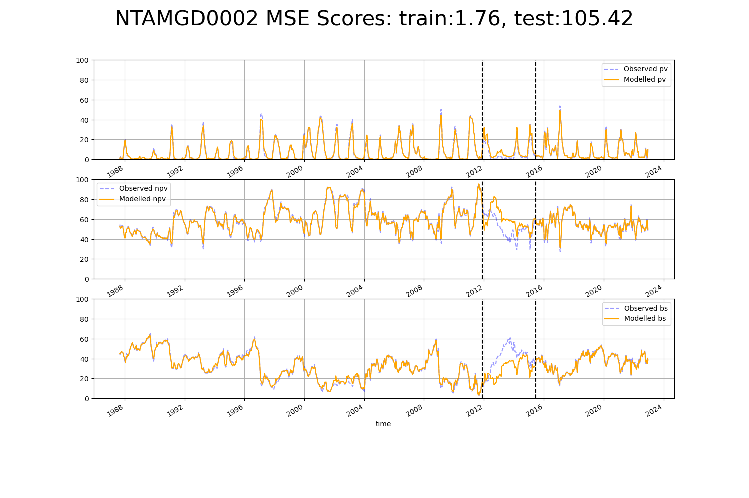

# NTAMGD0004

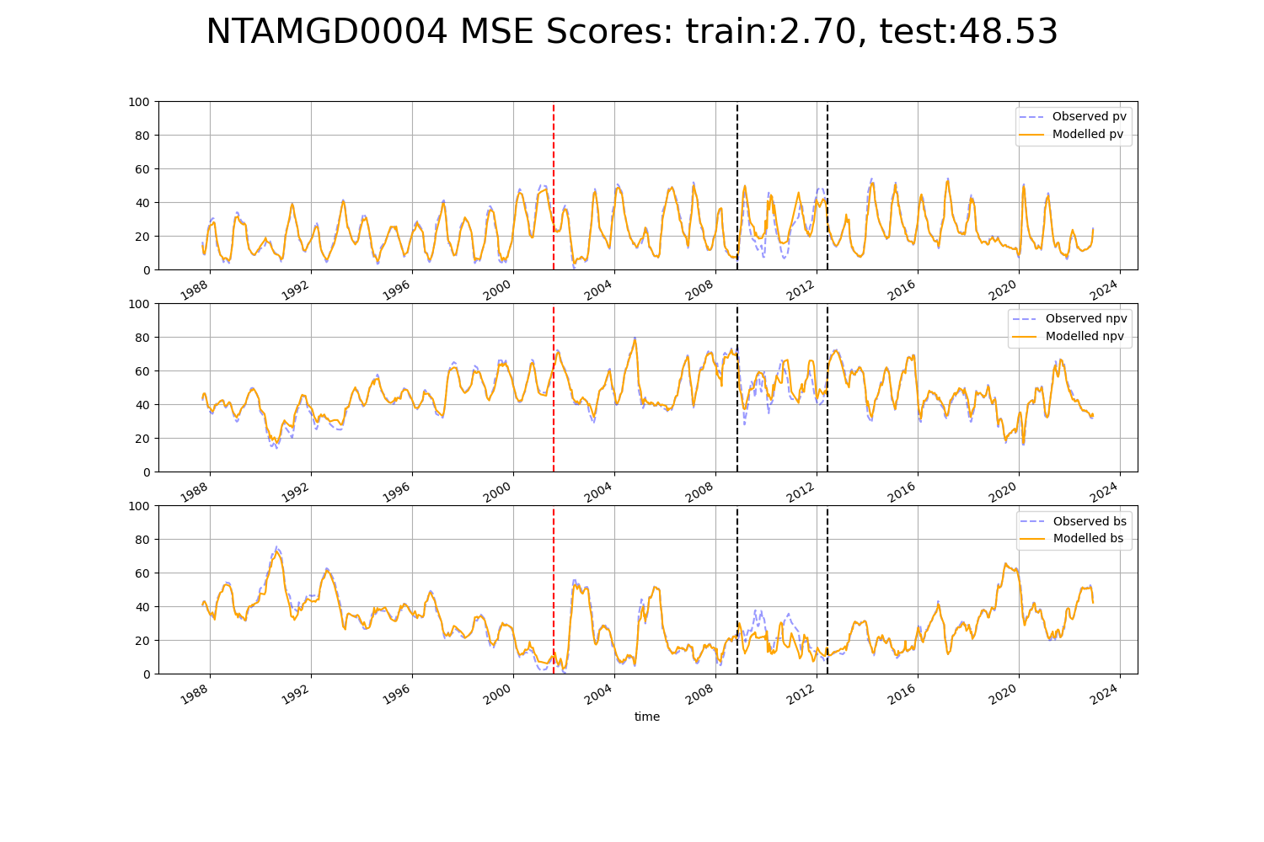

# NTAPCK0001

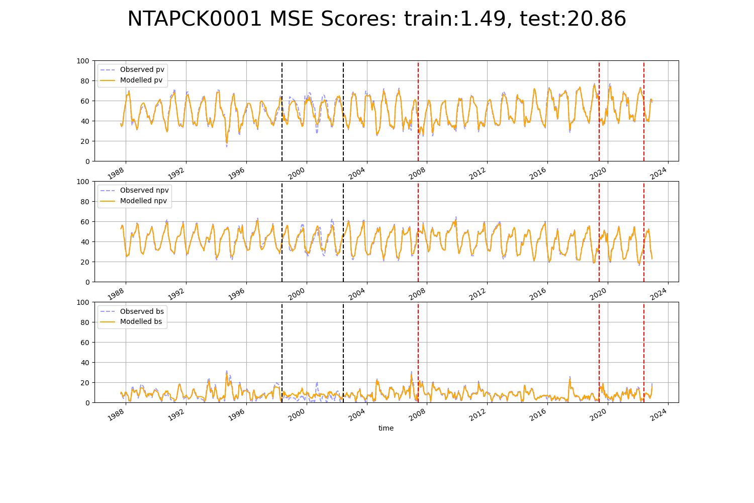

# NTAPCK0002

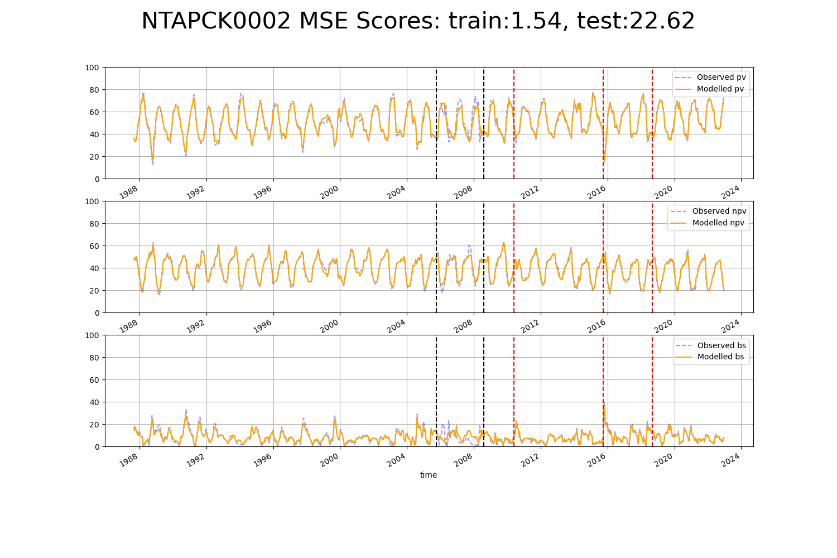

# NTAPCK0004

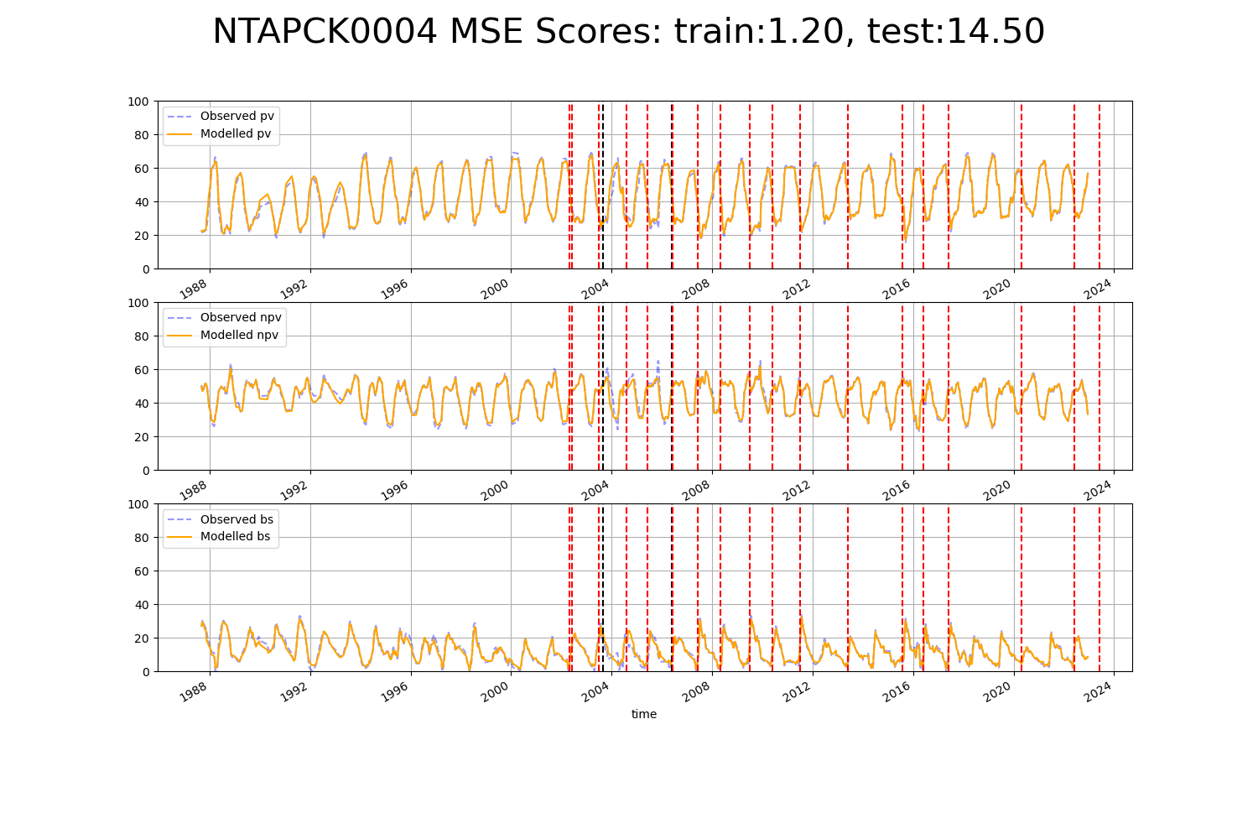

# NTAPCK0006

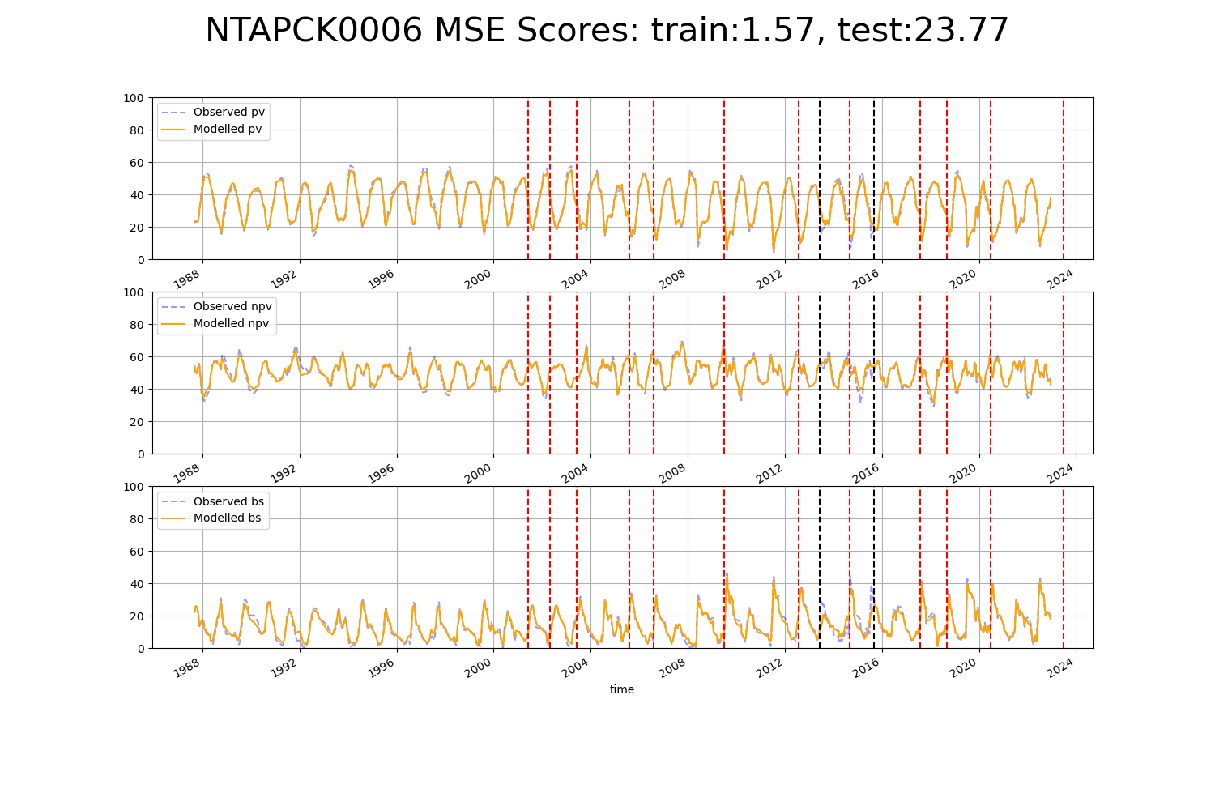

# NTAPCK0007

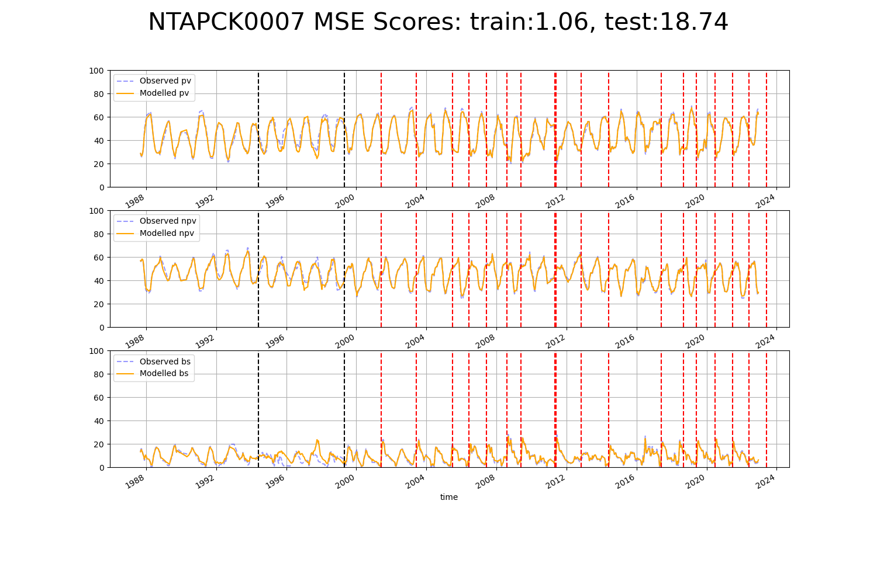

# NTAPCK1009

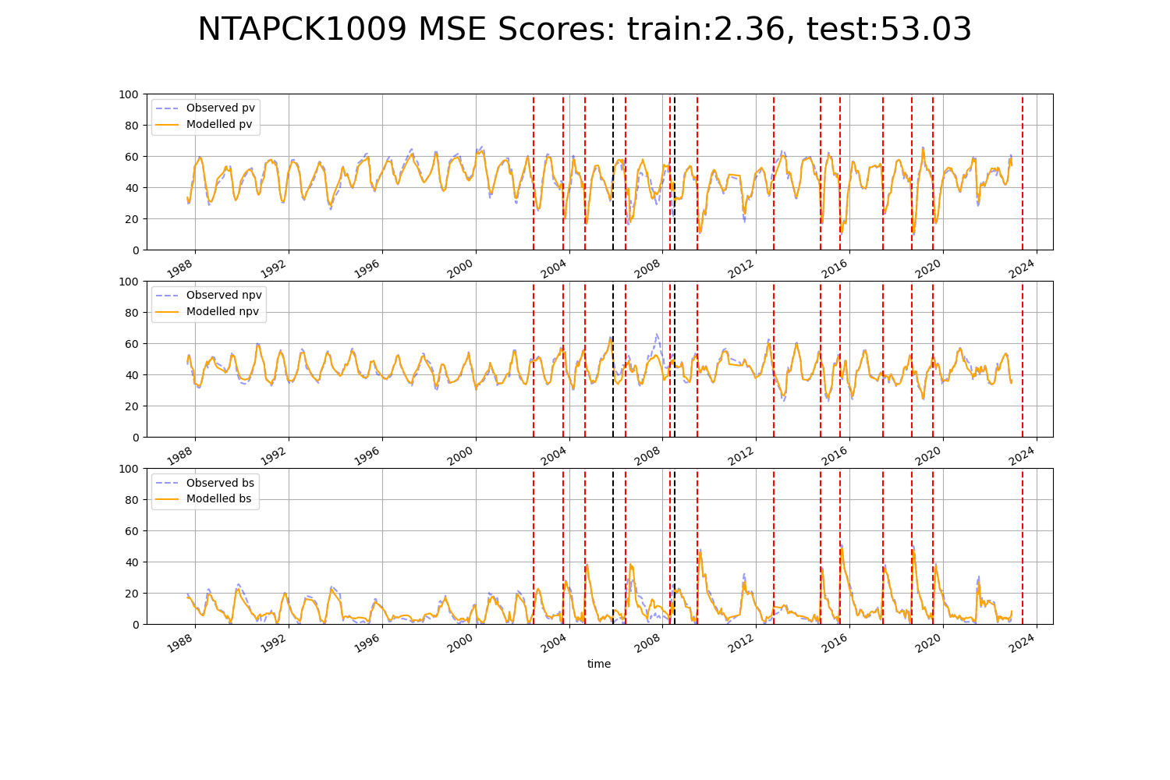

# NTAPCK1011

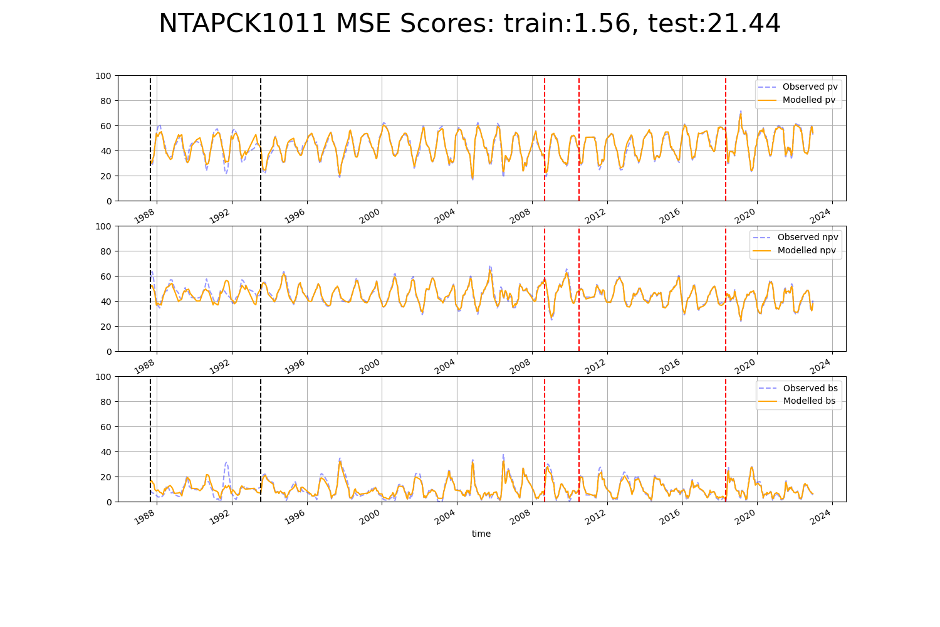

# NTAPCK2014

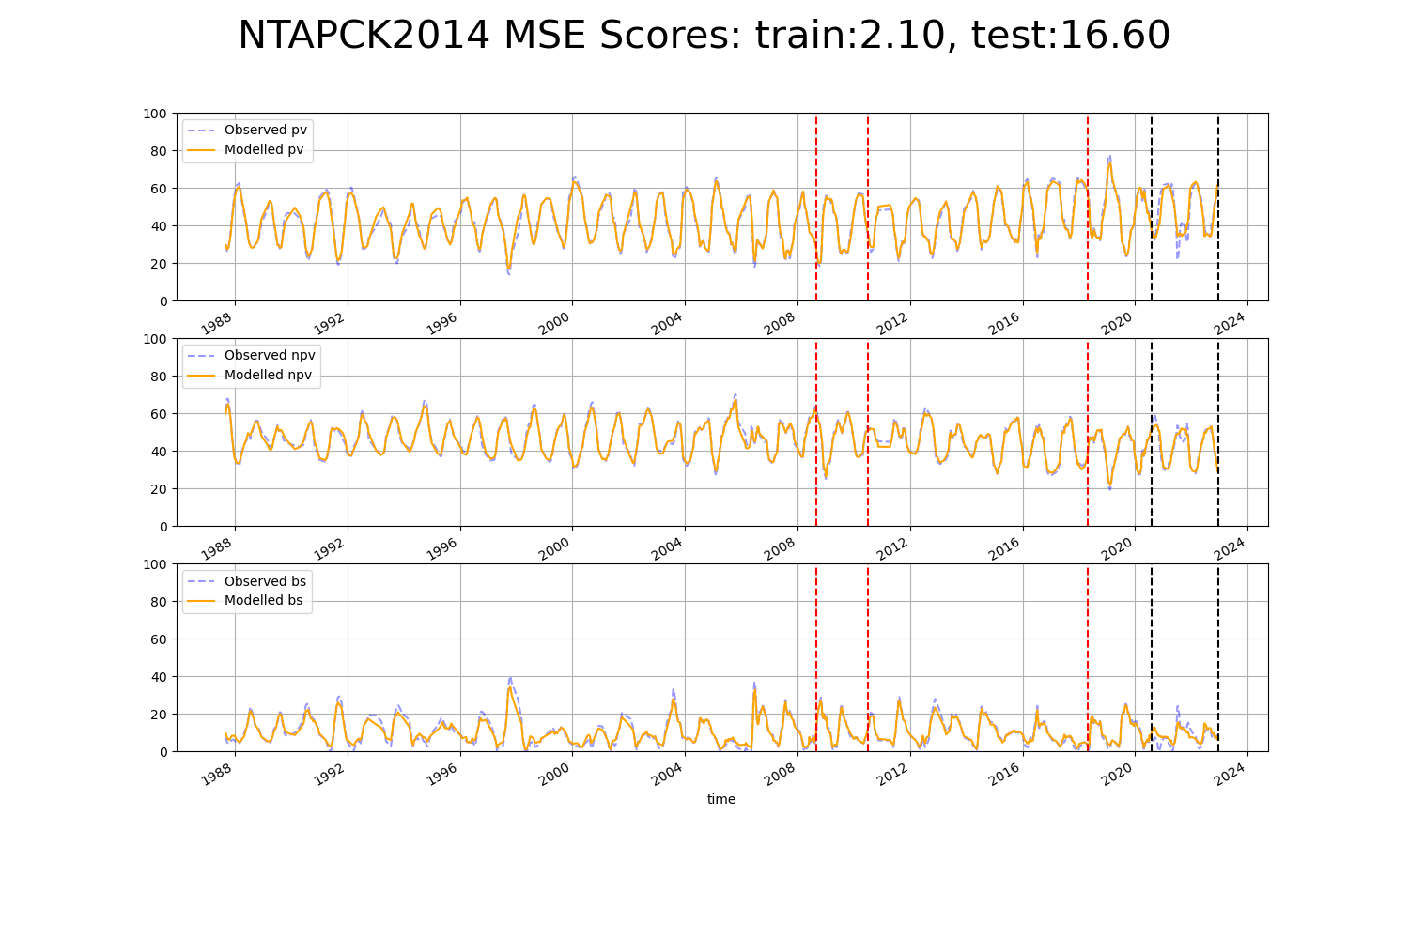

# NTASTU0001

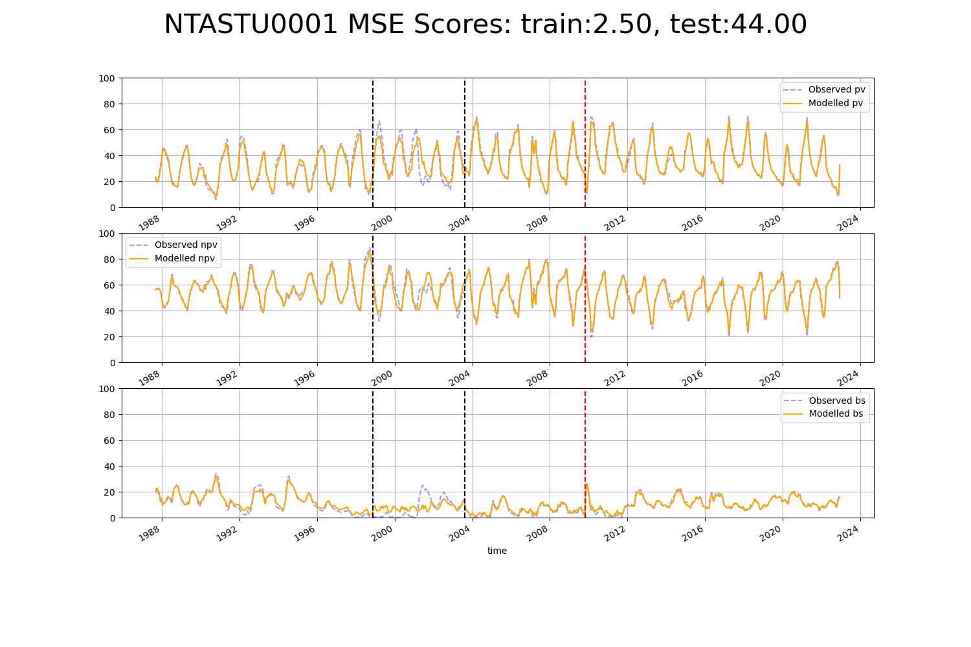

# NTASTU0002

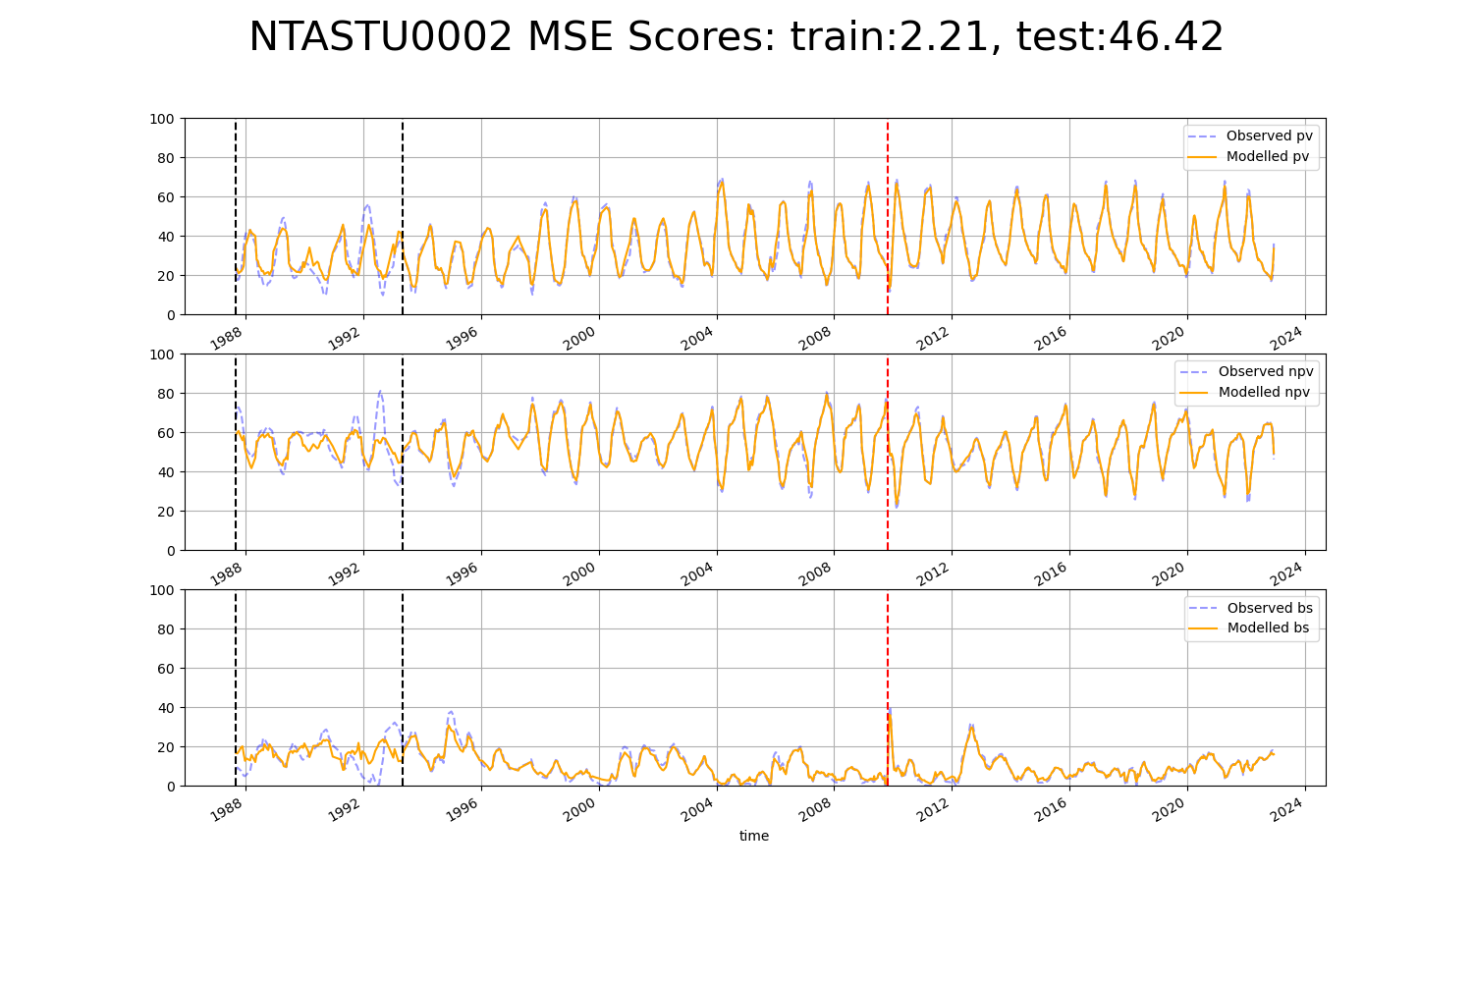

# NTASTU0003

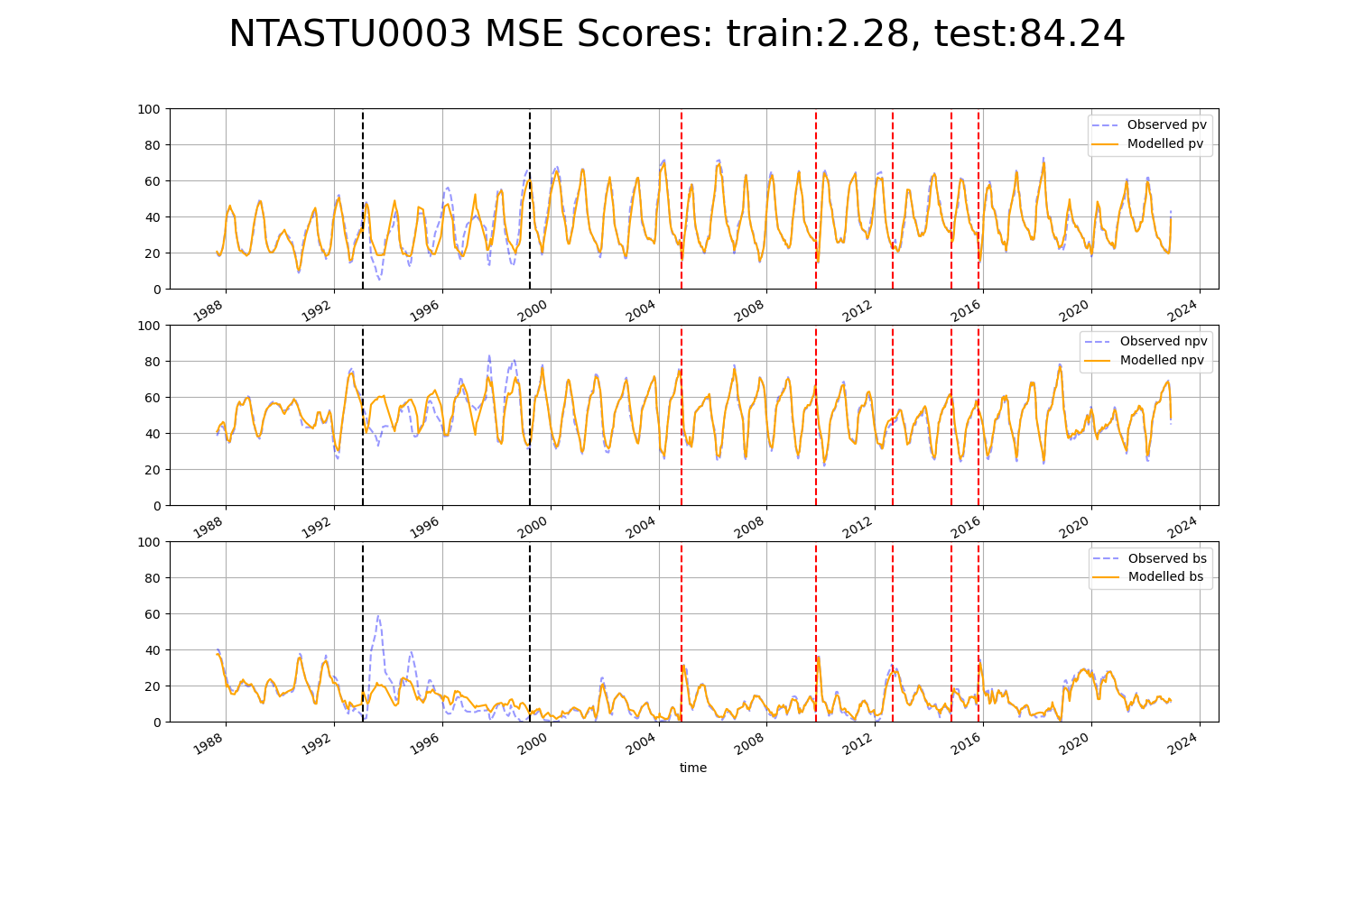

# NTASTU0004

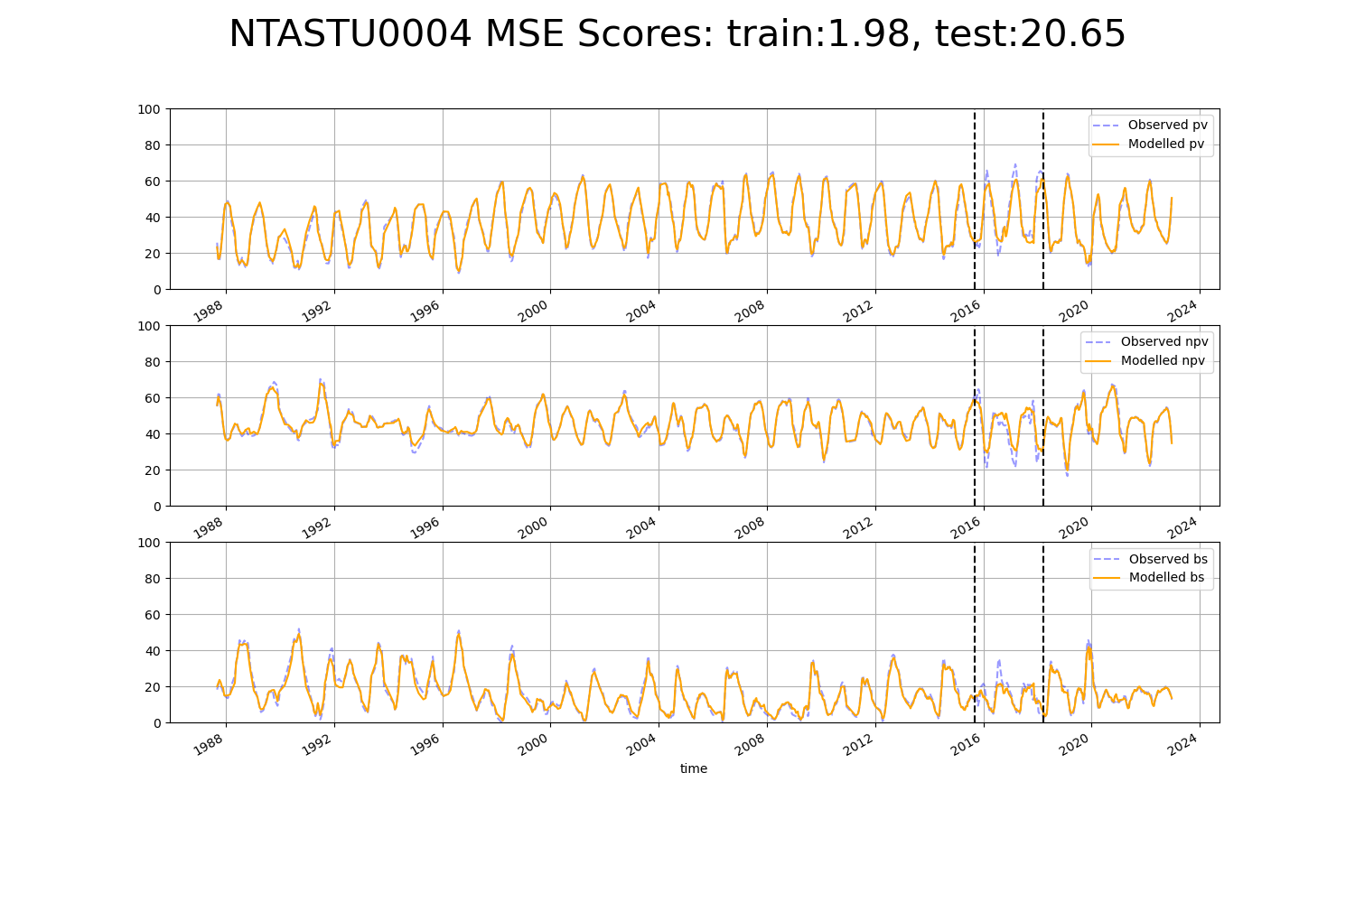

# NTASTU0005

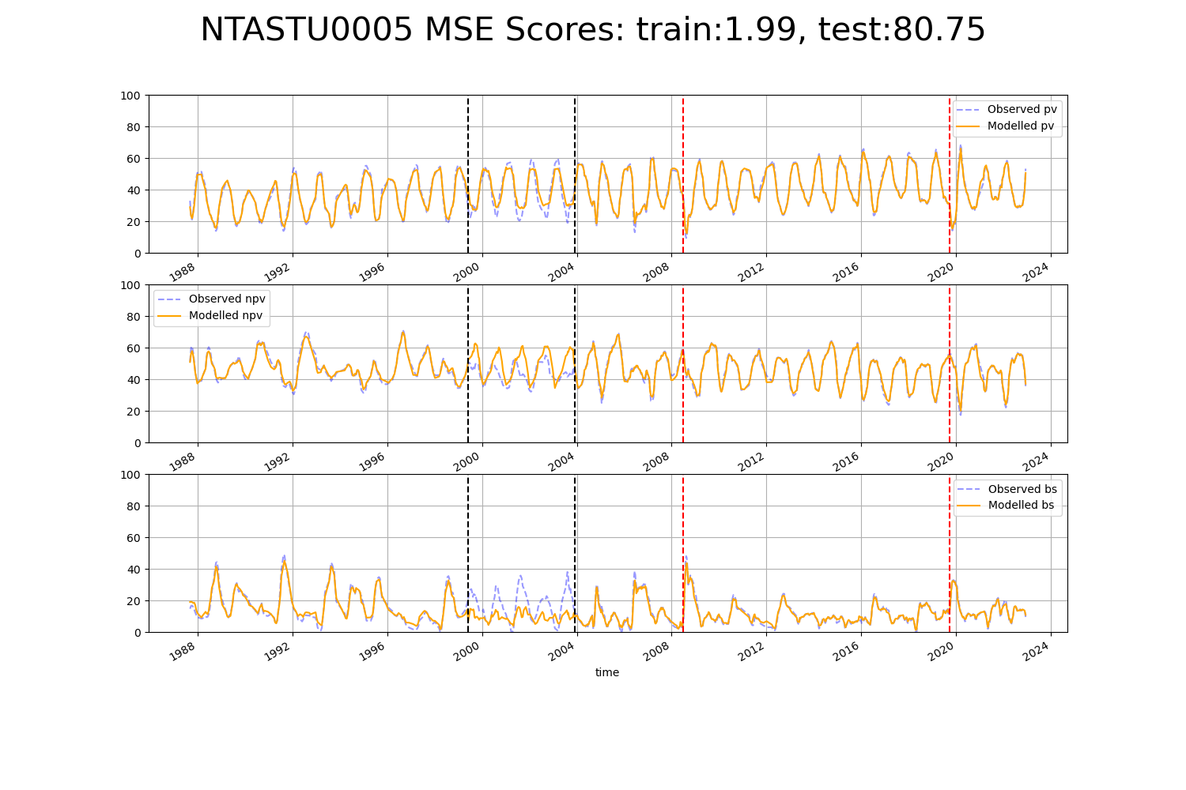

# NTTDAC0001

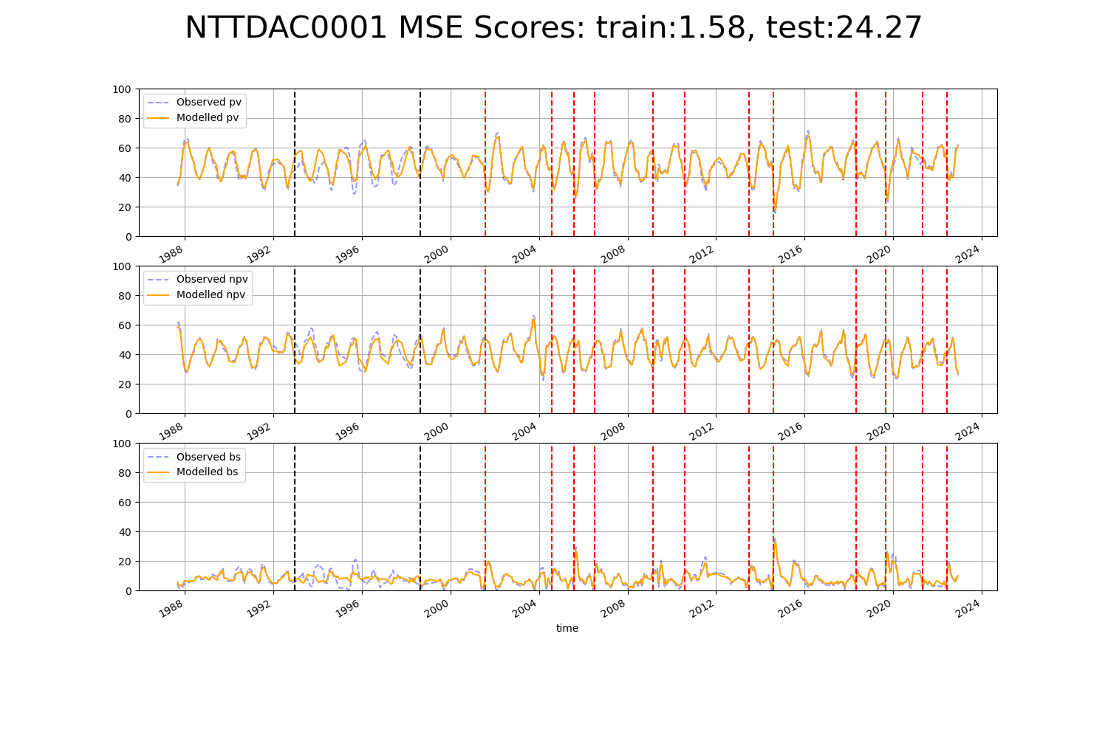

# NTTDMR0001

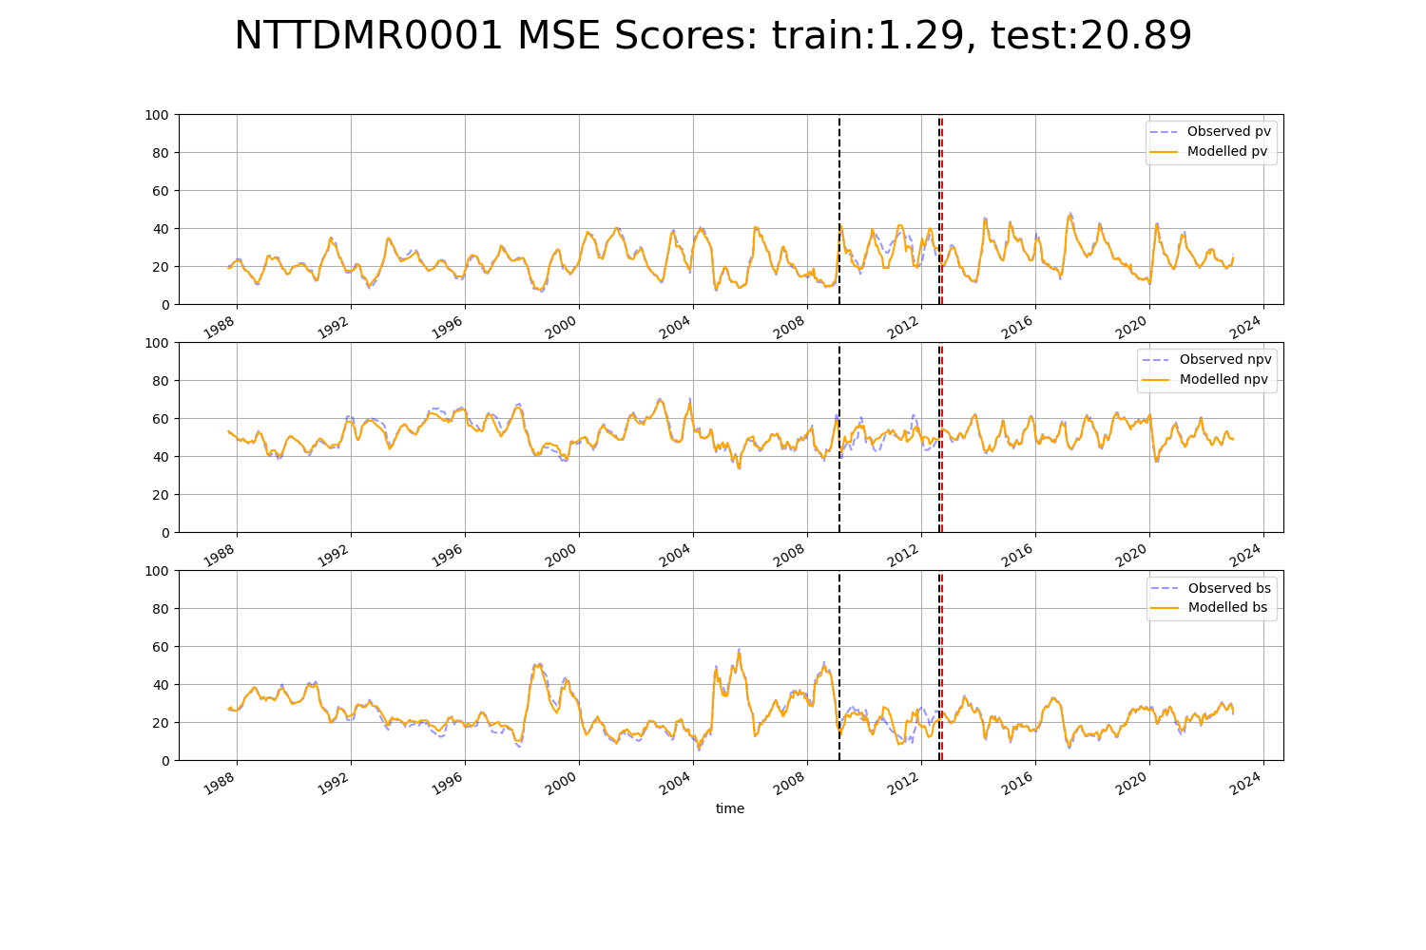

# NTTDMR0002

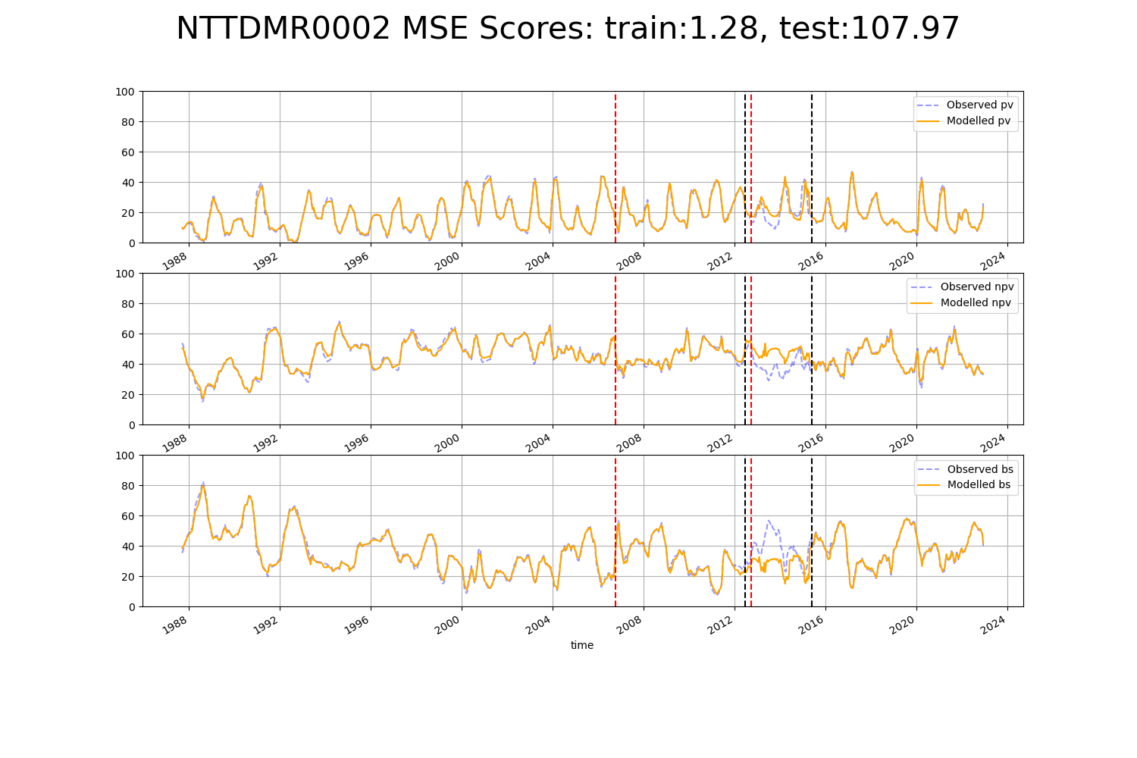

# NTTDMR0003

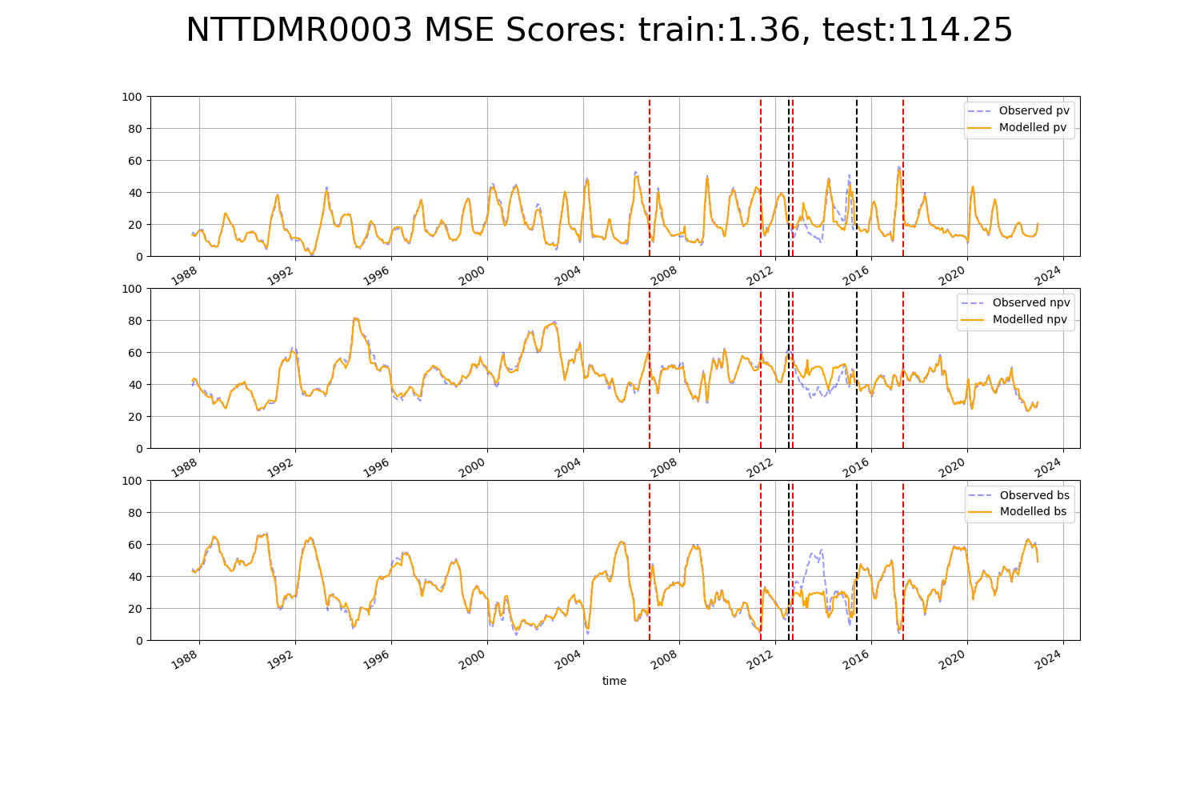

# NTTMGD0001

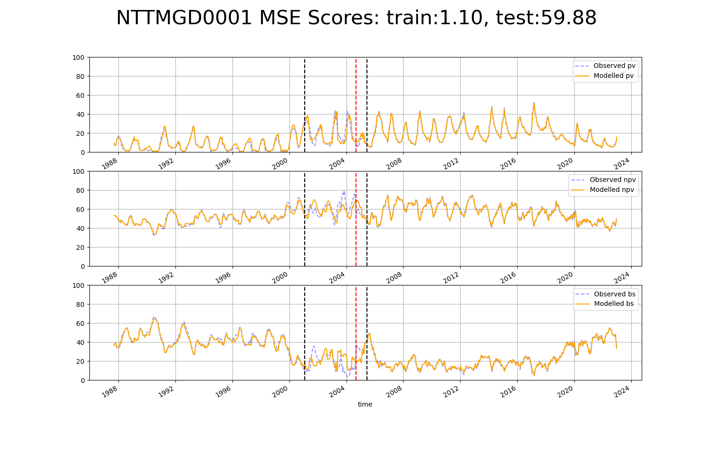

# QDABBS0001

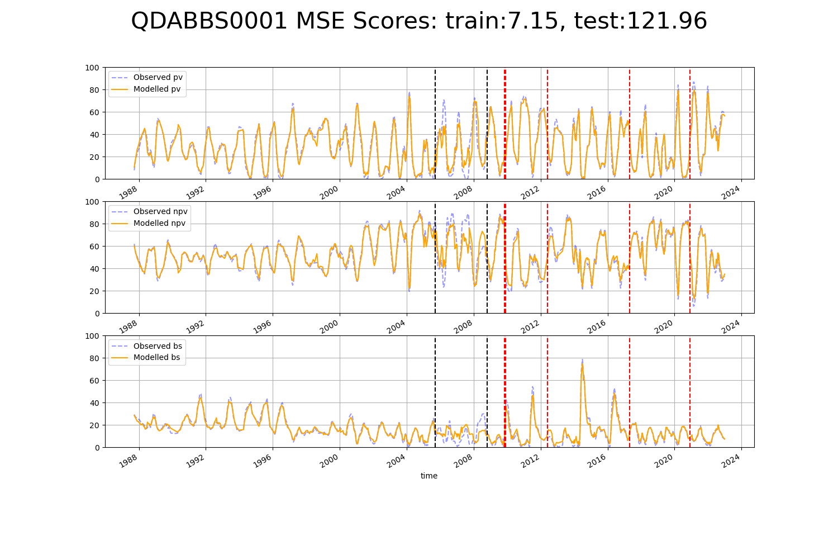

# QDABBS0002

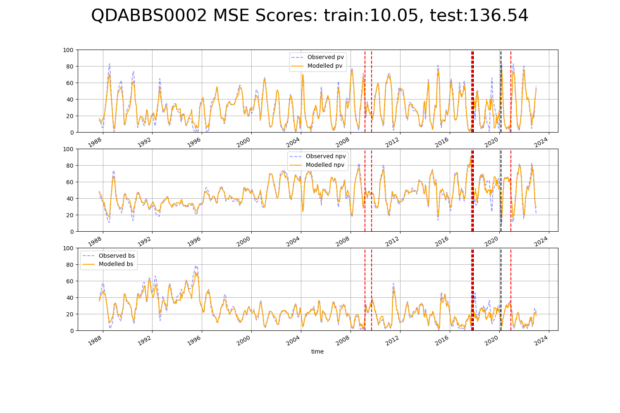

# QDABBS0004

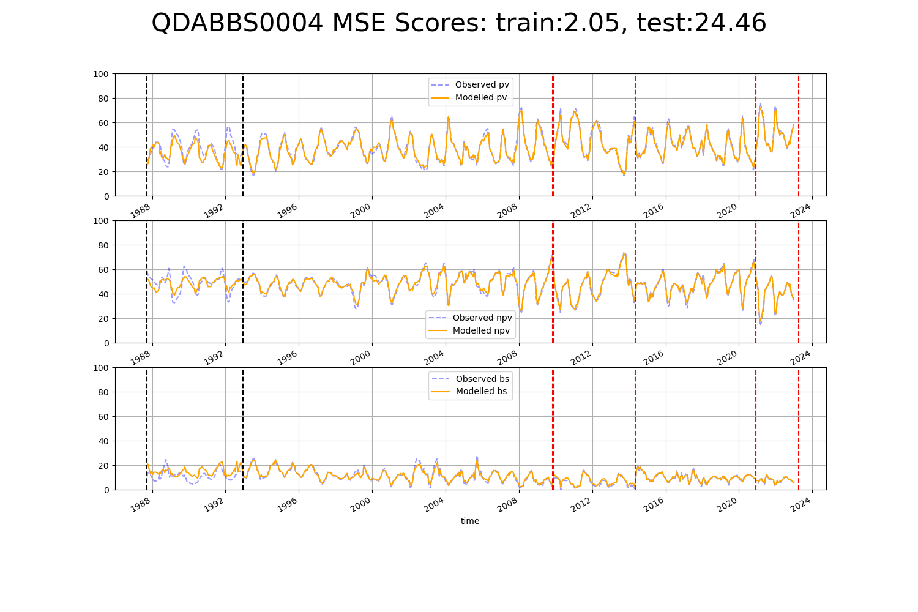

# QDABBS0006

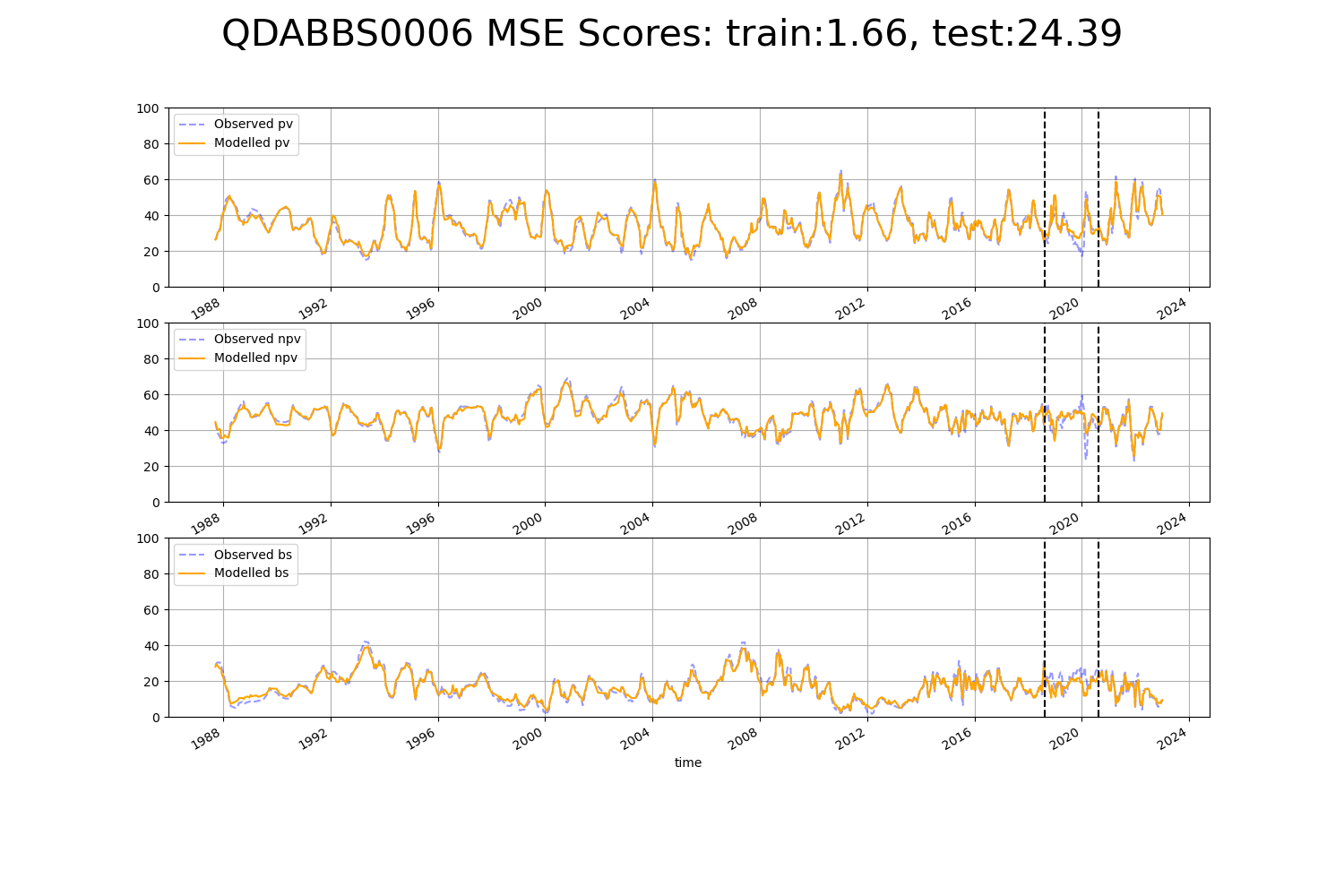

# QDABBS0007

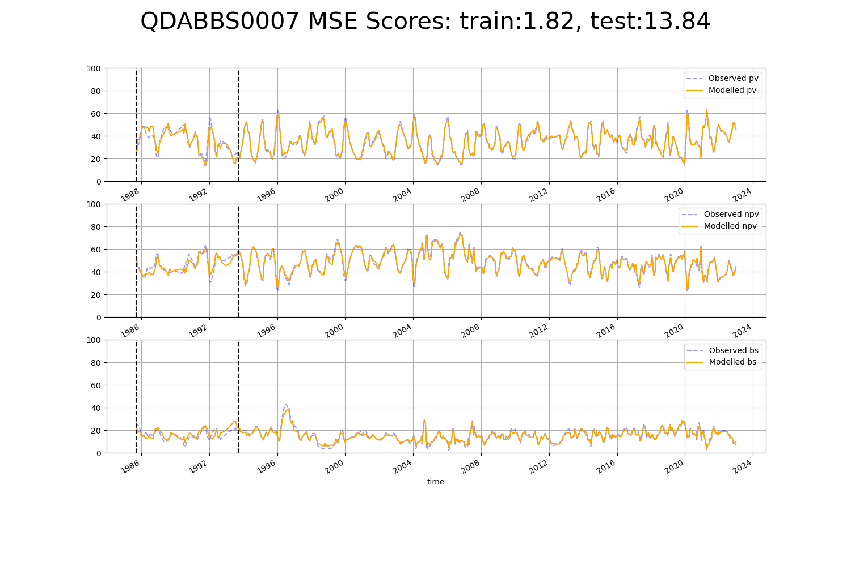

# QDABBS0008

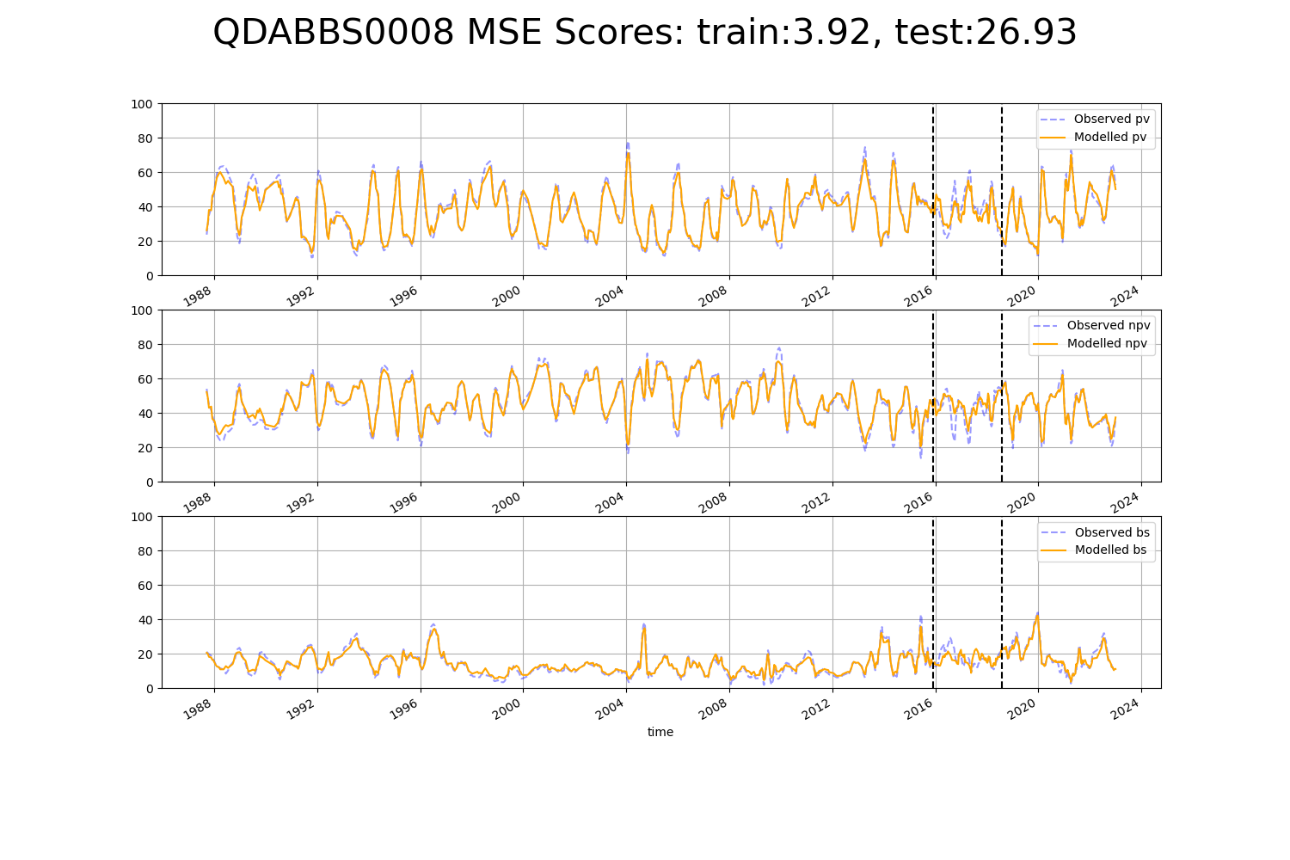

# QDACYP0004

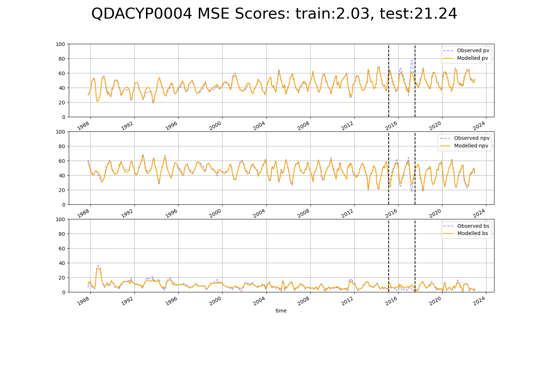

# QDACYP0005

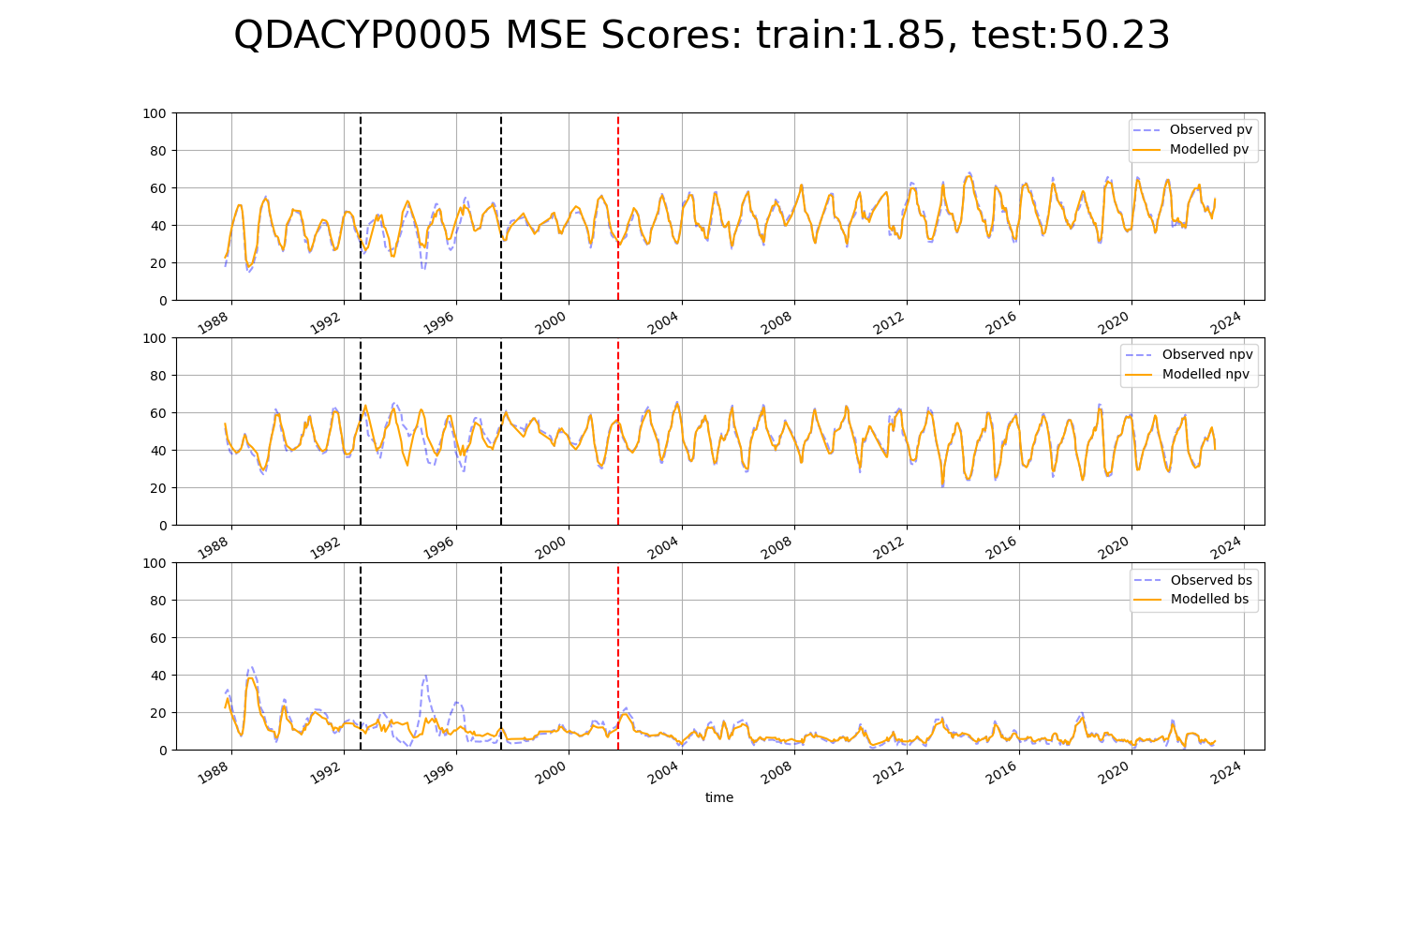

# QDACYP0006

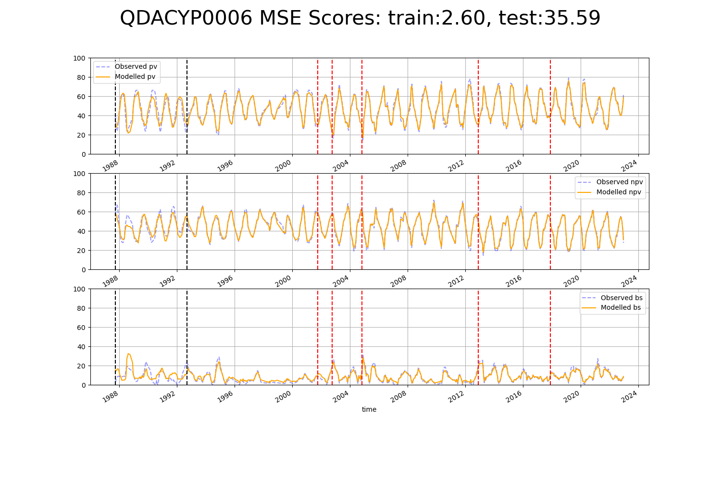

# QDACYP0007

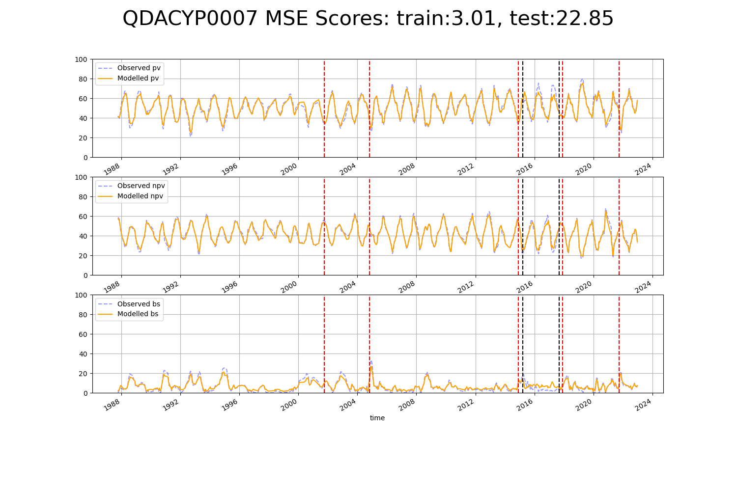

# QDACYP0009

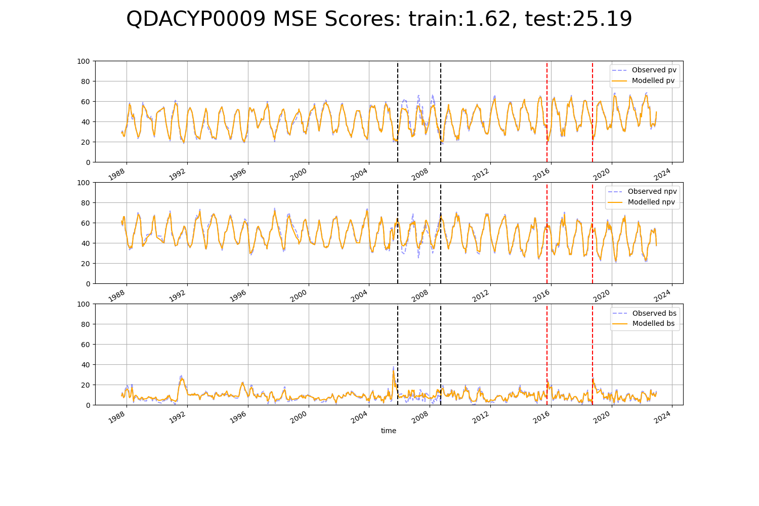

# QDACYP0010

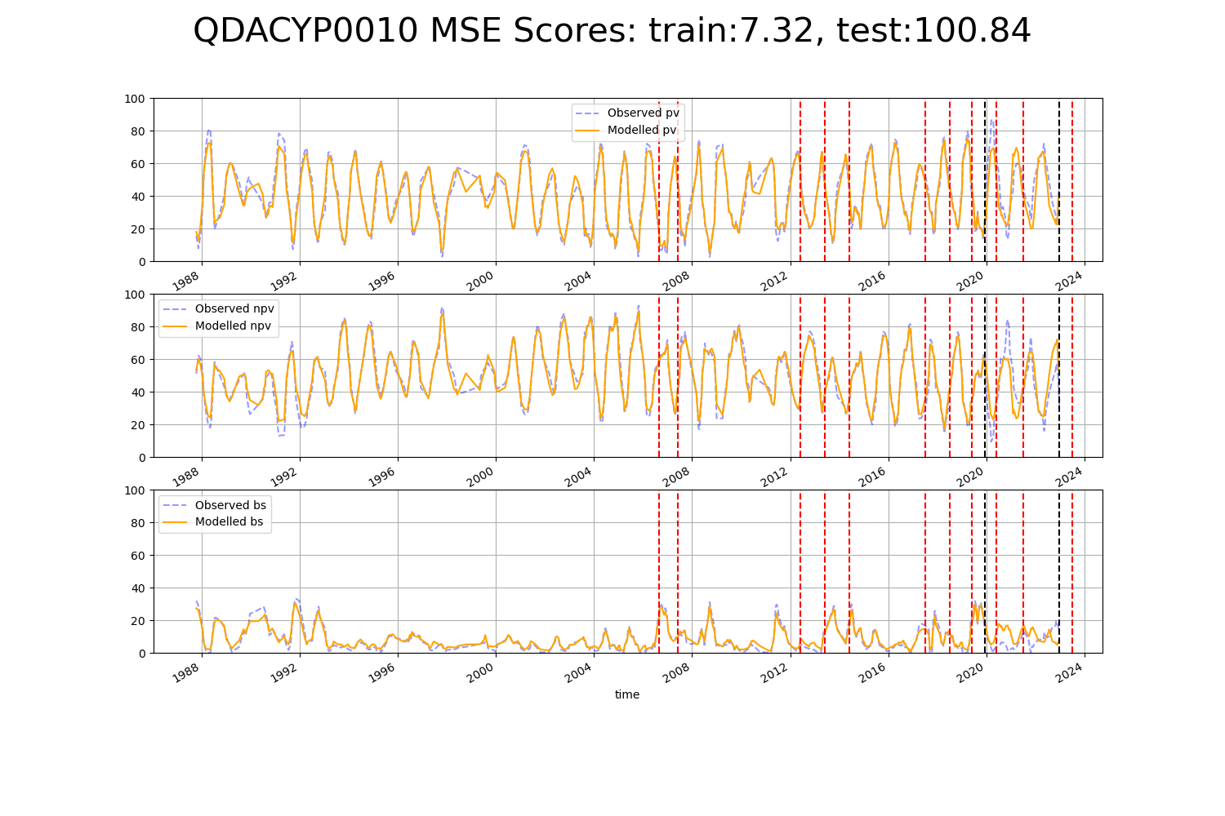

# QDACYP0011

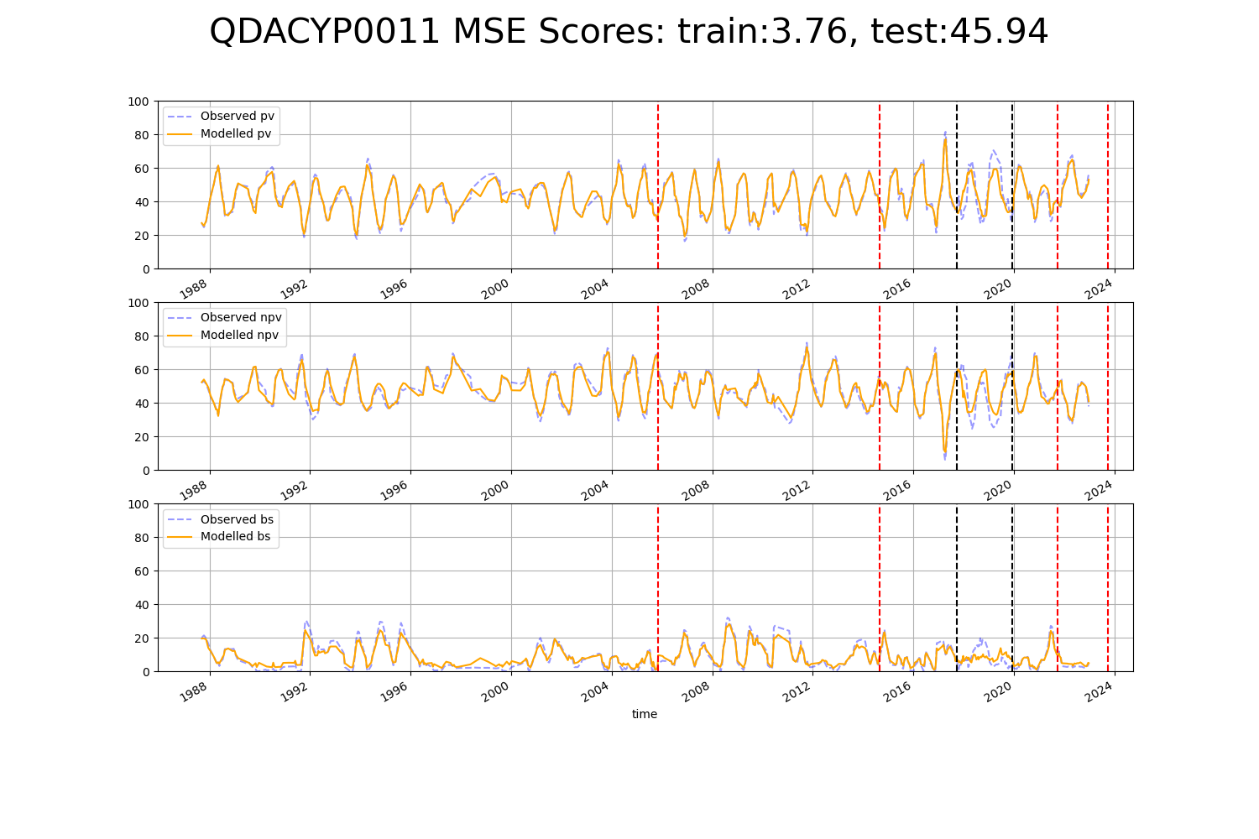

# QDACYP0013

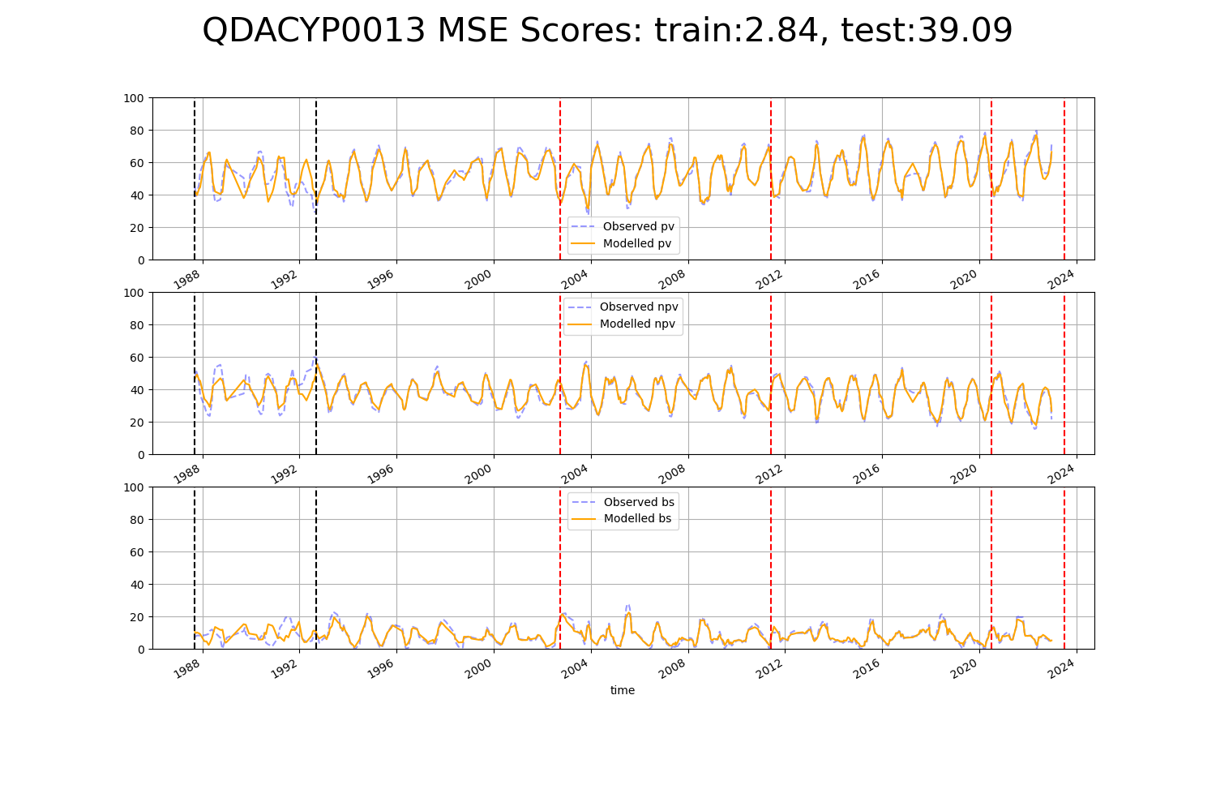

# QDACYP0014

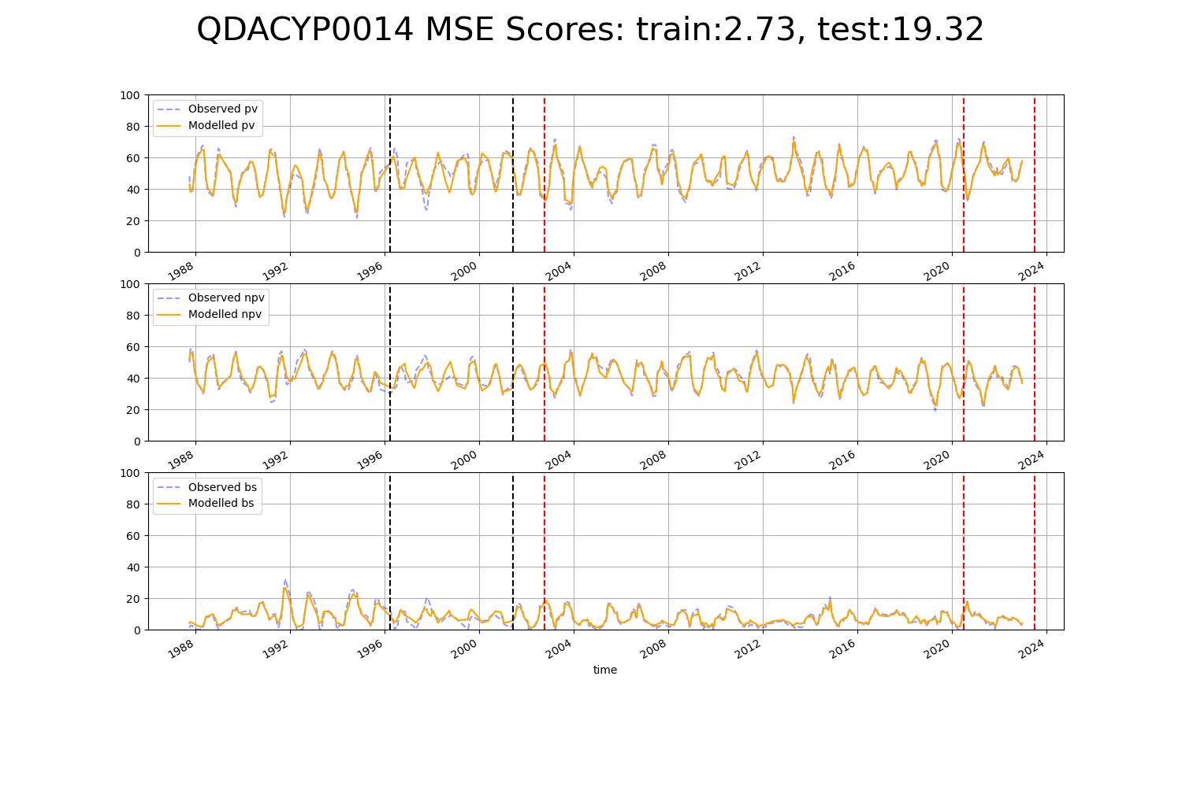

# QDACYP0015

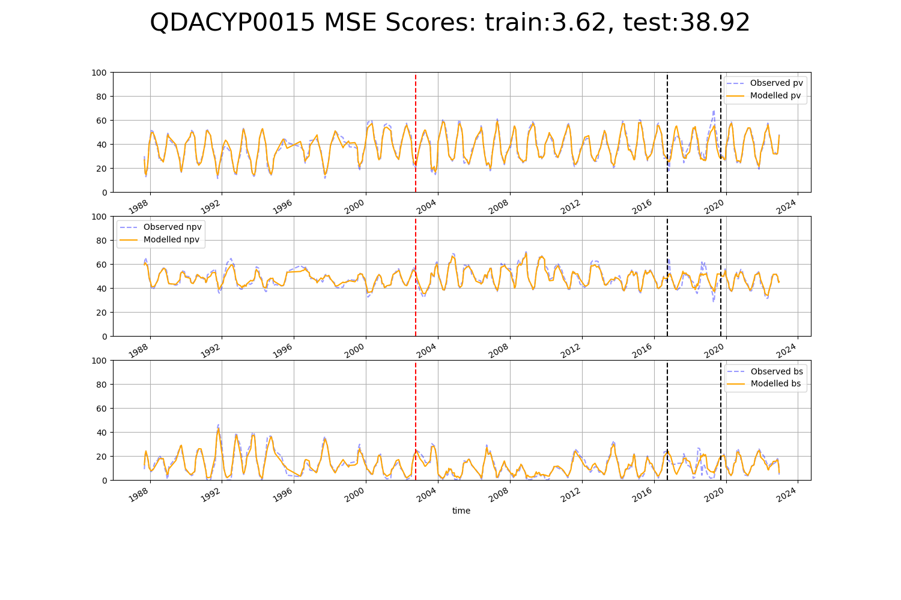

# QDACYP0019

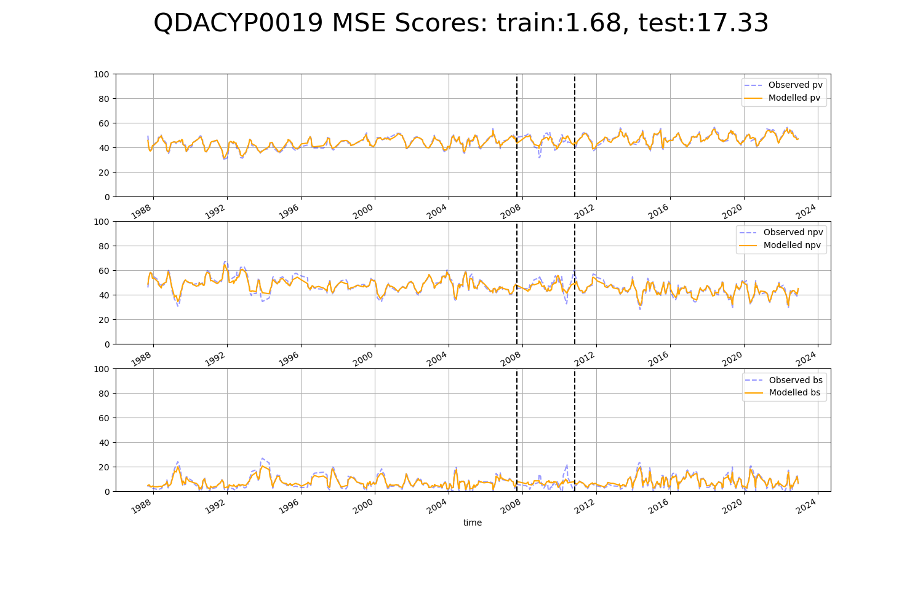

# QDACYP0022

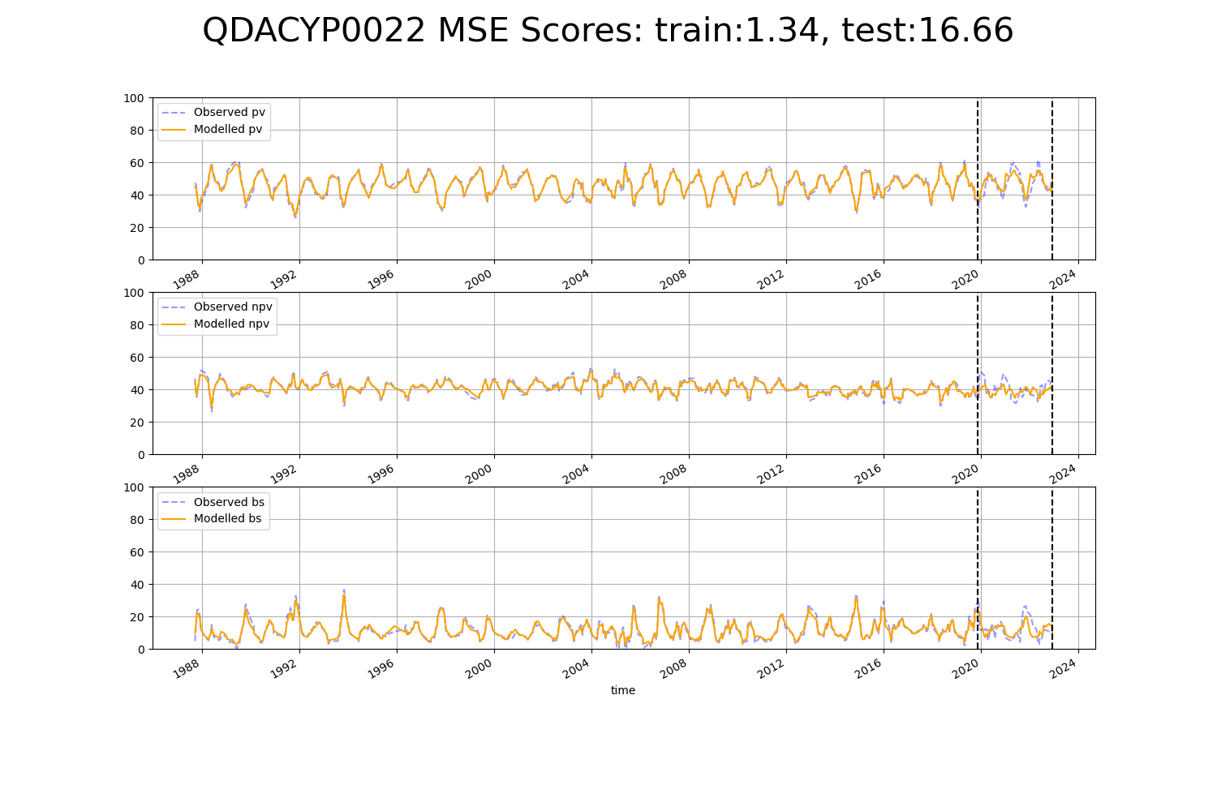

# QDACYP0023

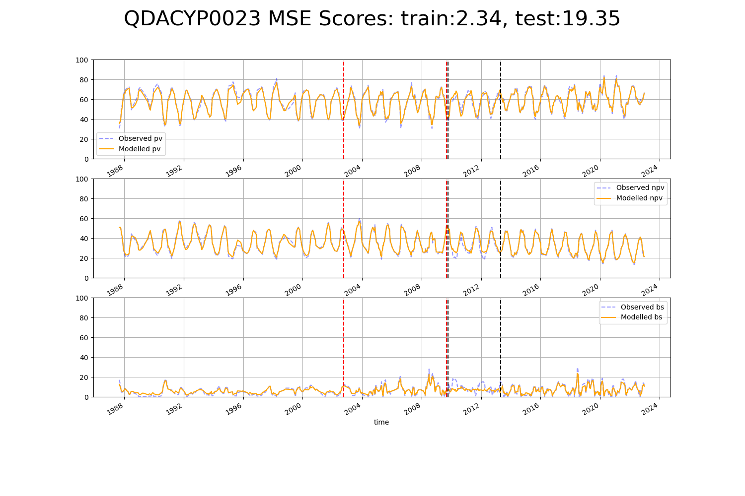

# QDADEU0001

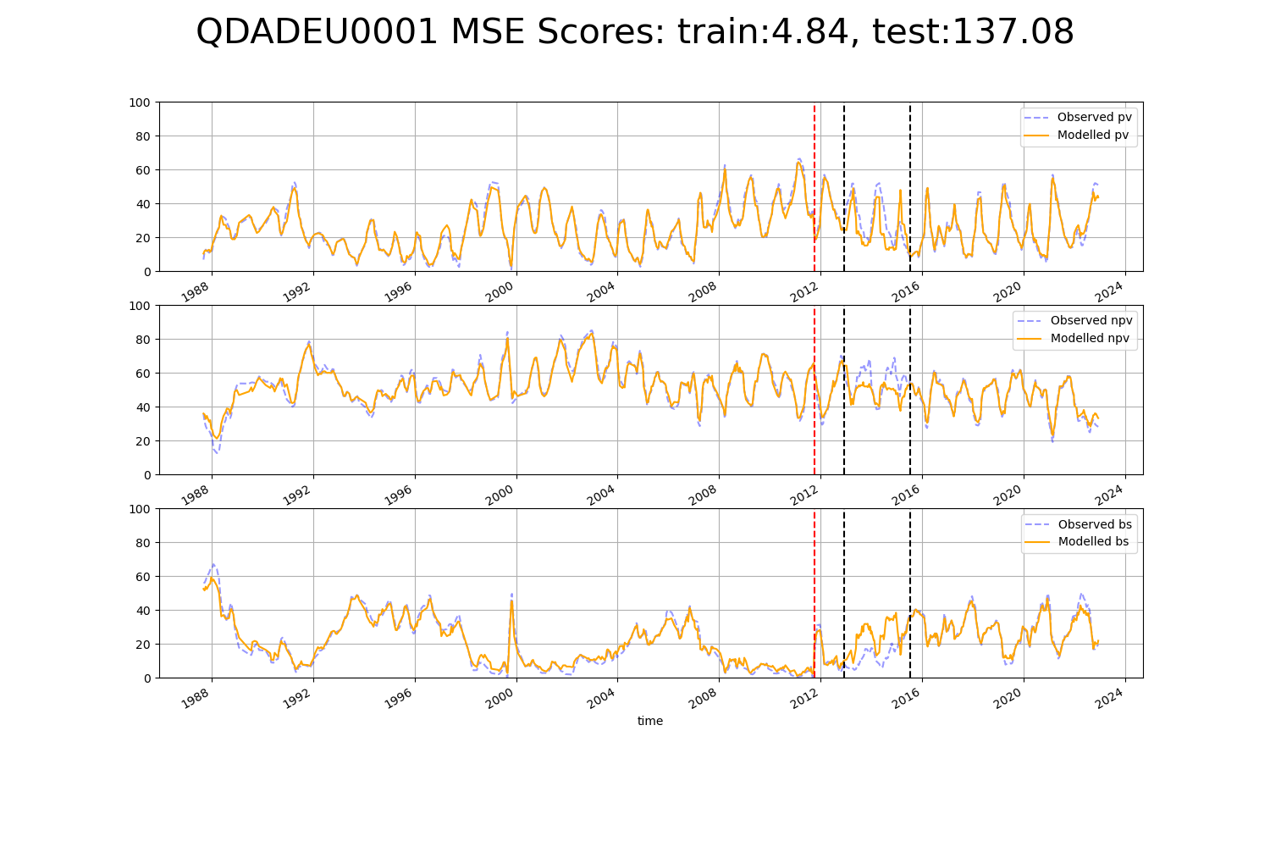

# QDAEIU0001

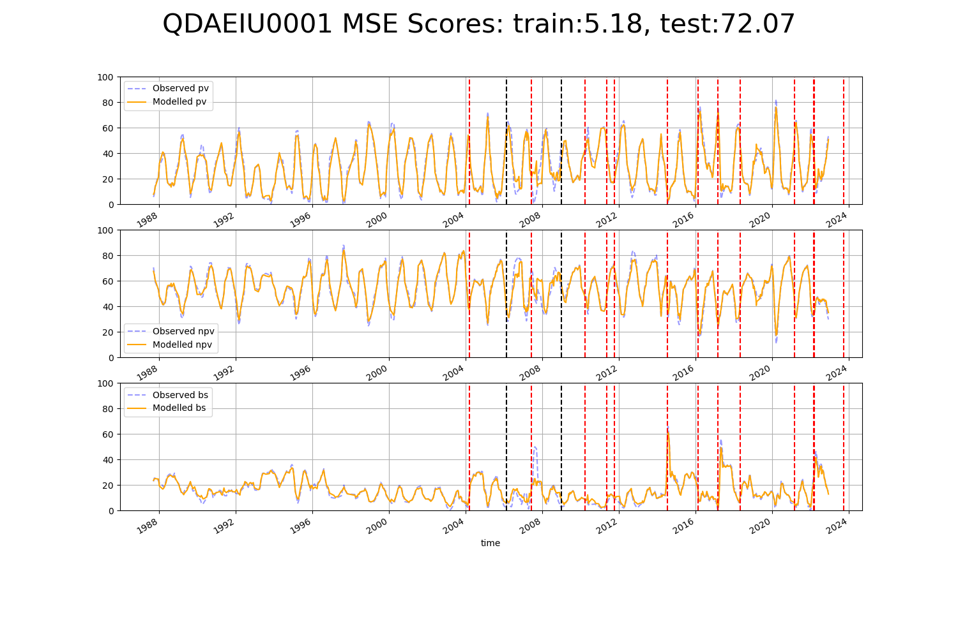

# QDAEIU0002

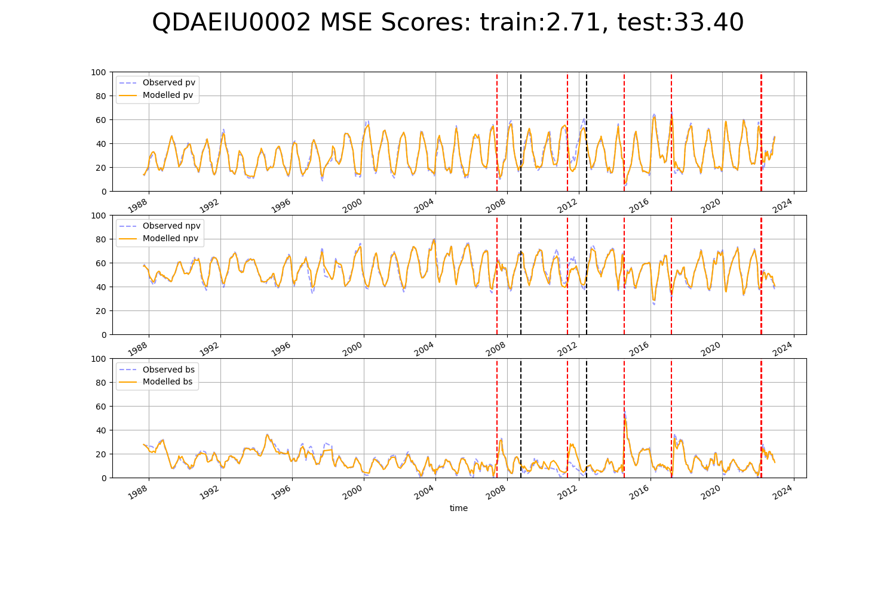

# QDAEIU0003

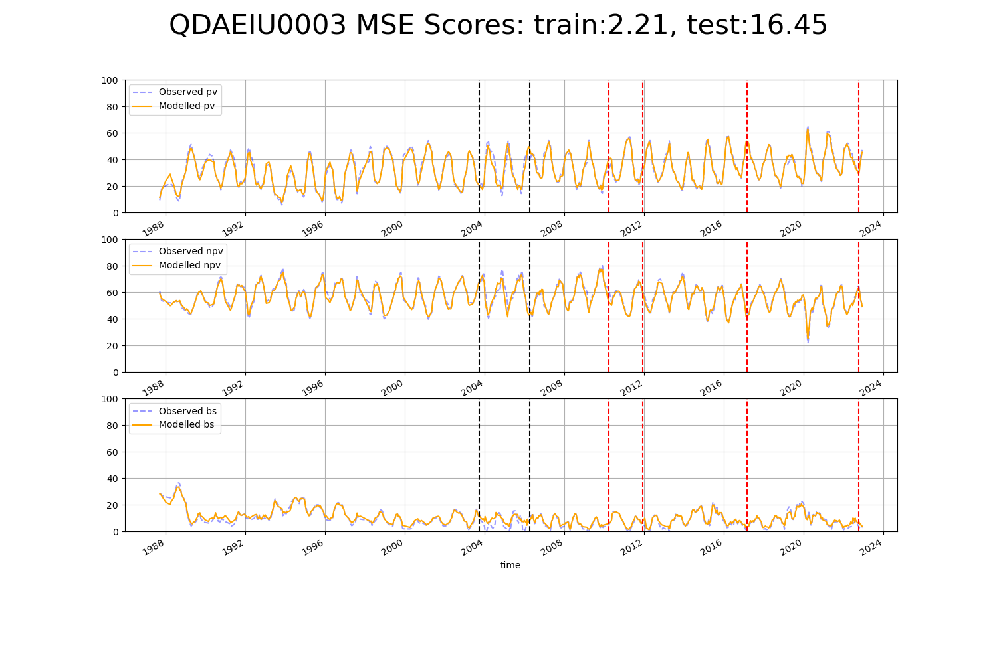

# QDAEIU0004

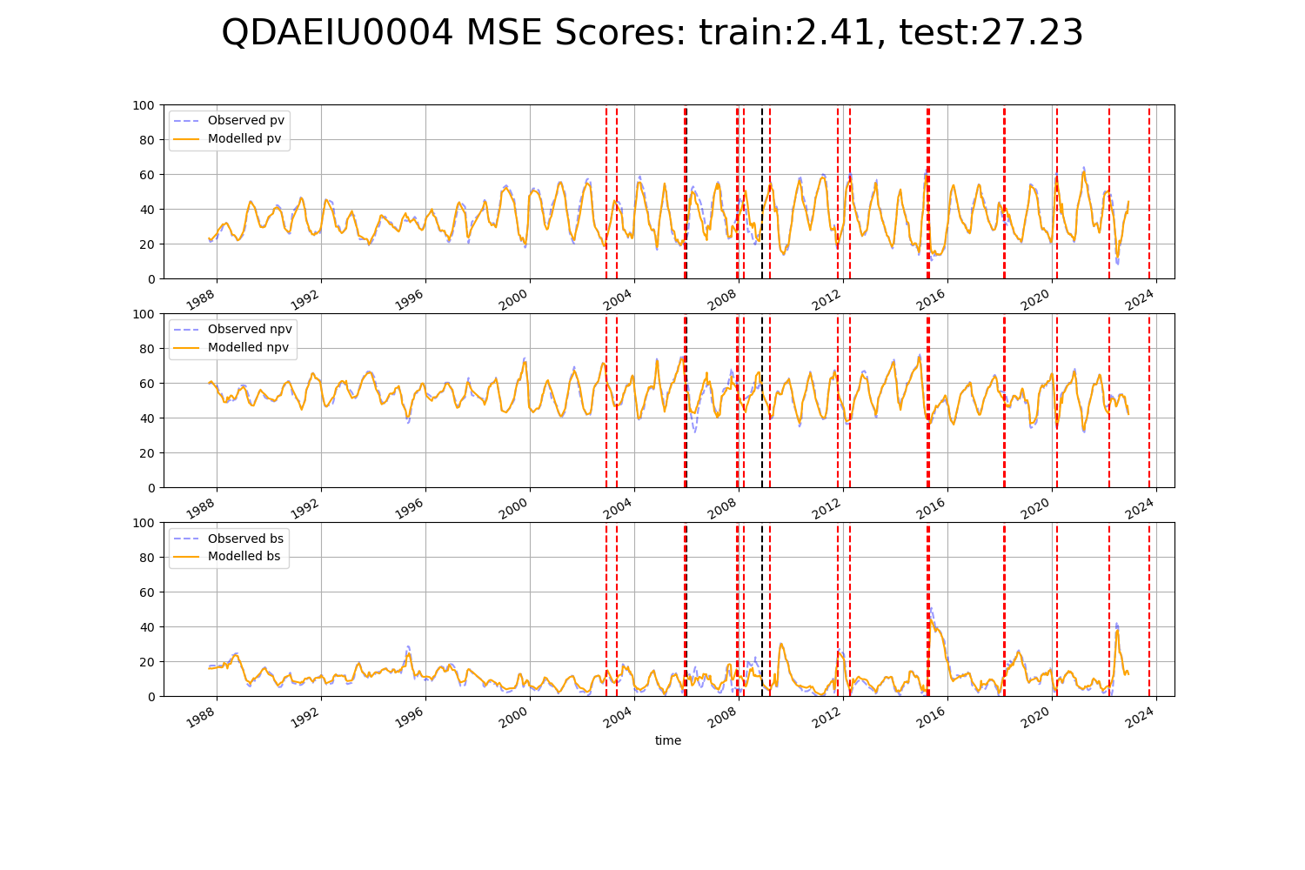

# QDAEIU0005

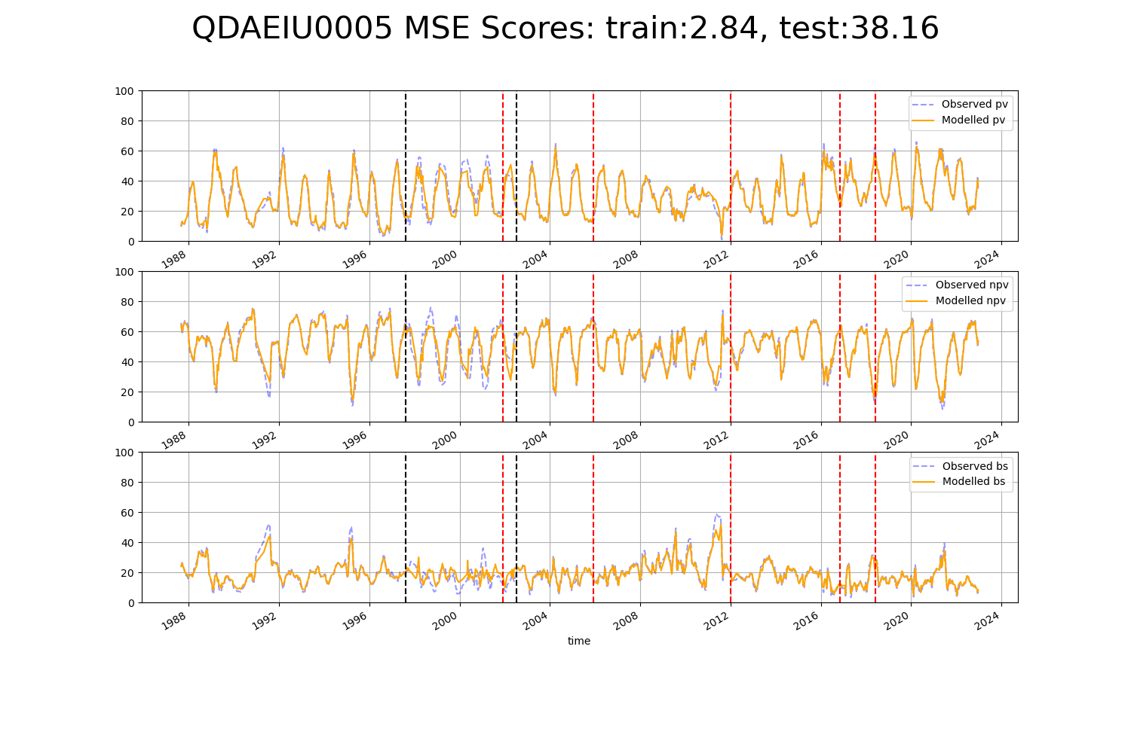

# QDAEIU0008

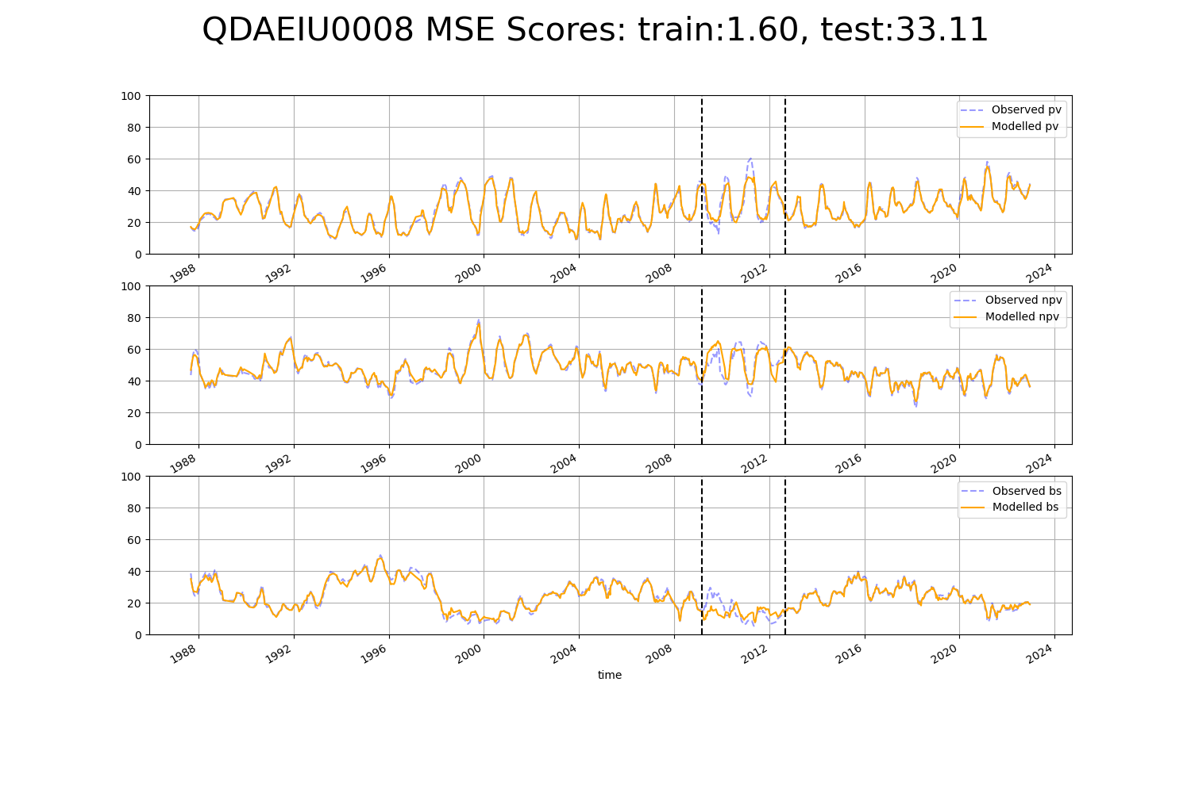

# QDAEIU0009

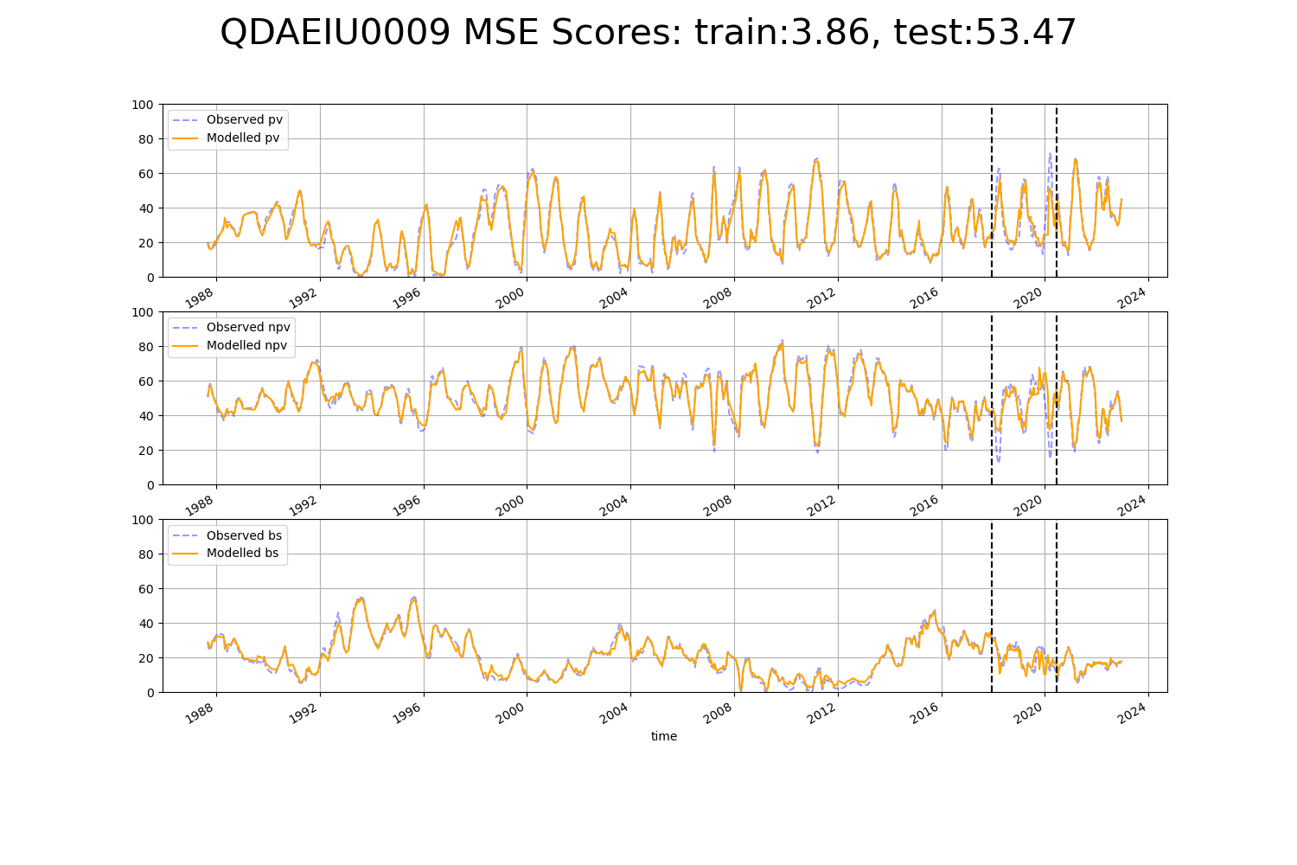

# QDAEIU0010

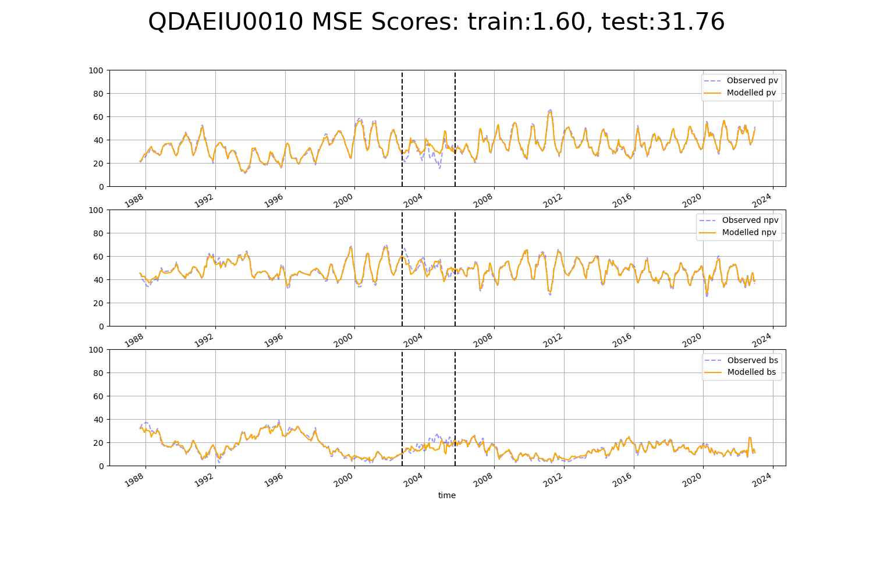

# QDAGUP0007

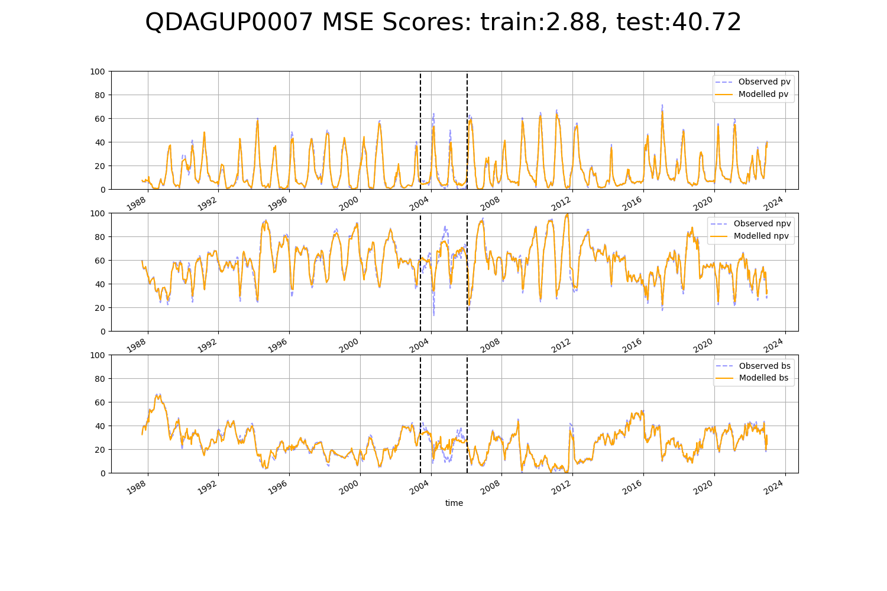

# QDAGUP0008

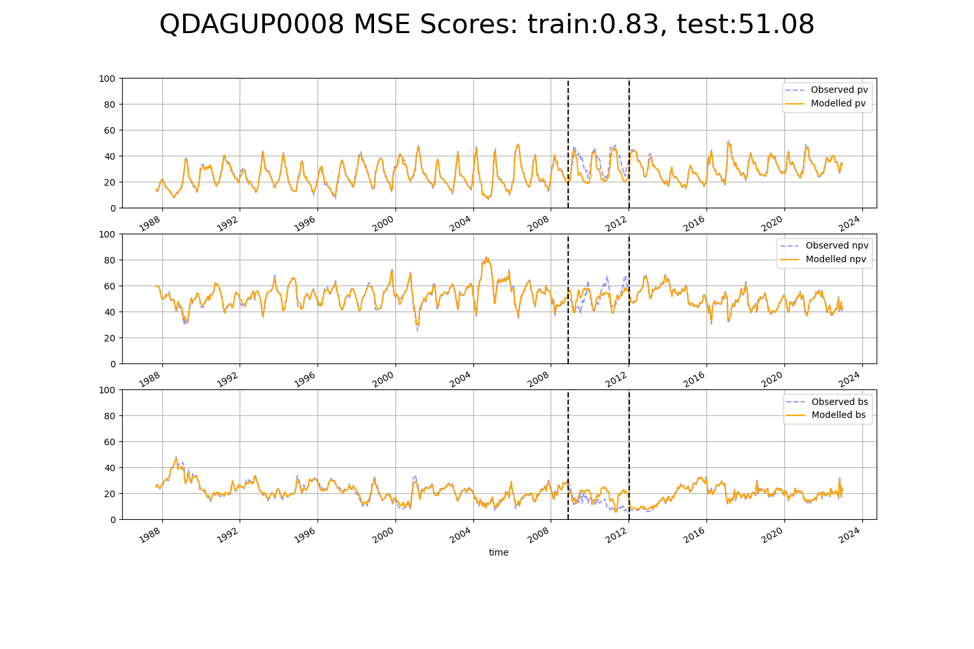

# QDAGUP0009

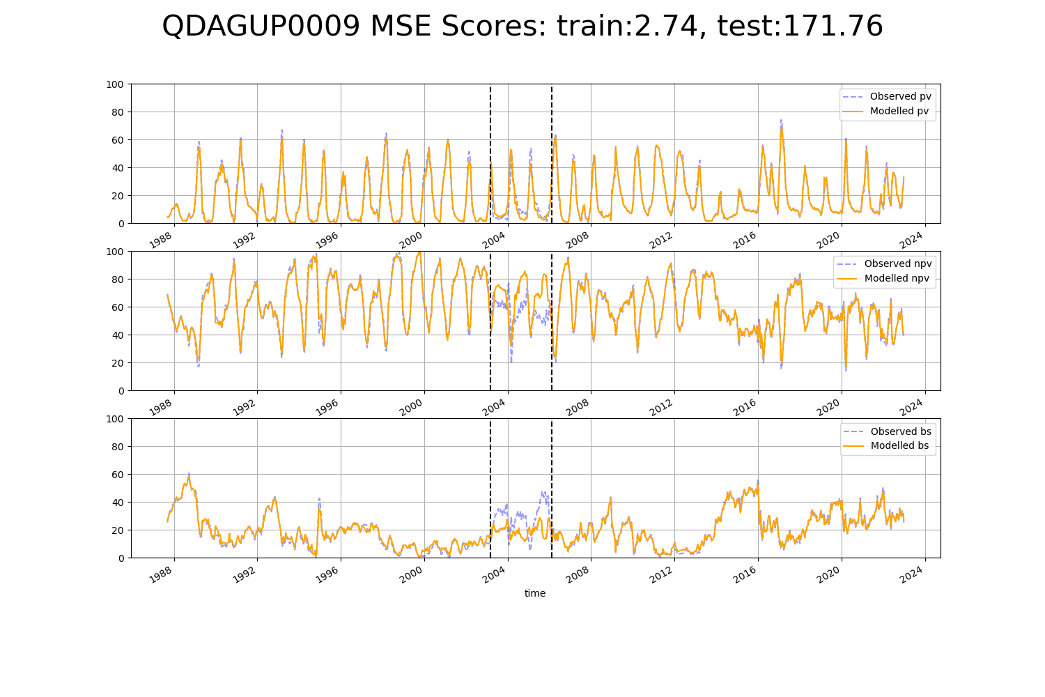

# QDAGUP0011

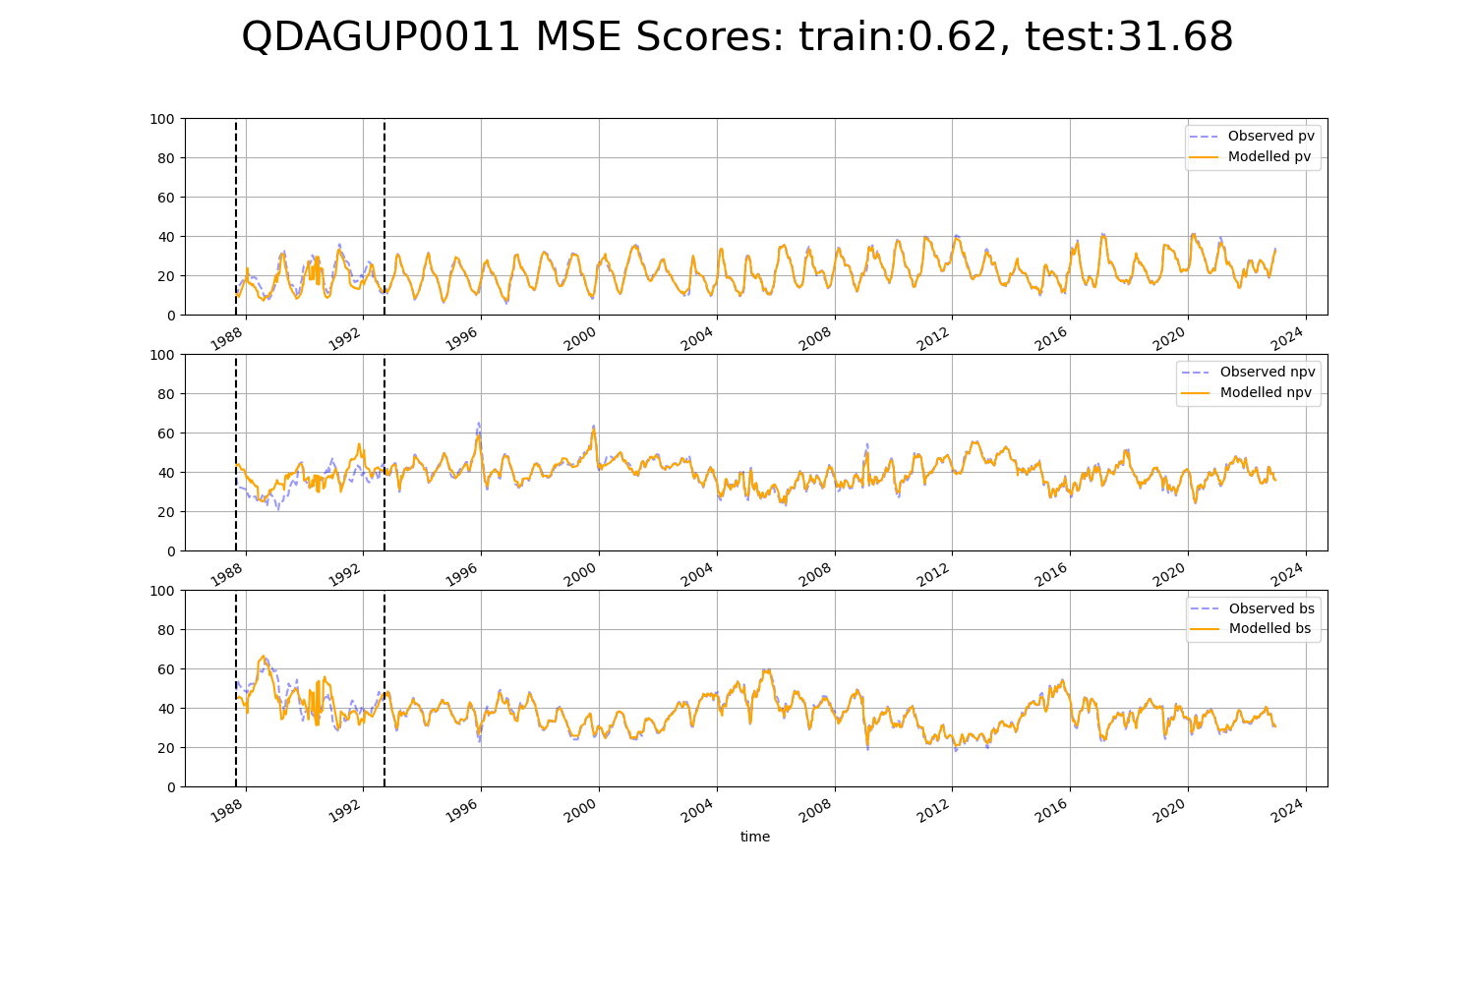

# QDAGUP0012

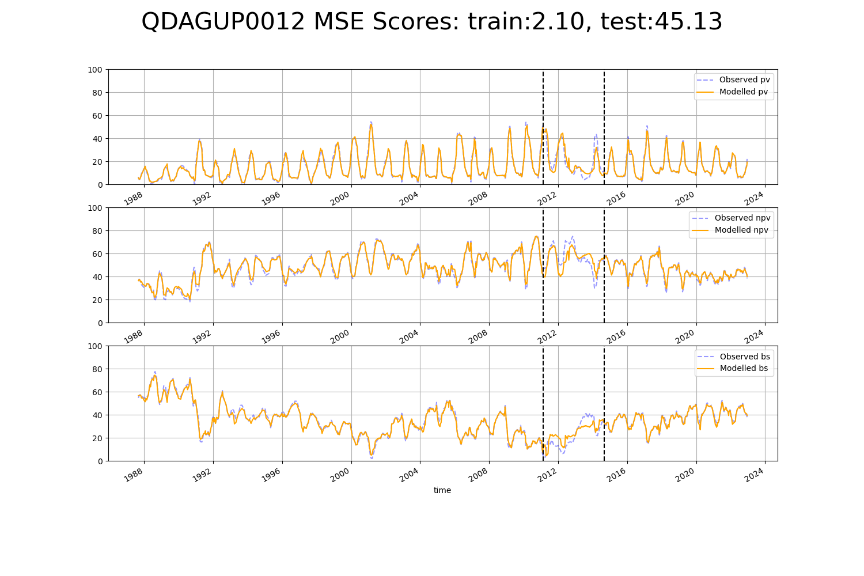

# QDAGUP0013

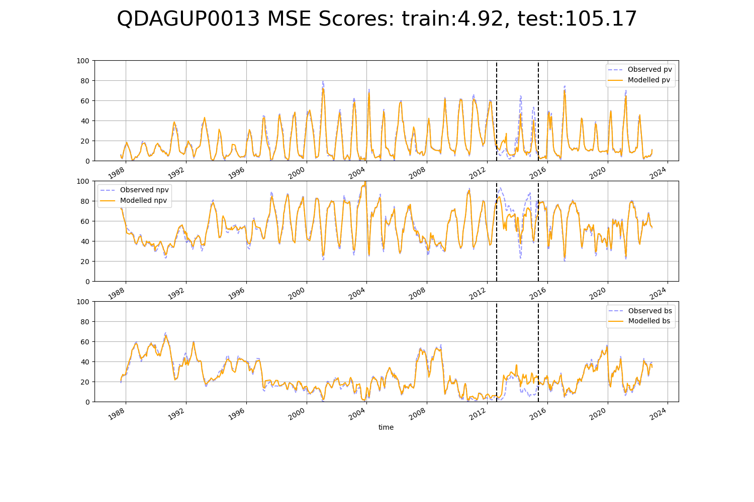

# QDAGUP0014

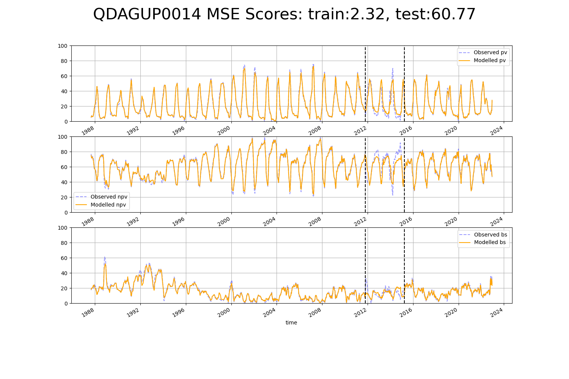

# QDAGUP0015

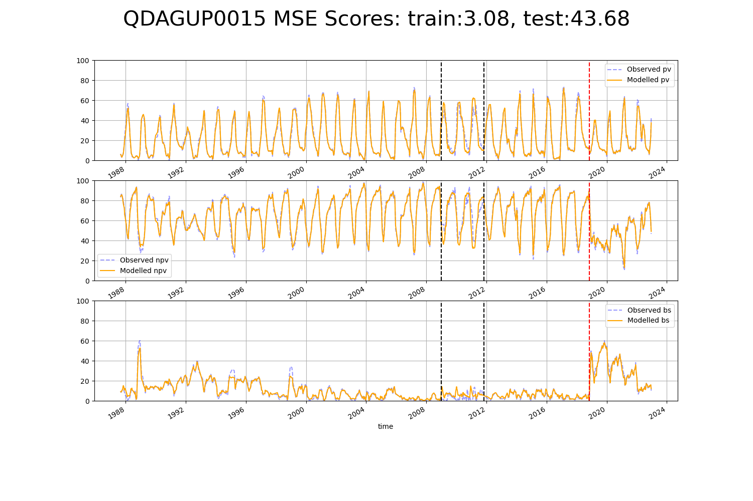

# QDAGUP0016

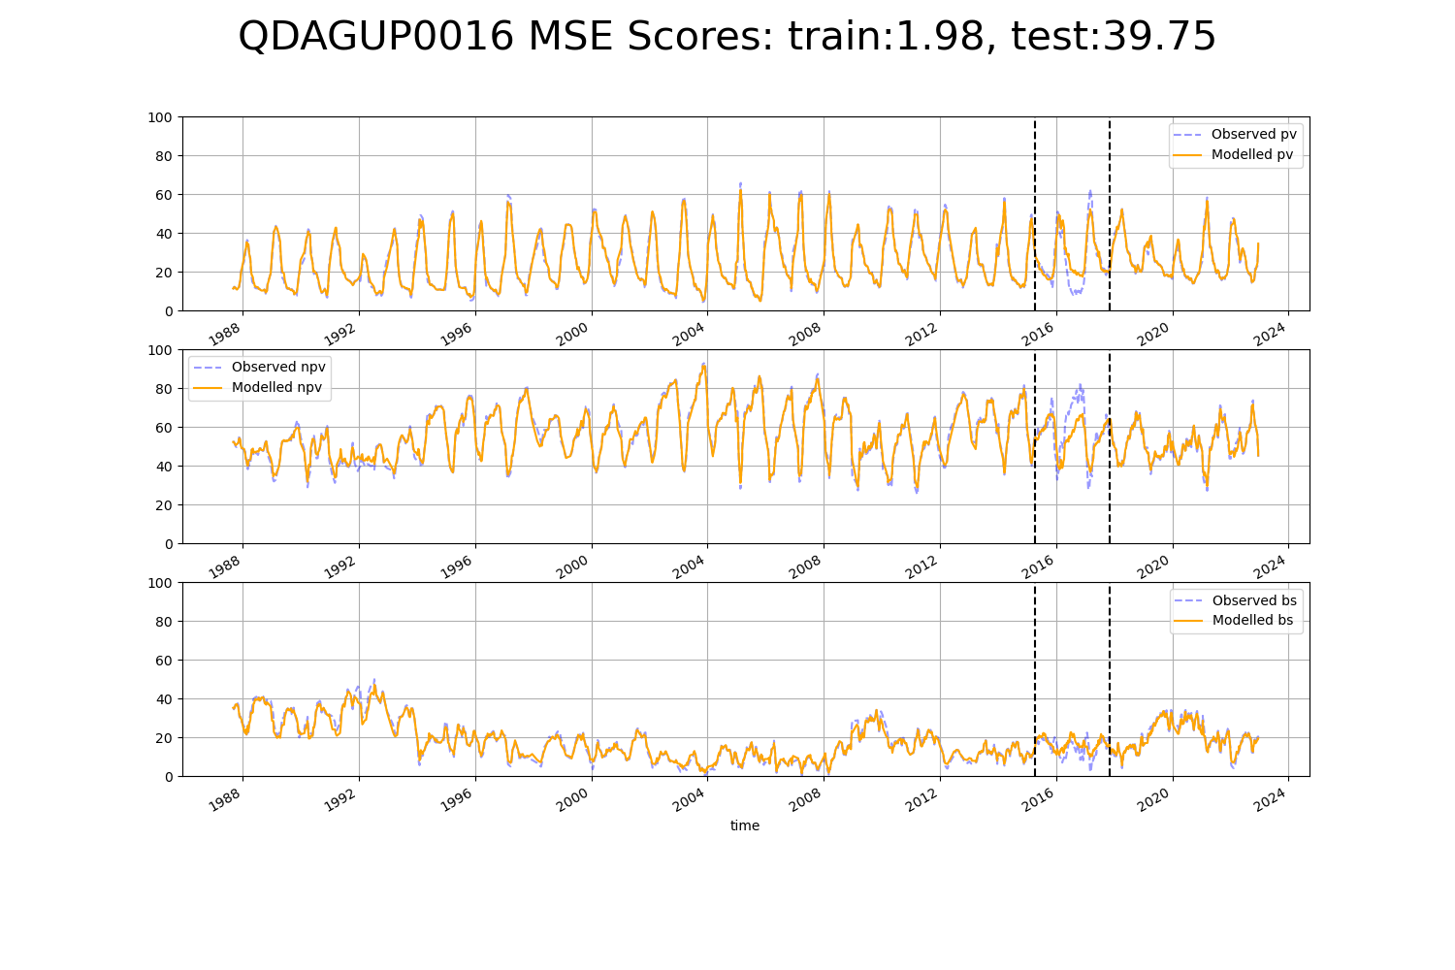

# QDAGUP0017

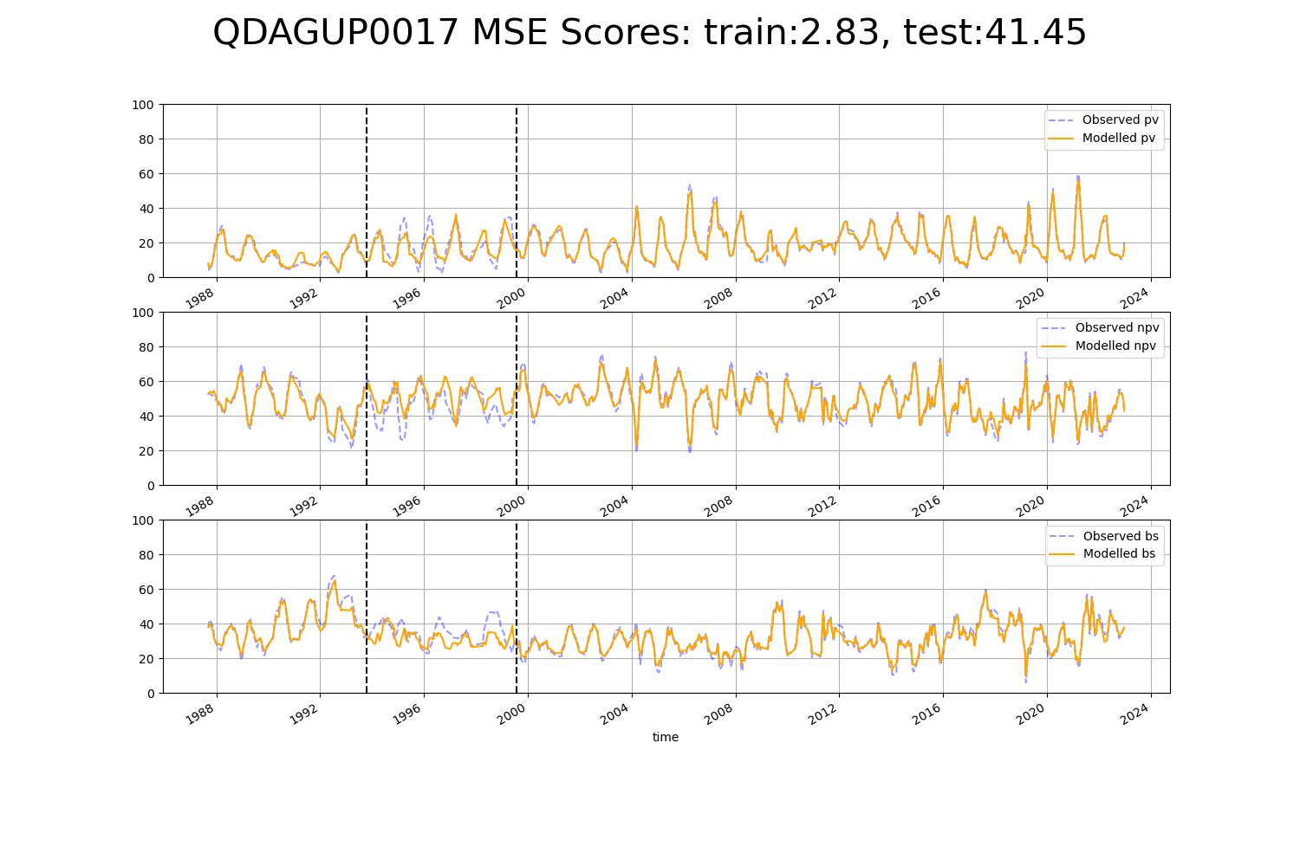

# QDAGUP0018

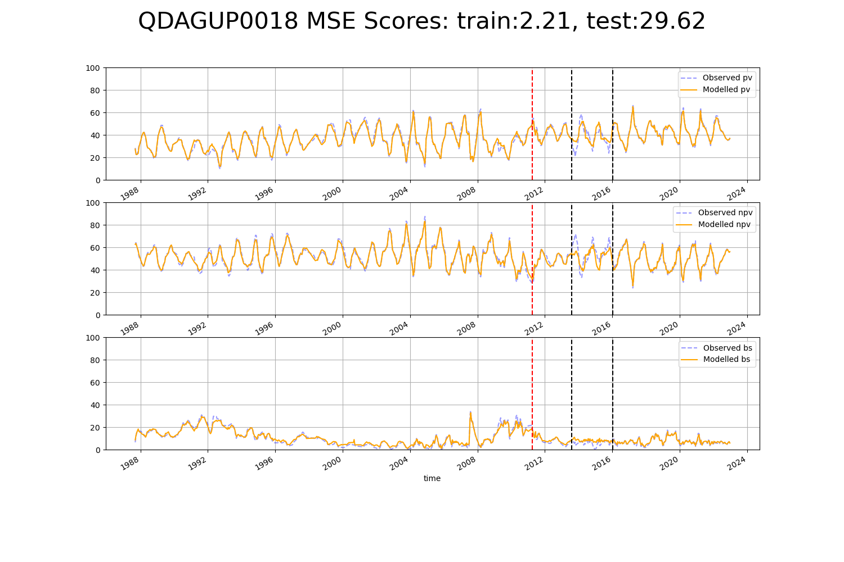

# QDAGUP0019

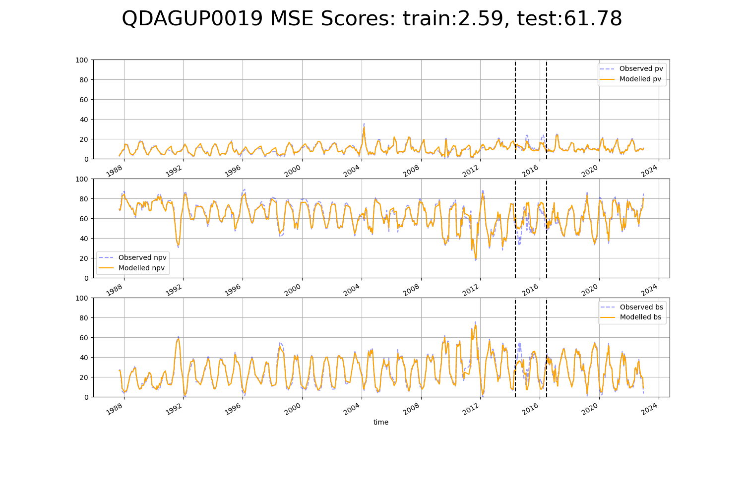

# QDAGUP0022

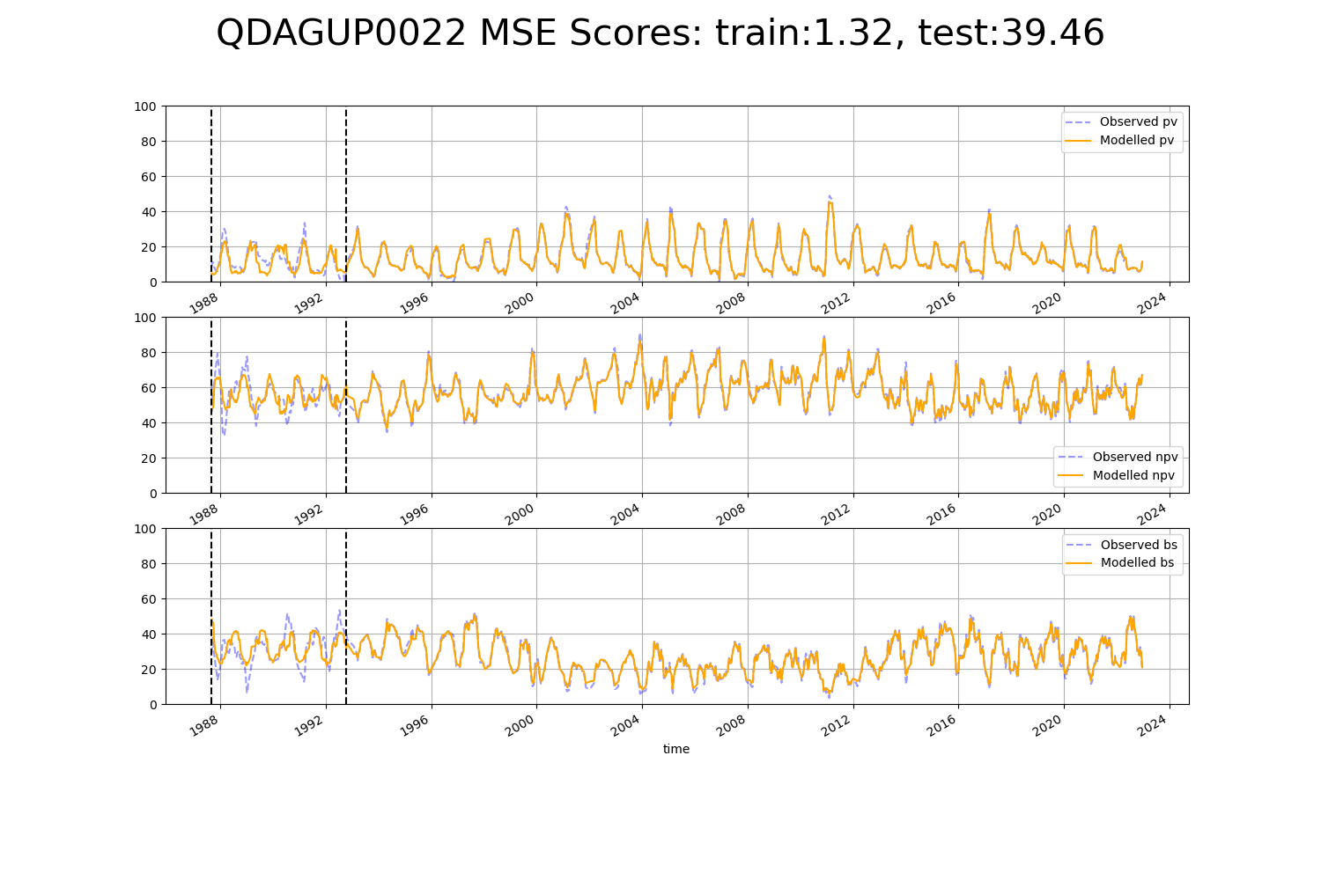

# QDAGUP0023

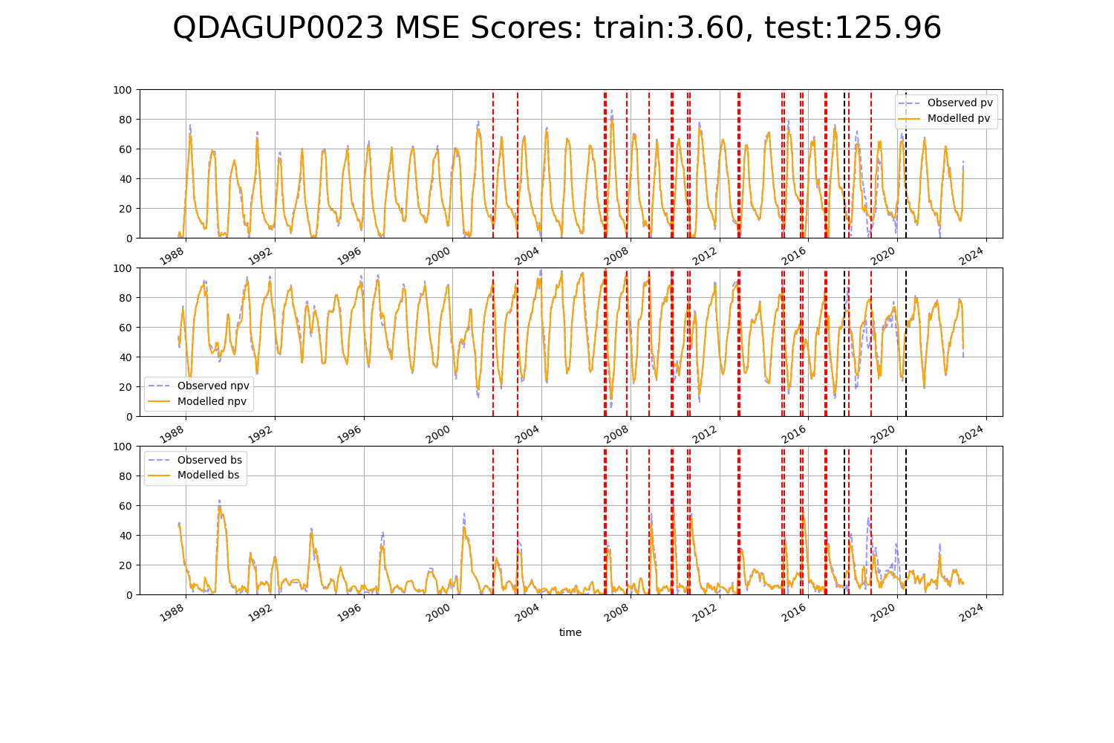

# QDAGUP0024

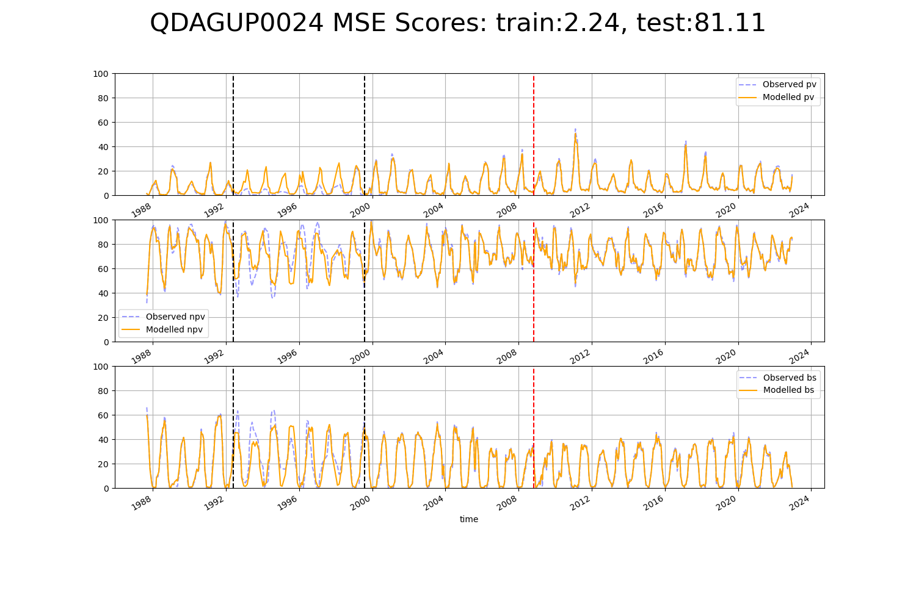

# QDAGUP0026

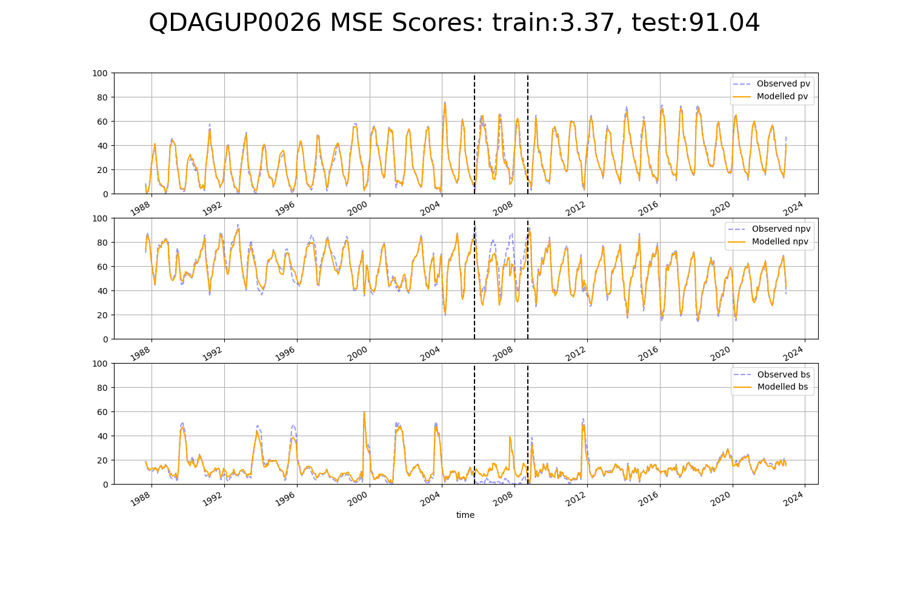

# QDAGUP0029

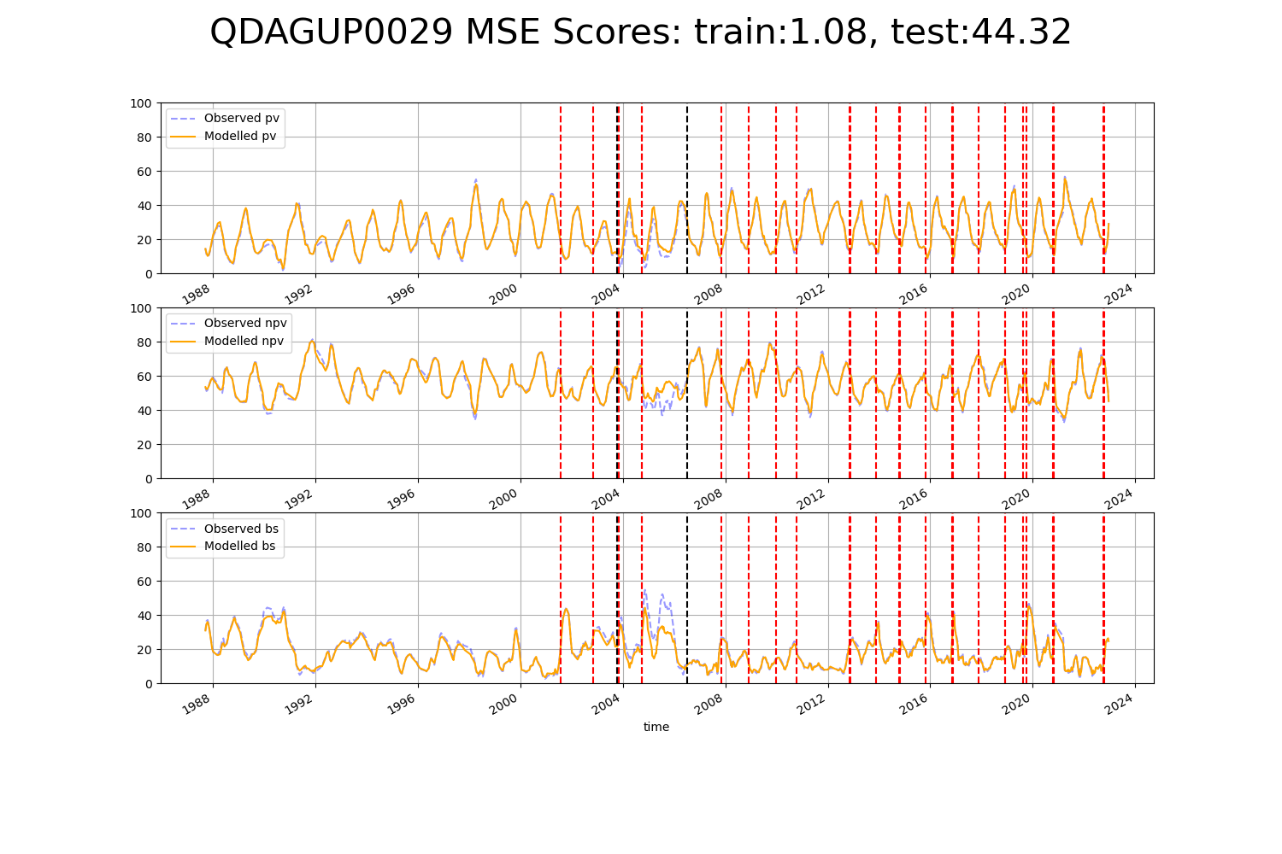

# QDAGUP0030

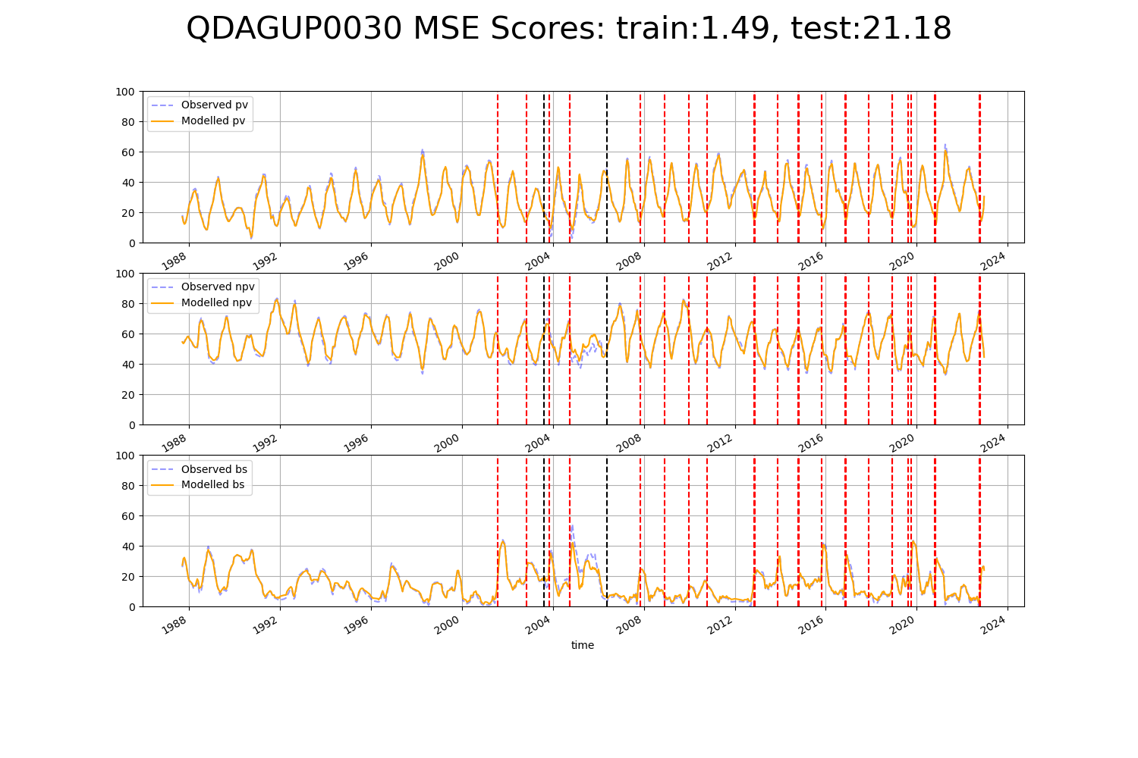

# QDAGUP0031

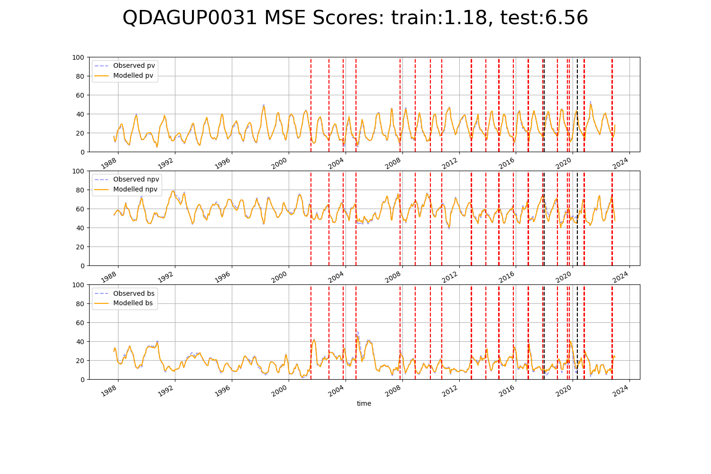

# QDAMGD0027

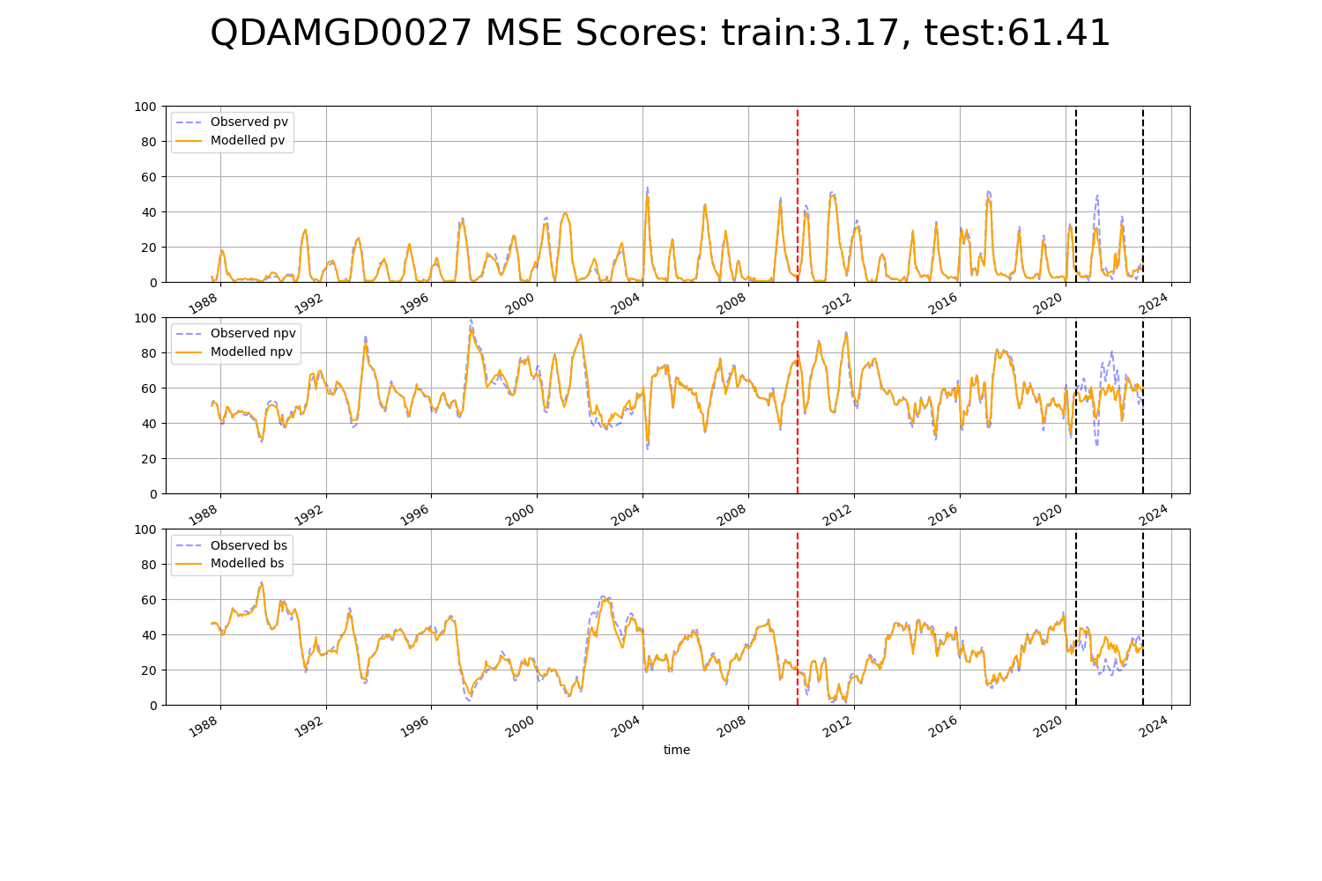

# QDAMGD0028

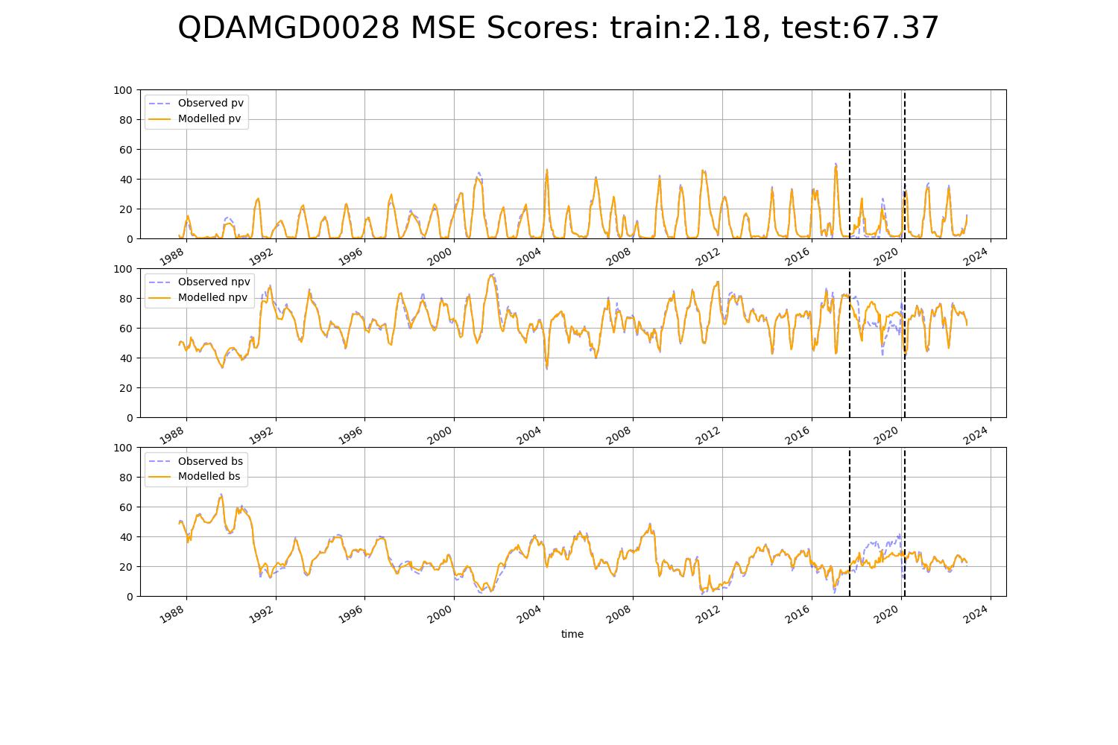

# QDAMII0001

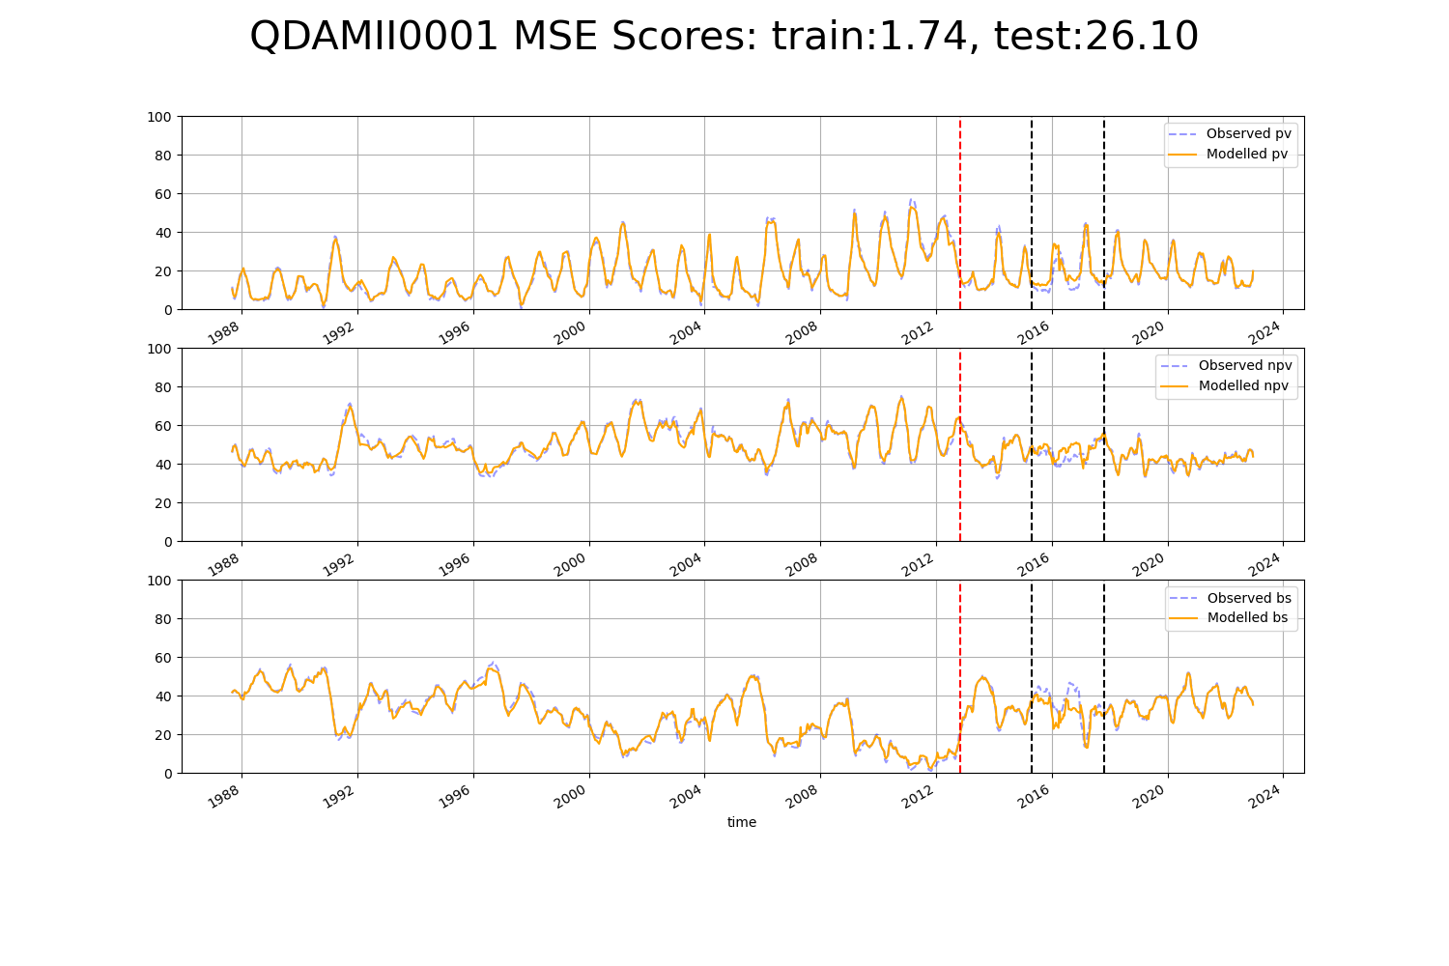

# QDAMII0002

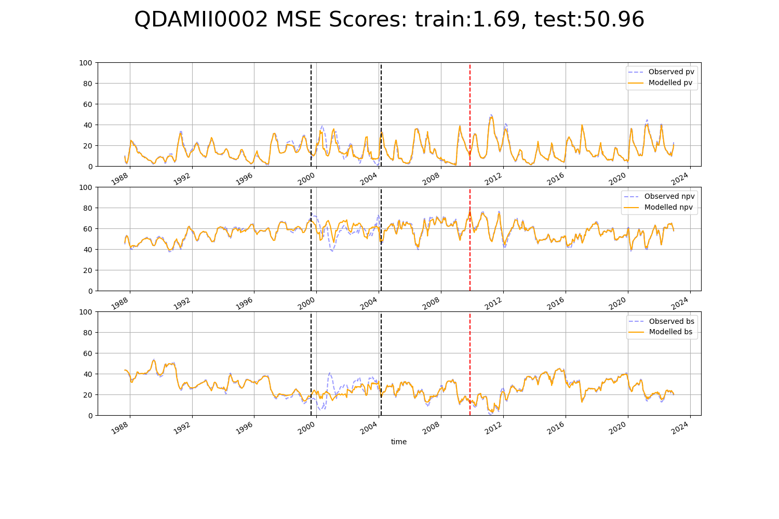

# WAACEK0002

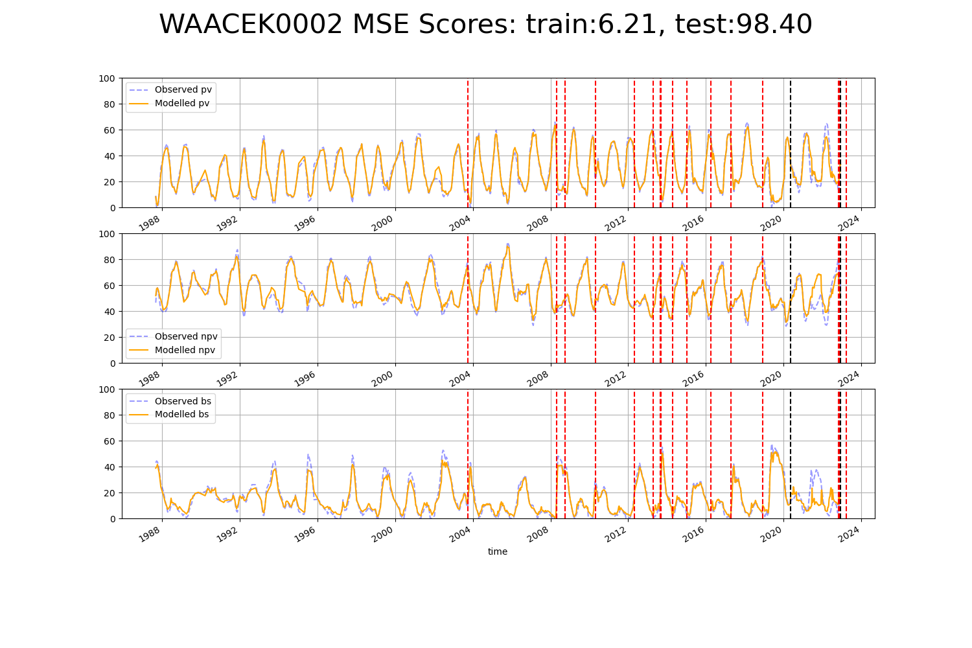

# WAADAL0001

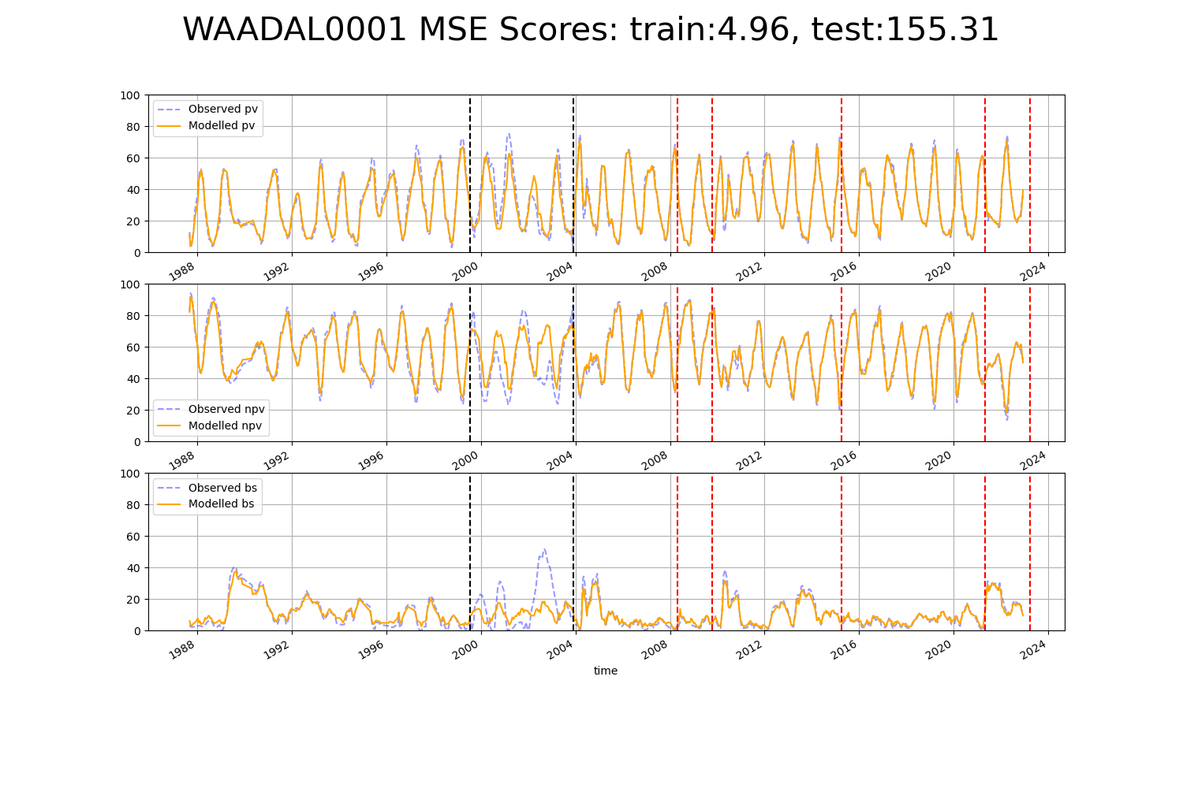

# WAADAL0005

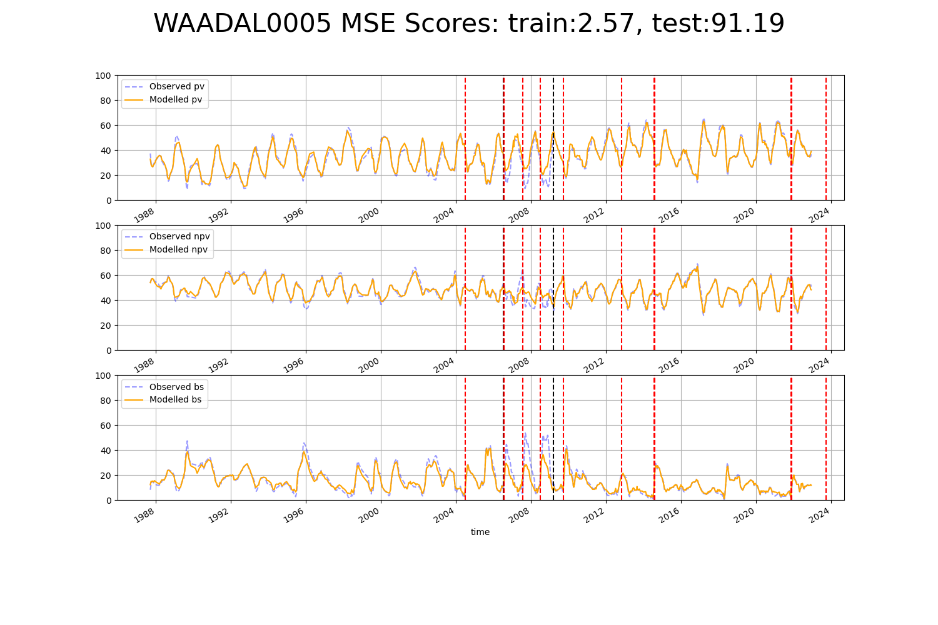

# WAANOK0003

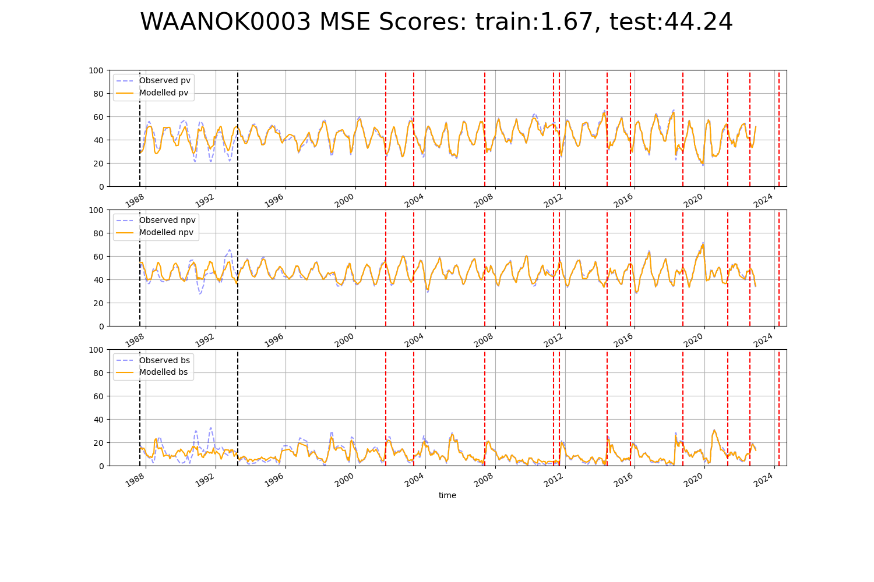

# WAANOK0004

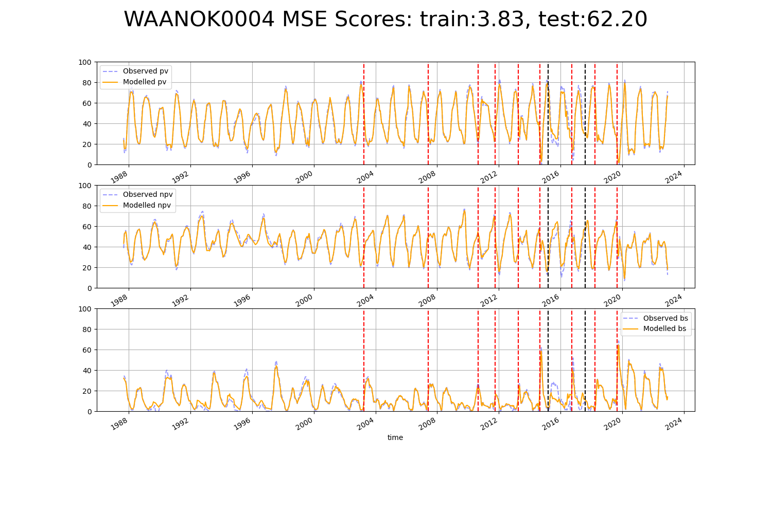

# WAANOK0005

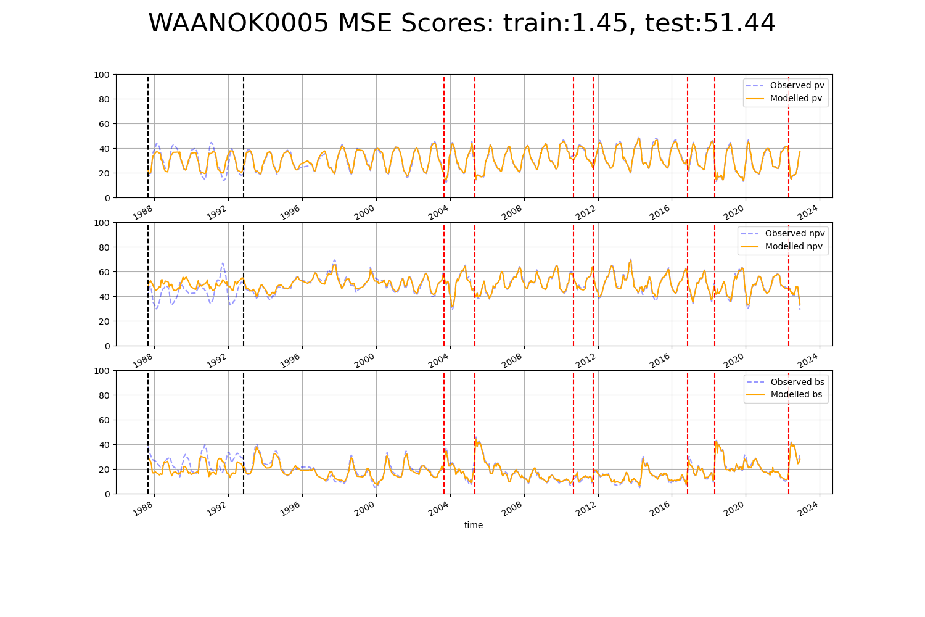

# WAANOK0007

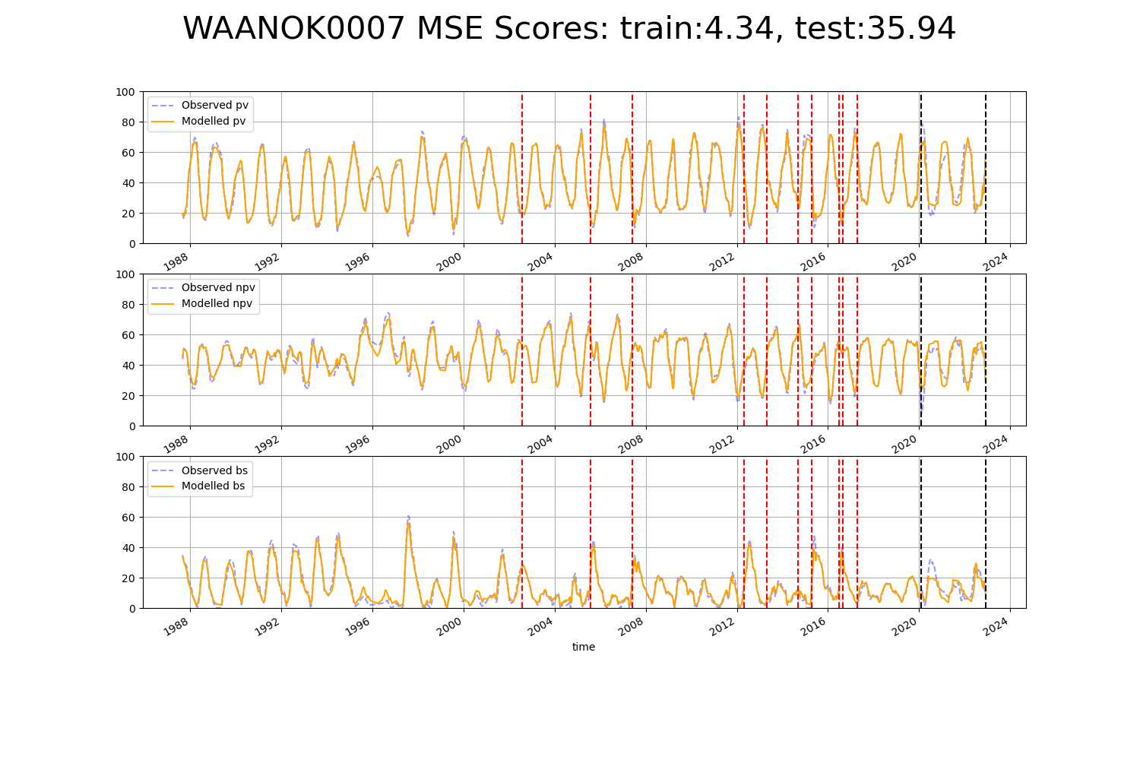

# WAANOK0008

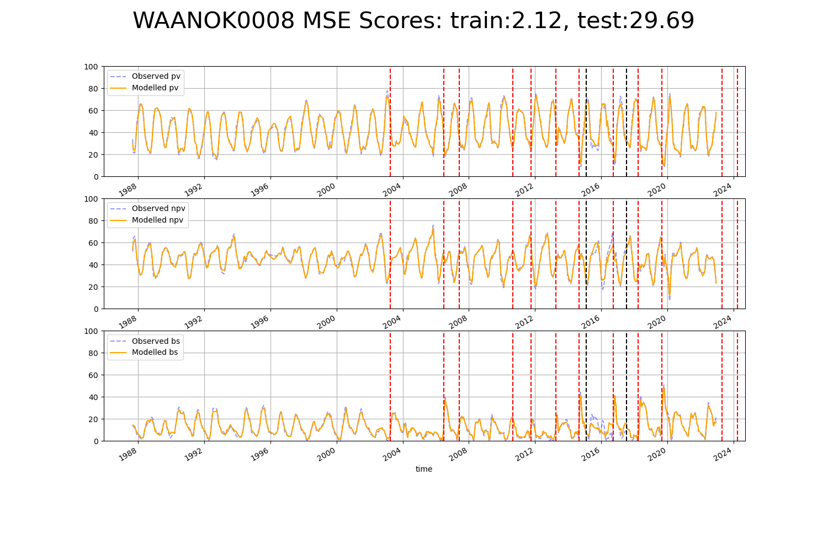

# WAAVIB0001

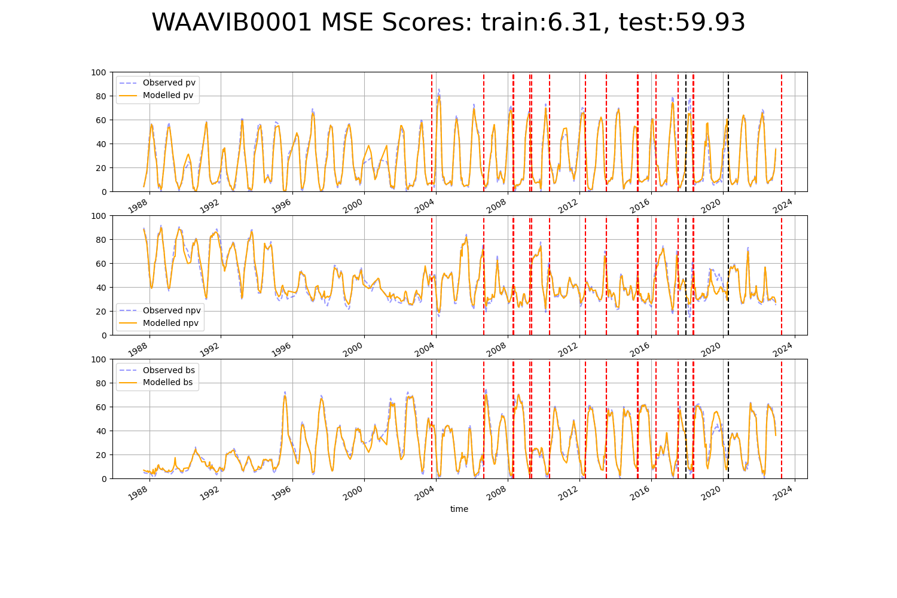

# WAAVIB0003

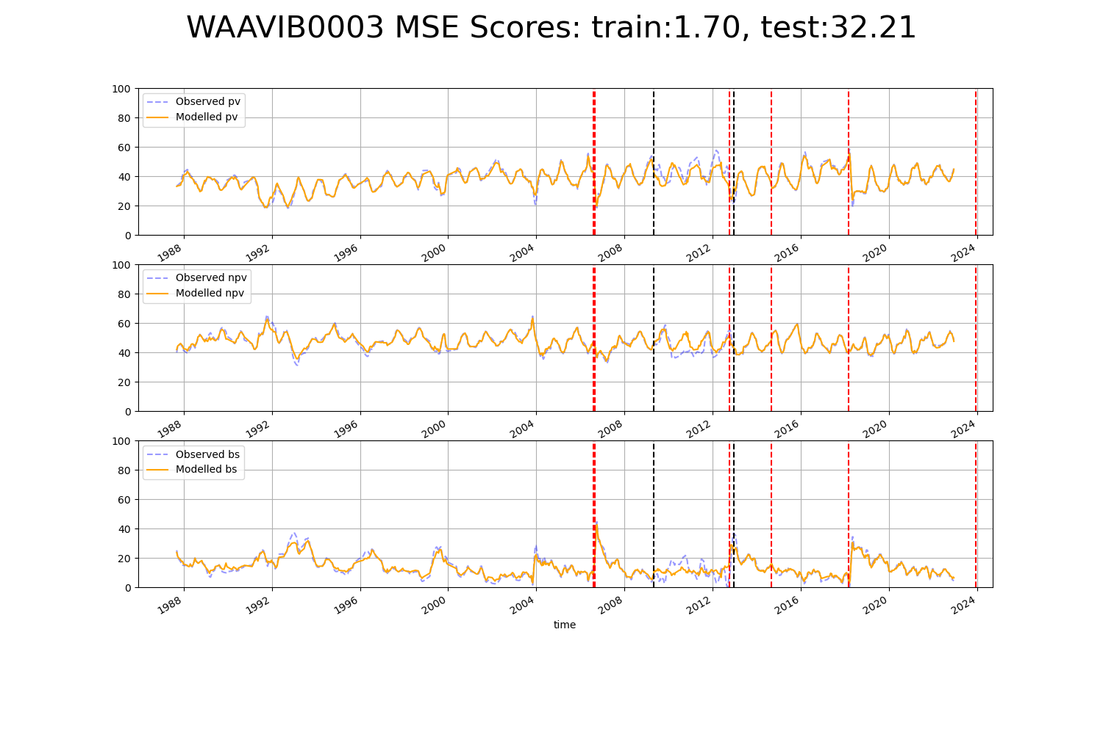

# WAAVIB0004

